**ANNALS OF GEOPHYSICS, VV, NV, PPPP, YYYY; doi:10.4401/ag-xxxx OPEN ACCESS**

**AdriaArray – a Passive Seismic Experiment to Study Structure, Geodynamics and Geohazards of the Adriatic Plate**

Petr Kolínský1*, Thomas Meier2, Matthew Agius3, Almir Bijedić4, Götz Bokelmann5, Felix Borleanu6, Dušica Brnović7, Musavver Didem Cambaz8, Fabio Cammarano9, Martina Čarman10, Carlo Cauzzi11, Dragana Chernih-Anastasovska12, Kristian Csicsay13, Snježana Cvijić Amulić14, Wojciech Czuba15, Jordi Diaz16, Liliya Dimitrova17, Edmond Dushi18, Christos Evangelidis19, Claudio Faccenna20, Liudmyla Farfuliak21, Wolfgang Friederich22, Gergana Georgieva23, Nikolaus Horn24, Ines Ivančić25, Yan Jia24, George Kaviris26, István János Kovács27, Sergei Lebedev28, Eline Le Breton29, Renata Lukešová30, Stanisław Mazur31, Mark van der Meijde32, Irene Molinari33, Shemsi Mustafa34, Thorsten Nagel35, Søren Bom Nielsen36, Anne Obermann37, Costas Papazachos38, Stefano Parolai39, Anne Paul40, Claudia Piromallo41, Vladimír Plicka42, Andreas Rietbrock43, Stéphane Rondenay44, Giuliana Rossi45, Georg Rümpker46, Christian Schiffer47, Karin Sigloch48, Hanna Silvennoinen49, Efthimios Sokos50, Petr Špaček51, Josip Stipčević52, Andrea Tallarico53, Timo Tiira54, Frederik Tilmann55, Dejan Valčić56, Joachim Wassermann57, Viktor Wesztergom27, Anila Xhahysa18, Mladen Živčić10 and the AdriaArray Seismology Group58

(1) Institute of Geophysics of the Czech Academy of Sciences, Prague, Czech Republic  
(2) Institute for Geosciences, University of Kiel, Germany

(3) Department of Geosciences, University of Malta, Msida, Malta

(4) Hydrometeorological Institute of Federation of Bosnia and Herzegovina, Sarajevo, Bosnia and Herzegovina

(5) Department of Meteorology and Geophysics, University of Vienna, Austria

(6) National Institute for Earth Physics, Magurele, Romania

(7) Sector of Seismology, Institute of Hydrometeorology and Seismology of Montenegro, Podgorica, Montenegro

(8) Kandilli Observatory and Earthquake Research Institute, Boğaziçi University, Çengelköy-İstanbul, Türkiye

(9) Department of Sciences, Roma Tre University, Rome, Italy

(10) Seismology and Geology Office, Slovenian Environment Agency, Ljubljana, Slovenia

(11) Observatories and Research Facilities for European Seismology (ORFEUS) & Swiss Seismological Service at ETH

Zürich, Switzerland

(12) Seismological Observatory, Faculty of Natural Sciences and Mathematics, St. Cyril and Methodius University

in Skopje, Republic of North Macedonia

(13) Earth Science Institute of the Slovak Academy of Sciences, Bratislava, Slovakia

(14) Republic Hydrometeorological Service, Banja Luka, Republika Srpska, Bosnia and Herzegovina

(15) Institute of Geophysics, Polish Academy of Sciences (Polish AdriaArray Seismic Group1**), Warsaw, Poland

(16) Geo3Bcn-CSIC, Barcelona, Spain

(17) National Institute of Geophysics, Geodesy and Geography, Bulgarian Academy of Sciences, Sofia, Bulgaria

(18) Department of Seismology, Institute of Geosciences, Polytechnic University of Tirana, Albania

(19) Institute of Geodynamics, National Observatory of Athens, Athens, Greece

(20) Section 4.1 Lithosphere Dynamics, Helmholtz-Centre Potsdam - German Research Centre for Geosciences (GFZ),

Potsdam, Germany, Dept. of Sciences, Università Roma TRE, Italy

(21) Subbotin Institute of Geophysics of the National Academy of Sciences of Ukraine, Kyiv and Lviv, Ukraine

(22) Institute for Geology, Mineralogy and Geophysics, Ruhr University Bochum, Germany

(23) Department of Meteorology and Geophysics, Faculty of Physics, Sofia University, Bulgaria

(24) GeoSphere Austria (formerly Zentralanstalt für Meteorologie und Geodynamik - ZAMG), Vienna, Austria

(25) Croatian Seismological Survey, Department of Geophysics, Faculty of Science, University of Zagreb, Croatia

(26) Seismological Laboratory, National and Kapodistrian University of Athens, Greece

(27) Institute of Earth Physics and Space Science, Sopron and Budapest, Hungary

(28) Department of Earth Sciences, University of Cambridge, Great Britain

(29) Géosciences Rennes, University of Rennes, France

(30) Institute of Rock Structure and Mechanics of the Czech Academy of Sciences, Prague, Czech Republic

(31) Institute of Geological Sciences, Polish Academy of Sciences (Carpathian Project Group[1]**), Warsaw, Poland

(32) Faculty of Geo-Information Science and Earth Observation (ITC), University of Twente, Enschede, the Netherlands

(33) Istituto Nazionale di Geofisica e Vulcanologia (INGV), Bologna, Italy

(34) Seismological Network of Kosovo, Geological Survey of Kosovo, Pristina, Kosovo

(35) Institute of Geology, Faculty of Geosciences, Geoengineering and Mining, Technische Universität Bergakademie

Freiberg, Germany

(36) Department of Geoscience, Aarhus University, Denmark

(37) Swiss Seismological Service at Eidgenössische Technische Hochschule Zürich (ETH), Switzerland

(38) Geophysical Laboratory, Aristotle University of Thessaloniki, Greece

(39) Department of Mathematics and Geosciences, University of Trieste, Italy

(40) Institut des Sciences de la Terre, Université Grenoble Alpes (French consortium Grenoble-Toulouse-Strasbourg1**),

Grenoble, France

(41) Istituto Nazionale di Geofisica e Vulcanologia (INGV), Rome, Italy

(42) Department of Geophysics, Faculty of Mathematics and Physics, Charles University, Prague, Czech Republic

(43) Geophysical Institute, Karlsruhe Institute of Technology (KIT), Karlsruhe, Germany

(44) Department of Earth Science, University of Bergen (Norwegian Broadband Pool1**), Bergen, Norway

(45) Centre for Seismological Research, National Institute of Oceanography and Applied Geophysics (OGS), Trieste, Italy

(46) Faculty of Geosciences and Geography, Goethe University Frankfurt, Germany

(47) Department of Earth Sciences, Uppsala University, Sweden

(48) Géoazur, Université Côte d’Azur, Sophia Antipolis, France

(49) Sodankylä Geophysical Observatory, University of Oulu, Finland

(50) Laboratory of Seismology, Department of Geology, University of Patras, Greece

(51) Institute of Physics of the Earth, Masaryk University, Brno, Czech Republic

(52) Andrija Mohorovičić Geophysical Institute, Department of Geophysics, Faculty of Science, University of Zagreb,

Croatia

(53) Department of Earth and Geo-environmental Sciences, University of Bari Aldo Moro, Italy

(54) Institute of Seismology, University of Helsinki, Finland

(55) Section 5.4 Seismology, Helmholtz-Centre Potsdam - German Research Centre for Geosciences (GFZ), Potsdam,

Germany

(56) Seismological Survey of Serbia, Belgrade, Serbia

(57) Department of Earth and Environmental Sciences, Ludwig-Maximilian University Munich, Germany

(58) <https://orfeus.readthedocs.io/en/latest/adria_array_main.html>; the list of individuals affiliated with the AdriaArray

Seismology Group is given later in the paper

Article history: received Month DD, YYYY; accepted Month DD, YYYY

**Abstract**

AdriaArray is a multinational initiative to cover the Adriatic Plate and its active margins by a dense regional array of seismic stations. AdriaArray provides data for imaging of the crustal and upper mantle structure and for the analysis of seismic activity and hazard. It will help to understand the causes of active tectonics and volcanic fields in the region. The network consists of 1068 permanent and 440 temporary broadband stations from 23 mobile pools. A homogeneous coverage of broadband stations is achieved in an area from the Massif Central in the west to the Carpathians in the east, from the Alps in the north to the Calabrian Arc and mainland Greece in the south. The backbone network (2022 – 2025) is complemented by locally densified broadband and short-period largeN deployments in the western Carpathians, along the Dubrovnik fault, in the Vrancea region and in Albania. Data recorded by AdriaArray stations is transmitted in real-time to 12 nodes of the European Integrated Data Archive (EIDA) where it is accessible as a single virtual network. Regular availability and quality checks ensure high data usability. AdriaArray, the largest passive seismic experiment in Europe to date, is based on the cooperation between local network operators, mobile pool providers, technicians, engineers, field teams, researchers, students, and institutions such as ORFEUS (Observatories and Research Facilities for European Seismology) and EPOS (European Plate Observing System). The AdriaArray Seismology Group, founded in 2022, is encompassing 64 institutions from 30 countries with 433 participants. Collaborative Research Groups are being established to coordinate data analysis and scientific research. We present the evolution of the experiment and its objectives, describe its preparation and planning, and we show maps of the AdriaArray Seismic Network, station properties and coverage. We further describe the data archiving and distribution, list the participating institutions, individuals and networks and discuss collaborative research topics.

Keywords: seismology, geodynamics, Adriatic plate; large seismic network; seismic imaging, crustal structure; upper mantle structure; seismic hazard; plate deformation

# Introduction

* 1. **General overview**

The densely populated area in the Central Mediterranean and around the Adriatic Sea is prone to geohazards such as earthquakes, tsunamis, landslides, flooding, and volcanic activity as the formerly much larger Adriatic Plate is being consumed in a tectonically active belt of subduction and collision zones spanning from Sicily, over the Apennines to the Alps, the Dinarides and the Hellenides, repeatedly generating earthquakes up to magnitude 7. To identify drivers of associated plate deformation, it is necessary to determine the plate boundaries, slabs, properties of active faults and of the lithospheric stress field. The AdriaArray Seismic Network covers the region of the Adriatic plate and also its deforming margins, with more than 1500 broadband stations and an approximate station spacing of 50 km. We took advantage of two previous large experiments in the area - AlpArray and PACASE - by incorporating 135 existing temporary stations and deploying 293 additional temporary stations. The AdriaArray initiative has made nearly 100 permanent stations, built years and sometimes decades before AdriaArray, available through EIDA, the European Integrated Data Archive, managed by ORFEUS.

AdriaArray is an initiative that brings together a large number of scientific groups from almost all European countries, with various foci and different institutional and financial support. Heterogeneous instrumentation and data transmission procedures used by these institutions are gradually integrated into EIDA. AdriaArray was created by a community of geoscientists interested in the study of the geodynamics and geohazards in the area of the Adriatic Plate and its surroundings. The number of temporary seismic stations built by AdriaArray, the number of involved mobile and permanent network operators, the number of participating institutions and also of participating individuals is unprecedented in Europe.

In addition to the expected challenges, we faced - and we still face - two unforeseen issues that significantly affected the preparation of the project: the years 2020 and 2021 were paralyzed by the covid pandemic and since 2022, the Russian invasion has hindered the deployment of stations in Ukraine, and also in Moldova. The seismological community managed to get through the pandemic, and is supporting our Ukrainian colleagues by hosting some of them, as well as by providing equipment for upgrading stations of the Ukrainian seismic network.

AdriaArray enables knowledge sharing and capacity building. This concerns the installation of temporary stations, data storage and exchange, as well as scientific cooperation. AdriaArray, together with ORFEUS and EPOS, organized several workshops that brought together students and researchers from 30 countries to share their expertise.

In this paper, we describe the history of AdriaArray and its technical and scientific objectives. We discuss the seismic network and its design, guidelines for installing temporary stations, and the archiving of the data. We introduce online repositories and tools to handle the station inventories and maps. We give the list of participants, member institutions and the list of seismic networks involved. Details on the design and performance of individual stations are presented in other papers of this special issue. We also list and discuss collaborative research topics that have emerged from the community discussions and will be addressed in the coming years.

* 1. **Tectonics of the region and open research questions**

As shown in Fig. 1, AdriaArray covers the active margins of the Adriatic Plate (Adria) and tectonic units to which nappes of the Adriatic Plate have been accreted including the Calabrian Arc, the Apennines, the Alps, the Dinarides, the Hellenides, the Pannonian Basin and the Carpathians (dark and light brown colors). Adria represents a disappearing plate that has been subducting beneath and colliding with the surrounding lithospheric units (e.g., Faccenna et al., 2014; Schmid et al., 2020; van Hinsbergen et al., 2020). There is geological evidence that intra-oceanic subduction at the eastern margin of Adria started in the Middle Jurassic and that continental collision occurred in the Late Cretaceous along the Sava suture (Ustaszewski et al., 2010; Handy et al., 2015; Schmid et al., 2020; van Hinsbergen et al., 2020). The present-day thrust front is located offshore in the Adriatic Sea (Fig. 1). It emerges to land in Istria and the Southern Alps. The East Ligurian Ocean and continental Adria have been subducted at the western Mediterranean in the Calabrian Arc and the Apennines since the Neogen (Malinverno and Ryan, 1986; Carminati et al., 1998; Faccenna et al., 2001; 2014; Rosenbaum and Lister, 2004). The size of Adria shrunk thus by more than 70% during progressive oceanic subduction and continental collision. Only a small piece of the formerly much larger continental lithosphere remains today almost undeformed beneath the Adriatic Sea (1300 km in NW-SE direction, 250 km in NE-SW direction, Fig. 1). In the Alps, the Adriatic Plate represents mainly the upper plate (Schmid et al., 1996; Handy et al., 2010; Rosenberg and Kissling, 2013). In contrast, it represents the lower plate along its western and eastern margins. Crustal nappes of Adriatic origin are found highly deformed within the surrounding orogens (Fig. 1). To the south, no localized plate boundary but a number of diffuse and poorly studied deformation zones covered by the accretionary wedges of Calabria and the Mediterranean Ridge are found. The transition from continental collision in the Hellenides to oceanic subduction of the Ionian lithosphere occurs along the Kefalonia Transform Fault Zone (Papazachos and Comninakis, 1971; McKenzie, 1972; Le Pichon and Angelier, 1979; Royden and Papanikolaou, 2011).

Because of its coherent motion with Africa for much of the Meso- and Cenozoic, the northward drift of Adria has long been considered as the main cause for continental collision with Eurasia (e.g. Beaumont et al., 1996; Schlunegger and Willett, 1999). Plate kinematic studies show however that Adria became independent from Africa during the last millions of years (Anderson & Jackson, 1987; D'Agostino et al., 2008; Le Breton et al., 2017). Slab pull and slab retreat as well as asthenospheric flow have been suggested as causes for Adria’s motion (Faccenna et al., 2014; Király et al., 2018; Kissling and Schlunegger, 2018; Andrić et al., 2018; Handy et al., 2019). Adria’s core in the Apennines, Dinarides and the Alps is showing mostly a NE to N counterclockwise motion with respect to Eurasia, that may be grossly described as a rotation around a pole positioned in the Po Plain. In contrast, its southern part in the Albanides-Hellenides shows mostly a S to SW clockwise motion around a pole located in the Aegean Sea (D'Agostino et al., 2008). This differential motion is associated with large-scale tectonic tearing and active deformation at the transition between Adria, Dinarides and Hellenides (e.g., Handy et al., 2019).

Adria offers the opportunity to study plate deformation, its geodynamic driving mechanisms, as well as its relation to geohazards. A quantitative framework linking geodynamic drivers, plate deformation and geohazards has yet to be fully developed. Achieving this requires the integration of seismotectonic observations, passive seismic imaging, detailed numerical geodynamic and physical geohazard simulations. The drivers of plate kinematics and plate deformation remain elusive because the slab geometry and the three-dimensional pattern of asthenospheric flow have not yet been unambiguously resolved. Initial isotropic images of slabs in the region, as provided by Bijwaard and Spakman (2000) and Piromallo and Morelli (2003), indicated double sided subduction in the Central Mediterranean with slabs subducting towards the west beneath Calabria and the Apennines and to the east beneath the Hellenides and Dinarides as well as the presence of complex subduction system in the Alps. Open questions concern, for example, slab break-off or the presence of delaminated continental mantle lithosphere in the southern Apennines (Giacomuzzi et al., 2012), slab break-off or continuous subduction in the western Alps (Lippitsch et al., 2003; Zhao et al., 2016a), the orientation of subduction and the depth of a broken-off Eurasian slab segment in the eastern Alps (Lippitsch et al., 2003; Kästle et al., 2020; Handy et al., 2021; Timkó et al., 2024), the presence and length of an Adriatic slab beneath the Dinarides (Handy et al., 2015; Šumanovac et al., 2017; El-Sharkawy et al., 2020; Belinić et al., 2021), the presence of a horizontal tear beneath the Hellenides, a vertical tear in the area of the Kefalonia Transform Fault Zone or smooth transition 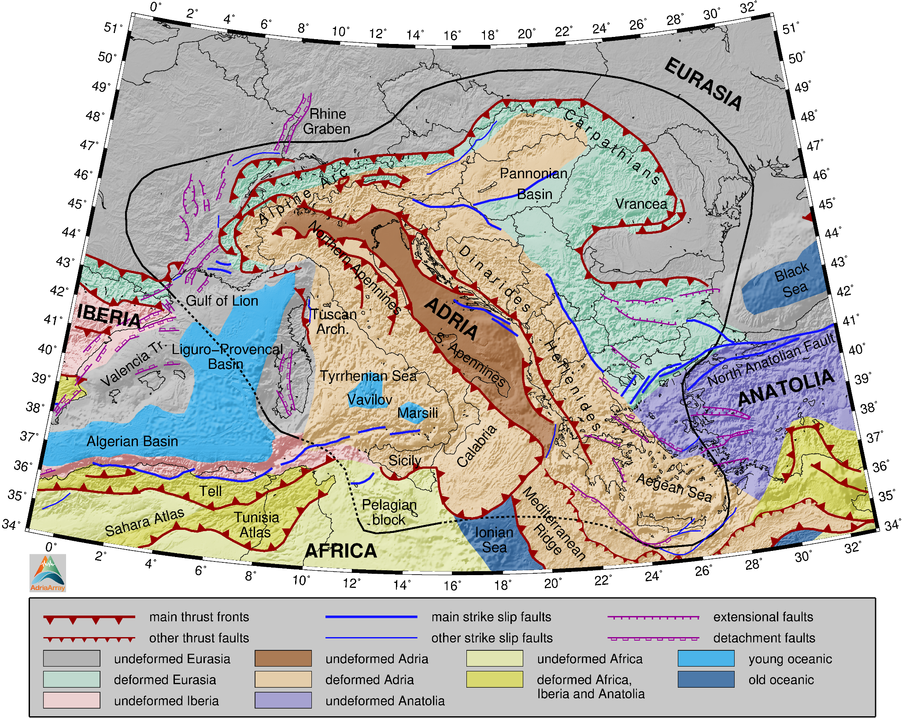from oceanic subduction in the Aegean to delamination of continental mantle lithosphere (Wortel and Spakman, 2000; Suckale et al., 2009; Evangelidis, 2017; Halpaap et al., 2018; Özbakir et al., 2020). The role of asthenospheric mantle flow in driving lithospheric deformation in the region has been highlighted by several studies (e.g., Horváth et al., 2006; Faccenna et al., 2014; Handy et al., 2015; Subašić et al., 2017; Király et al., 2018; Hein et al., 2021; Salimbeni et al., 2022; Pondrelli et al., 2023). Asthenospheric flow is strongly linked with the slab geometry and remains thus debated as well. A digital three-dimensional plate model of the entire central Mediterranean deciphering the geometry and properties of critical internal features like basins, faults and magma sources determining relevant societal hazards remains to be determined.

**Figure 1.** Tectonic map of the Central European and Mediterranean region, modified after Faccenna et al. (2014). The Adriatic Plate and neighboring plates are labeled. Thick barbed red lines represent the main thrust fronts, thin red lines are other thrust faults. The barbs point in the direction of subduction or underthrusting. Thick and thin blue lines show main and other strike slip faults, respectively. Extensional faults are shown by magenta lines with ticks on the downthrown side. Magenta lines with empty ticks are extensional detachment faults. The AdriaArray region is delineated by the black line. Undeformed Adriatic Plate is shown by dark brown, deformed continental Adriatic units accreted into orogens are by light brown. Undeformed Eurasia is grey and deformed Eurasian units are in green.

Thus, the following four overarching topics will be addressed by AdriaArray.

1. How do continental plates deform and dissolve during continental collision? We are just starting to have a complete picture of the recent and active deformation patterns within and at the margin of tectonic plates and of Adria in particular. We need to (i) image the interior of the plate and its boundaries and plate interfaces at high-resolution, (ii) define its kinematics and deformation, (iii) map recent and active faults, and (iv) define the vertical motion consistently at plate scale. Moreover, conditions for strain localization remain poorly understood: Why does strain localize at fault zones in some regions whereas deformation is rather diffuse in others? The ratio between aseismic and seismic deformation on active faults needs to be quantified and constraints favoring seismic deformation have to be identified.
2. Which processes drive plate deformation? Contrasting models have been proposed so far to explain the deformation system in and around Adria. A first class of models proposed that Adria’s deformation results from plate interactions, whereas the second class proposes that deformation is caused by mantle dynamics. To answer this question, we need to update our knowledge of the structure of the area down to the mantle depth. Seismic imaging will allow to define the geometry and properties of subducting Adriatic mantle lithosphere, asthenospheric flow, as well as of mantle upwellings. Exploration of the massive amounts of collected data should spur the development of new, innovative, automated, and robust data processing tools. Anisotropic waveform inversion algorithms should lead to advances in our understanding of plate deformation.
3. How do plates evolve in time? At active margins, the lower part of the Adriatic lithosphere is subducting into the mantle, whereas crustal nappes got delaminated and are now moving with the Eurasian plate. This results in a backward migration of the plate boundary and a continuous shrinking of undeformed Adria. The area thus offers the option to study plate deformation, including plate disintegration. In contrast, a new oceanic and continental lithosphere is formed in the Tyrrhenian and Pannonian back-arc basins, respectively, leading to consolidation and reorganization of plates. Hence, the disappearance as well as the creation of a new lithosphere can be studied in-situ.
4. How does plate deformation influence geohazards? Geohazards such as earthquakes, tsunamis, landslides, flooding, volcanic eruptions, but also sea level rise induce significant societal impact around the Adriatic plate. Active deformation induces earthquakes with significant damage (see section 1.4 below) and significant topographic disequilibrium favouring landslides or flooding events. Last but not least, we need to quantify and to understand how tectonic plate deformation creates such geohazards. Integration of tectonic, seismic, and geodetic observations and numerical forward modelling is required to constrain the causes of geohazards.
   1. **Seismicity and Seismic Hazard**

The risk of losses and casualties associated with multi-hazards such as seismicity, tsunamis, landslides, floods and volcanic activity is increasing around the Adriatic Sea due to the growing population in the area. Examples of geohazards include the largest known volcanic eruption in Europe, which occurred about 37000 BP at Campi Flegrei (Italy), the devastating earthquakes of Dubrovnik (Croatia) in 1667, and of Messina (Italy) in 1908, which caused major societal destructions.

The frequent occurrence of earthquakes with magnitudes larger than 6 to both sides of the Adriatic Sea, such as the M7.2 Kefalonia (Greece, 1953), the M7.2 Bar (Montenegro, 1979), the M5.9 L’Aquila (Italy, 2009) or the recent M6.4 Durrës (Albania, 2019-11-26), the M6.8 Ionian Sea (Greece, 2018-10-25), the M6.4 Petrinja (Croatia, 2020-12-29) earthquakes, and the sequence of M6.2, M6.1 and M6.5 events close to Norcia, central Italy (2016-10-30), to name just a few, are obvious indications of ongoing internal plate deformation. Geodynamic modeling based on high-resolution images of the lithosphere, slabs, and asthenospheric flow needs to be coupled to physical hazard modeling to understand geodynamic drivers of geohazards.

Figure 2 shows a subset of the 2020 European Seismic Hazard Model (ESHM20), by EFEHR (European Facilities for Earthquake Hazard and Risk) see Danciu et al. (2021), centered at the AdriaArray region, emphasized by the green line. Colors are proportional to the peak ground acceleration (PGA) on rock-like ground type for a 10% probability of exceedance in 50 years, corresponding to a mean return period of 475 years. The seismically active margins of the Adriatic Plate and widespread intraplate seismic activity, particularly in south-eastern Europe, are evident. The highest PGA values in the AdriaArray region are expected along the Calabrian Arc, the Apennines, along the southeastern Adriatic coast, the Hellenic Arc and at the westernmost tip of the North Anatolian Fault.

Best practice in seismic hazard assessment requires homogeneous input data sets, including earthquake catalogs, which can only be obtained with a dense coverage of seismic stations. Due to the variable density of the permanent seismic stations in central and southeastern Europe, observations of seismic activity are heterogeneous. This holds in particular for the magnitude of completeness of existing regional earthquake catalogs. AdriaArray enhances seismic monitoring in the region by the deployment of temporary stations and by supporting the operation and development of permanent seismic networks. This will improve the detection and location of earthquakes in the area, allowing better identification of seismically active faults and assessment of their current state and activity, as well as calibration of regional ground-motion prediction models. The AdriaArray initiative will contribute further to the harmonization of detection and location procedures and the improvement of the background velocity models. Focal mechanisms of small-magnitude earthquakes will also be determined to provide new insight into the three-dimensional lithospheric stress field and associated plate deformation.

* 1. **Previous experiments**

As early as in 1895, Ernst von Rebeur-Paschwitz proposed, in the first description of recordings of a teleseismic event, to build a global network of identical stations to monitor the world-wide seismic activity (von Rebeur-Paschwitz, 1895; Schweitzer and Lay, 2019). Around 100 Wiechert-seismometers deployed world-wide until the 1920s were part of such a network, but it was not until the 1960s that the ca. 120 stations of the World-Wide Standardized Seismograph Network (WWSSN) provided the global infrastructure, technical station capabilities, and open data-exchange procedures necessary to analyze waveforms using a global network (e.g. Oliver and Murphy, 1971). Since the late 1970’s, analogue recordings have been increasingly replaced by digital data acquisition and national permanent networks have been continuously densified. In Europe, ORFEUS was founded in 1987 to organize and ensure the open exchange of broadband data. Today, ORFEUS EIDA archives digital data of 23500 stations mainly from the Euro-Mediterranean region.

**Figure 2**. Ground shaking hazard map of the 2020 European Seismic Hazard Model (ESHM20) by EFEHR. The map shows

spatial distribution of the peak ground acceleration (PGA) mean values in [g] for a 10% probability of exceedance in 50 years, corresponding to a mean return period of 475 years. Figure replotted after Danciu et al. (2021).

In addition to permanent networks, temporary networks and local arrays have been deployed to achieve higher coverage in target areas and to measure the propagation direction and speed of seismic waves, respectively. Early examples are the Yellowknife Seismological Array installed in Canada in 1962 (Somers and Manchee, 1966), the LASA array installed in the United States in 1964 (Green at al., 1965), or the Gräfenberg Array being deployed in Germany since 1976 - the first digital broadband array that is still operational today (Buttkus et al., 1986). The era of digital temporary passive broadband seismic experiments started in Europe with the NARS initiative (Nolet et al., 1986). Since the 1990s, the number of stations deployed in temporary experiments by various pools has steadily increased from tens to a few hundreds and the duration of the experiments increased from a few weeks to several years. Permanent networks and temporary installations merged into regional arrays that grew across national boundaries and covered entire tectonic units. On-shore 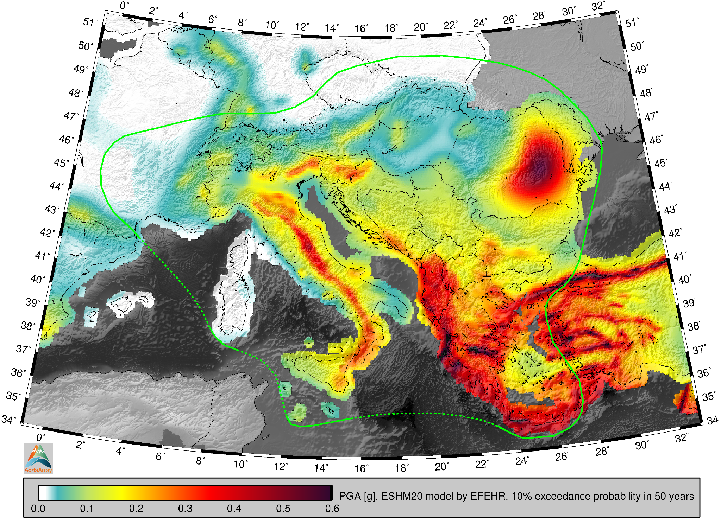stations were complemented by the deployment of ocean bottom seismometers (Sutton and Duennebier, 1987).

The USArray with about 400 temporary stations rolled from west to east across the continental United States from 2004 to 2015 and was installed in Alaska in 2014. The aperture of the simultaneously deployed stations was about 2100 km north-south and 850 km east-west with a station spacing of about 70 km in the contiguous U.S. Each station was operated for 1.5 - 2.0 years, see the white paper by Meltzer et al. (1999) and the report by Busby et al. (2018). There are hundreds of papers based on the USArray data and more are being continuously published.

Examples of experiments in central and northern Europe include the TOR project (Teleseismic Tomography across the Tornquist Zone; Gregersen & Voss, 2002). Between 1996-1997, 120 seismometers of that project were deployed as an elongated array from Sweden to Denmark and Germany. ScanArray 2012-2017 (Thybo et al., 2021) covered the Baltic Shield with 192 broadband stations. The PASSEQ experiment (PASsive Seismic Experiment in TESZ; Wilde-Piórko et al., 2008) kept almost 200 stations in place for more than two years in 2006 - 2008. The size of the array was about 1200 km in length and 400 km wide with a station spacing of about 60 km on average and of 20 km in the central parts. However, only one quarter of the stations were broadband. PASSEQ built up an international consortium of 17 institutions from 10 countries. Many other experiments were carried out in Europe, for further examples we refer to overviews by Hetényi et al. (2018), Schlömer et al. (2024) and Plomerová et al. (2025).

In the Mediterranean region, the EGELADOS (Exploring the Geodynamics of Subducted Lithosphere Using an Amphibian Deployment of Seismographs) experiment (2005 - 2007) covered the southern Aegean Sea with 49 broadband stations onland and 22 ocean bottom seismographs (Friederich & Meier, 2008). Between 2007 and 2009, 80 broadband stations were also deployed in the Anatolia-Aegean region in the framework of the SIMBAAD experiment (Seismic Imaging of the Mantle Beneath the Aegean-Anatolia Domain; Salaün et al., 2012). IberArray (Díaz et al., 2009 and 2015; Díaz and Gallart, 2014) covered northern 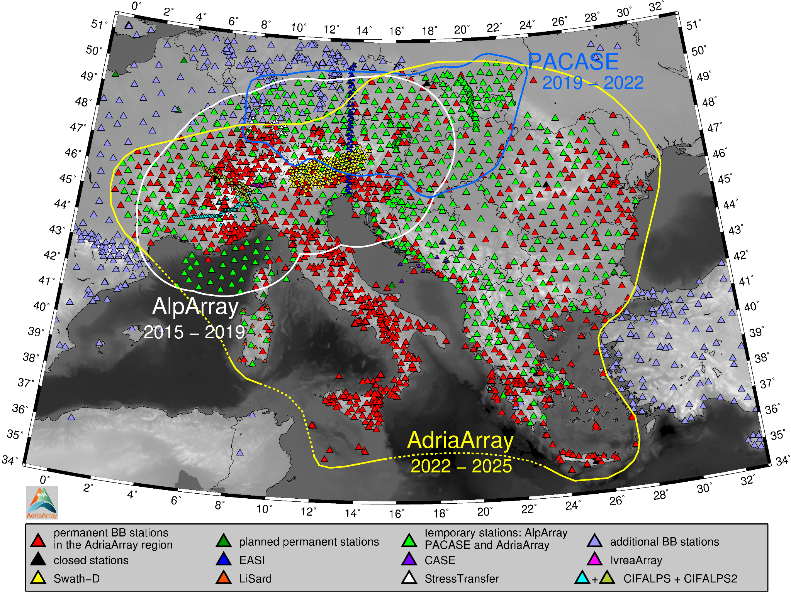Morocco and the whole Iberian Peninsula in three successive deployments between 2007 - 2013, resembling the rolling spirit of the USArray, with IberArray moving from south to north. The station spacing was 60 km and the three deployments comprised 55 stations in the first deployment to almost 100 stations in the third one. Every station stayed at its place for at least 1.5 years. Efforts continued with the PYROPE experiment (PYRenean Observational Portable Experiment, 2009 - 2013, Chevrot et al., 2014), which was synchronized with the third deployment of the IberArray and allowed investigations on both the Spanish and French sides of the Pyrenees.

**Figure 3.** Temporary broadband stations of the current AdriaArray Seismic Network together with the previous large

experiments, the AlpArray and the PACASE, are shown by light green triangles. Stations of the AlpArray complementary experiments EASI, CASE, IvreaArray, Swath-D, LiSard and StressTransfer as well as of CIFALPS and CIFALPS2 experiments are shown by various colors. Outlines of all three large-scale deployments are shown. Blue triangles are permanent broadband stations outside of the AdriaArray region and temporary stations inside the AdriaArray region not being part of the AdriaArray Seismic Network. Dark green are permanent stations to be built in near future, and black are permanent and temporary stations, which were operational during the AdriaArray time period (after May 2022), but are closed already. This map contains also some permanent and temporary stations which are not connected to EIDA yet.

A more recent example of large dense seismic networks in Europe is the AlpArray experiment (Hetényi et al., 2018), which covered an entire orogen - the Alps - with 276 temporary broadband stations placed among the existing 352 permanent broadband stations, complemented by 30 ocean-bottom seismometers in the Ligurian Sea, achieving the densest station spacing so far with an average distance of 52 km between the stations. AlpArray was followed by the PACASE experiment (Schlömer et al., 2024), where 63 stations were added to the eastern margin of the former AlpArray deployment with similar station density.

Figure 3 shows all temporary stations deployed in the Alpine area during the last decade. Various colors depict AlpArray, PACASE and the other AlpArray complementary experiments EASI (Eastern Alpine Seismic Investigation, 2014 - 2015, Hetényi et al., 2018b), CASE (Central Adriatic Seismic Experiment, 2016 – 2018, Molinari et al., 2018), IvreaArray (2017 – 2019, Hetényi et al., 2017), SWATH-D (2017 – 2019, Heit et al., 2021), LiSard (Lithosphere of Sardinia, 2016 - 2018) and StressTransfer (2018 - 2021, Mader et al., 2021) as well as CIFALPS (China-Italy-France Alps seismic survey, 2012-2013, Zhao et al., 2015) and CIFALPS2 (2017-2019) experiments. See also the list of seismic networks below for further references to the particular seismic network codes and their DOIs.

AdriaArray follows directly the two major deployments conducted in the area - the AlpArray and PACASE experiments. These three experiments spanned consecutive three-year operation periods with AlpArray operating between 2016 and 2019, PACASE from 2019 to 2022 and AdriaArray from 2022 to 2025. AlpArray started officially in 2016, even though the deployment began already in 2015 in some countries. AdriaArray has not only shifted the deployment of temporary stations to the southeast, it also covers almost the entire region previously covered by AlpArray and fully includes PACASE. With AdriaArray we can now study the Adriatic Plate, its plate margins and geohazard related to plate deformation. Improvement of seismic monitoring and hazard assessment are actually the most urgent tasks for many researchers of the AdriaArray community.

# Preparation and installation of AdriaArray

* 1. **Compilation of information on existing permanent stations**

The first task which we tackled starting in 2019, which was specific to AdriaArray compared to previous experiments, was to compile information on existing permanent stations in the AdriaArray region. For many countries, lists of existing stations were available from various sources, but information on sensor types and the operational status was largely missing. For some countries, lists of existing stations were also not readily available. We therefore assembled this information from network operators and included not only broadband, but also strong-motion and short-period stations. This resulted in a list of more than 3000 existing stations with information on station locations, operation periods, sensor types, network codes, and data archiving, see the inventory sheets on the AdriaArray GitHub page (links are given in Appendix A). 2257 permanent stations are located inside the AdriaArray region, of which 1068 are broadband stations with a corner period equal to or longer than 30 s. Although the vast majority of permanent stations listed in our inventory are connected to EIDA and therefore their metadata are available, the inventory still contains about 220 stations (in the whole rectangular map cut-off, both inside and outside of the AdriaArray region), for which basic station parameters cannot be easily found because these stations were not included in EIDA. It was found that a significant number of operational stations in the AdriaArray region were not connected to European data infrastructures in 2019. Due to the AdriaArray initiative, data of more than 100 existing broadband stations are now streamed to the European archive (ORFEUS EIDA).

In addition to permanent stations in operation, we also listed sites where stations have been located in the past. These were usually sites of temporary installations during previous experiments. These sites could potentially be used again for temporary stations. We also listed planned station locations, if reported by the local network operators.

* 1. **Involved mobile pools and design of AdriaArray**

Based on maps of existing stations, preliminary plans for the installation of temporary stations were developed according to the availability of mobile pools. Remarkably, more than 440 temporary stations from 23 mobile pools from 14 European countries were available for AdriaArray. This shows the potential for coordinated large-scale passive seismic experiments in Europe. Intensive discussions between hosting network operators and mobile pool representatives led to plans for the distribution and installation of temporary stations with the aim of achieving a homogeneous backbone network of broadband stations. Figure 4 shows all the broadband stations, both permanent and temporary, both inside as well as outside of the AdriaArray region all denoted by the same symbol on a colored topographical map of the region.

For planning purposes, we divided the region into five geographical subgroups, each containing certain local permanent networks and selected mobile pools. These subgroups were: “West”: France, Sardinia; “Center”: Croatia, Bosnia and Herzegovina, north Italy; “North”: Germany, Czech Republic, Austria, Slovakia, Hungary, Serbia; “East”: Poland, Ukraine, Romania, Moldova, Bulgaria; “Southeast”: Montenegro, Kosovo, Albania, North Macedonia, Greece. Other countries in the AdriaArray region - Switzerland, Slovenia and Türkiye - are covered with dense permanent networks and temporary stations were not planned there. Station sites of mobile pools were then arranged only within the given subgroup area. This subdivision was used for planning and logistical purposes only and has no impact on data sharing.

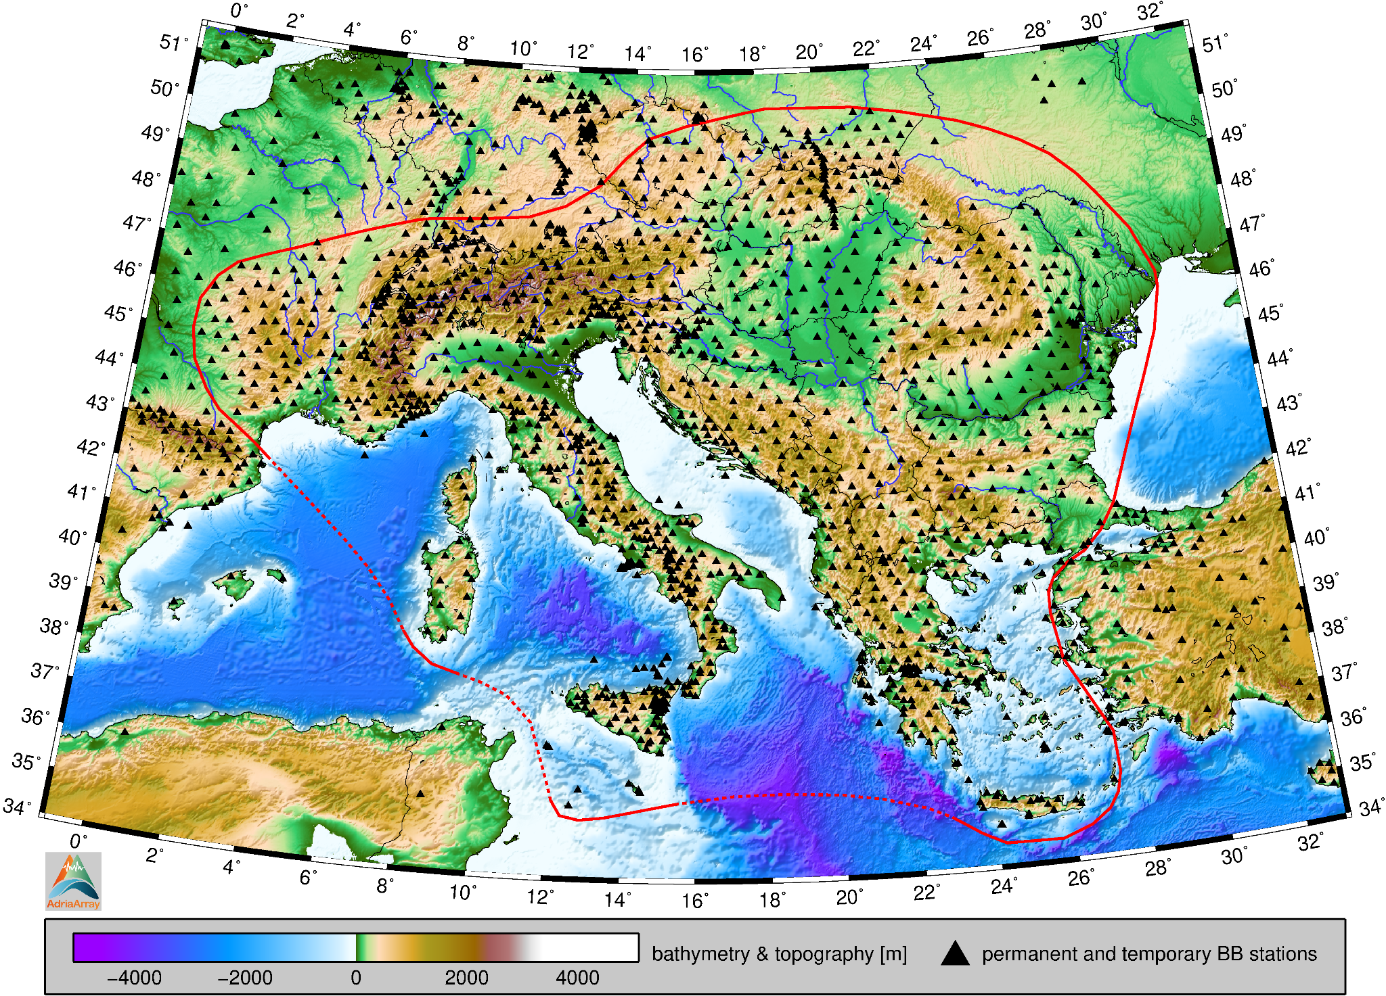Before planning the temporary stations, we did not set any a priori station spacing nor did we introduce any strict decision on the region to be covered. We also did not apply any strict rule for the corner periods of the backbone stations. All these three parameters (spacing, region, corner period) were obtained as a result of negotiations with mobile pools operators willing to join the project. The deployment was initially proposed by providing points on the map without any relevance to real field conditions. Later, these coordinates were usually given to the local permanent network operators, who suggested modifications based on their knowledge of the region, field trips and overall experience. Later, during scouting for the actual temporary station sites, the plan was modified again.

**Figure 4.** Topography and bathymetry of the region with major rivers. Triangles show currently operating broadband

stations. Data of the ETOPO Global Relief Model is provided by the NOAA Physical Sciences Laboratory and is used also in all the other maps in this paper.

Figure 5 shows all permanent and temporary stations in the region. Temporary ones are distinguished by five shades of pinkish colour according to the five regional subgroups. Inside the AdriaArray region, we show both stations in EIDA as well as those still waiting to be connected to EIDA. Stations outside of the AdriaArray region are broadband, short-period and strong-motion stations in EIDA which have been operating after May 2022.

Figure 6 shows all the temporary stations color-coded according to their respective mobile pools. Colors of the triangles denote the provider of fundamental parts of the stations, for example the sensor. The dot inside the triangle indicates that additional equipment was provided by another mobile pool. The figure therefore contains 30 combinations of colored triangles and dots. The GIPP (Geophysical Instrument Pool Potsdam) stations are split into several patches (Sardinia, Carpathian profile, Ukraine, Romania, Serbia). In each region, the deployment is maintained by the local network operator with the help of various institutions from other countries such as the Czech Republic, Sweden, Germany, Italy and Poland. Further information on the mobile pools, institutions supporting the logistics, data transmission, field deployment and maintenance of the temporary stations is given in Appendix B.

293 temporary AdriaArray stations were installed after May 2022. In addition, 135 stations were already in place from the previous PACASE experiment (Schlömer et al., 2024). Of these, 73 stations had already been installed in the framework of the AlpArray project (Hetényi et al., 2018). It is worth noting that 277 temporary stations (both newly deployed or inherited from AlpArray and PACASE) have been installed in countries other than the origin of the mobile pool.

* 1. **Field work**

**Figure 5.** All permanent broadband, short-period and strong-motion stations are shown with filled triangles inside and

empty triangles outside of the AdriaArray region. Red, orange and yellow color denote the corner period for broadband stations. Temporary stations are shown with empty triangles, showing that sometimes these temporary stations were deployed at an already existing station location, usually short-period or strong-motion permanent site (green inside the temporary station triangle) or it keeps an existing PACASE site (blue inside).

The fieldwork was carried out in cooperation between the incoming mobile pool operators and the hosting permanent network operators. The start of the installation was largely determined by the availability of the temporary stations and the necessary funding. In particular, funding had to be secured for the shipment of the stations, scouting and installation of the stations. Funding was raised by mobile pool and hosting network operators and was provided by national funding agencies as no European funding was available for the installation of AdriaArray. Each institution approached this task according to its internal capabilities, the policy of their national funding agencies, and the availability of international funding sources. Some 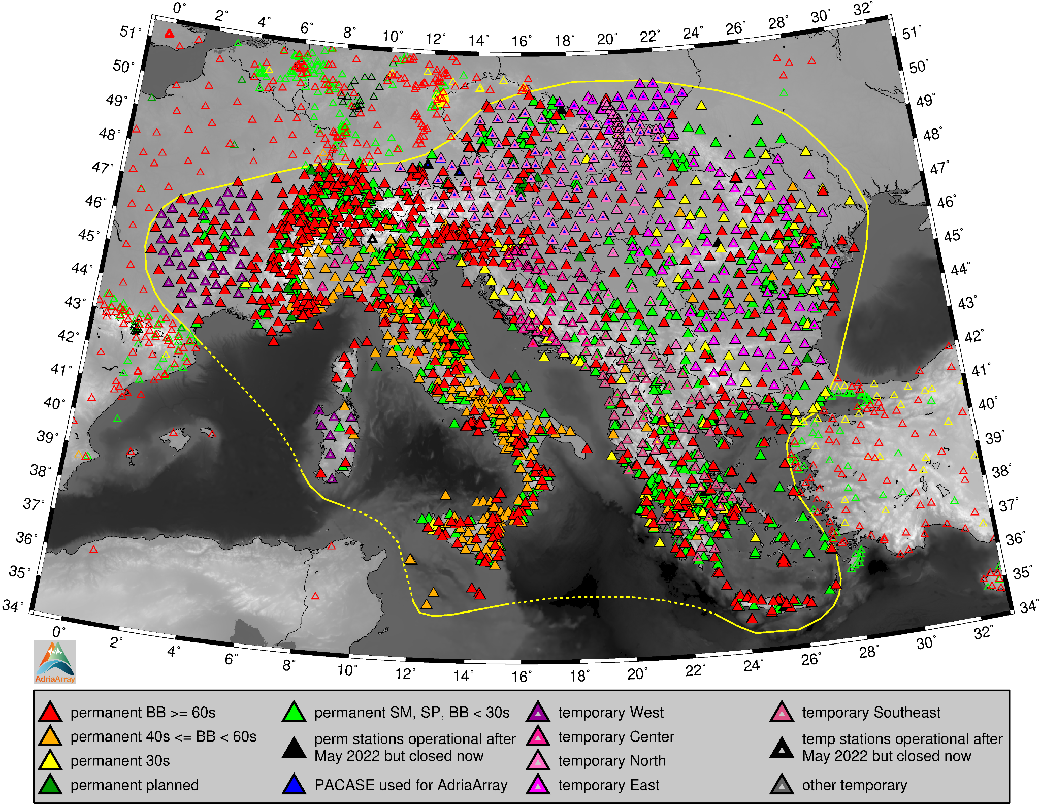institutions received grants from their national funding agencies as a stand-alone project, others used internal institutional budgets. Two institutions from different countries got funded by an international bilateral grant. AdriaArray has also incorporated several projects that were planned simultaneously or independently taking advantage from integration into a larger initiative.

We note that 67 temporary stations from EU countries have been installed in 7 non-EU countries (Albania, Bosnia and Herzegovina, Kosovo, Montenegro, North Macedonia, Serbia, and Ukraine) with specific customs procedures. Also, 12 stations from a non-EU country - Norway - were installed in an EU-country - Croatia. To illustrate the diversity of the area, participants speak 24 different languages, write in 5 different alphabets and use 19 different currencies.

Due to the COVID pandemic, we were unable to meet in person for almost two years between 2020 and 2022. This slowed down the scientific discussions and, of course, the fieldwork.

The first installation of mobile stations was planned by the Polish team in Ukraine. This became impossible because of the Russian invasion in February 2022. In 2023, the European community established new contacts with Ukrainian colleagues and equipment for the upgrade of 5 permanent stations in the AdriaArray region has been sent by groups in France and Germany to Ukraine. Three of these stations are already installed, operational and sending data to the EIDA node in Romania, the other two stations are currently being installed.

* 1. 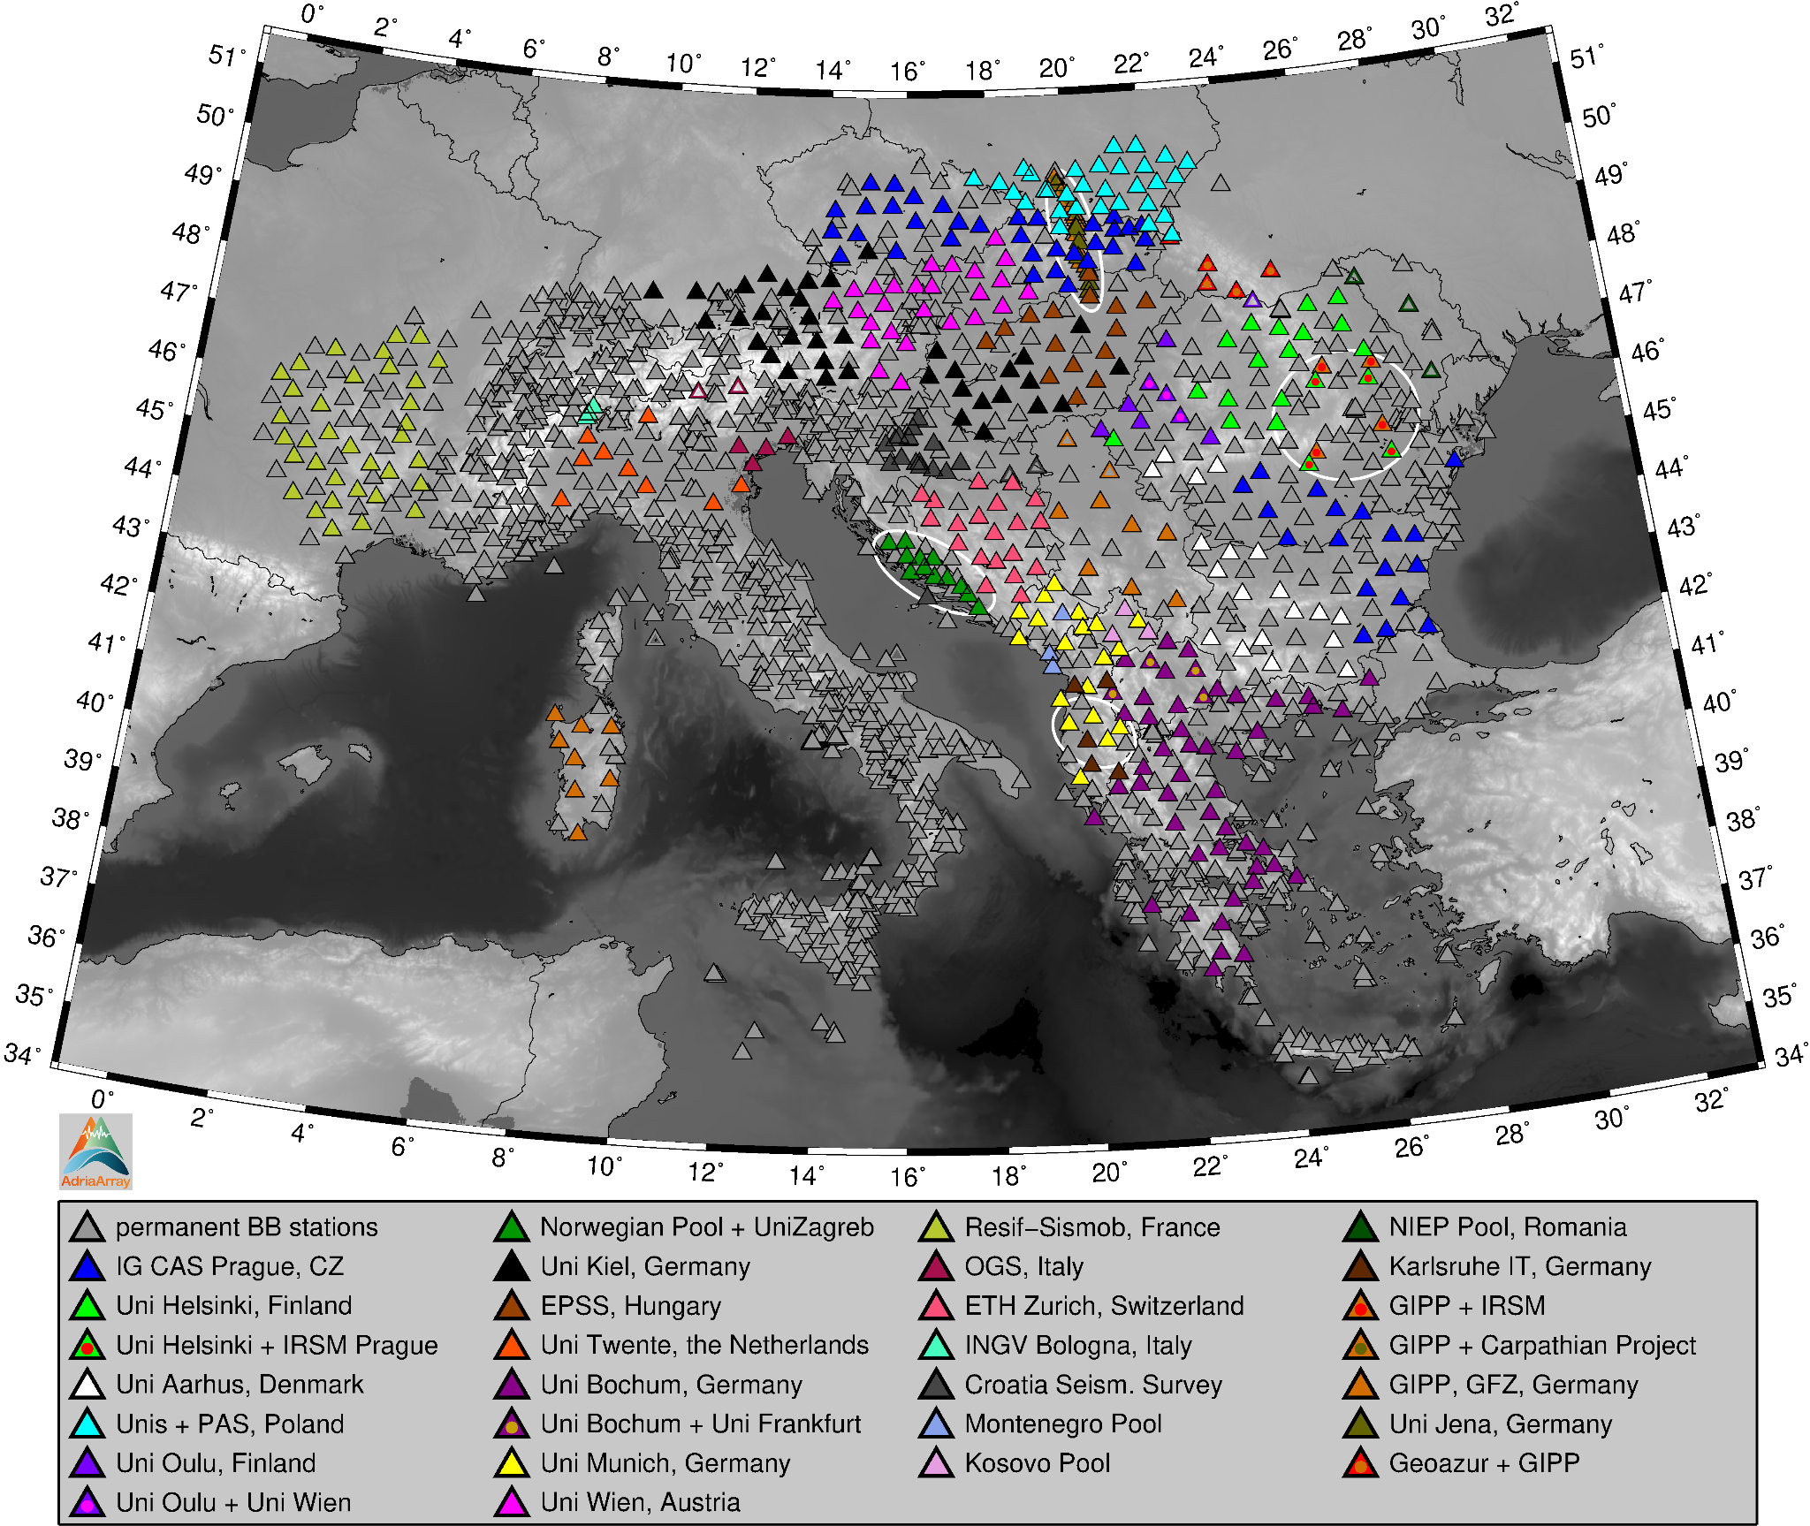**Local experiments**

In addition to the backbone network, the AdriaArray initiative includes local experiments. These represent local densifications with broadband, short-period or strong-motion stations in regions of particular interest. Examples are densifications at the Adriatic coast in Croatia, in the Vrancea region (Romania), and the Carpathian profile. The latter consists of 18 stations installed in 2023 incorporating backbone stations deployed in 2019. Access to data of local experiments follows the same rules as access to any backbone station. See Appendix B for the list of institutions involved in these local experiments. Further local experiments in particular along the Adriatic east coast are in preparation including marine ones. In addition, there was also the ANTICS largeN experiment in Albania (Agurto-Detzel et al., 2025, not shown in the maps), composed of 350 short-period and 50 broadband sensors, independently from the AdriaArray backbone. The ANTICS stations were offline and will be backfilled to EIDA. Simultaneously with AdriaArray, also the DIVEnet experiment took place in Italy (Confal et al., 2025, not shown in the maps).

**Figure 6.** Temporary stations are color-coded by respective mobile pools, permanent stations are gray. Filled triangles are

the deployed stations, empty triangles are the stations planned. This applies to both permanent and temporary stations. Dots inside the triangles mark stations where equipment is provided by two mobile pools.

* 1. **Coverage**

One of the main objectives of the initiative was to cover the AdriaArray region as homogeneously as possible using the temporary stations available for each subregion. The upper map in Fig. 7 shows the station coverage for the permanent stations including also stations outside of the AdriaArray region. The lower map shows the current coverage for all stations - permanent and temporary together. Circles of 10, 20, 30 and 40 km radius are plotted around every broadband station. The darker the visual impression of the map the better the coverage. In the areas with high permanent network density, as in Switzerland, 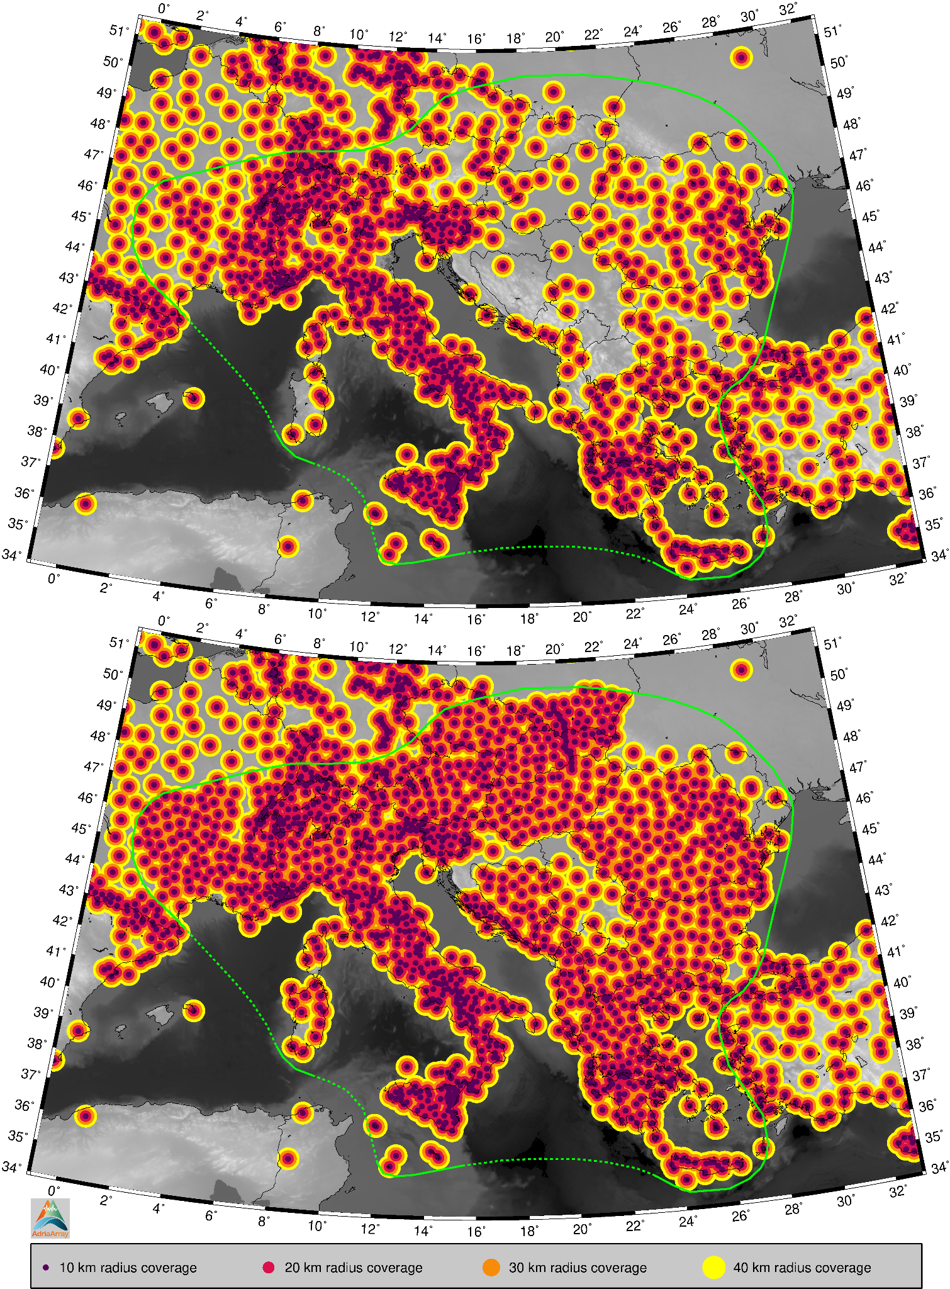French-Italian border, the Apennines, north-eastern Italy and Slovenia, the coverage shows mostly dark red color, meaning, there is no place more than 20 km distant from the closest broadband station. The temporary stations complement the network so that most of the region is covered with the orange color, meaning the distance to the closest broadband station is up to 30 km. Towards the eastern margin of the region, the coverage slightly decreases. All countries in the region are however covered. Figure 7 shows only stations incorporated in EIDA as of January 2025 with open and embargoed access inside the AdriaArray region, and open access outside of the region.

**Figure 7.** Upper map: coverage of the permanent stations. For example, areas covered by orange and darker color mean,

that there is no place more distant than 30 km from the nearest broadband seismic station. Lower plot: the same

as in the upper map shown now for both permanent and temporary stations. Only the stations registered in EIDA

are used to plot the coverage maps.

# AdriaArray – sources of information and technical description

* 1. 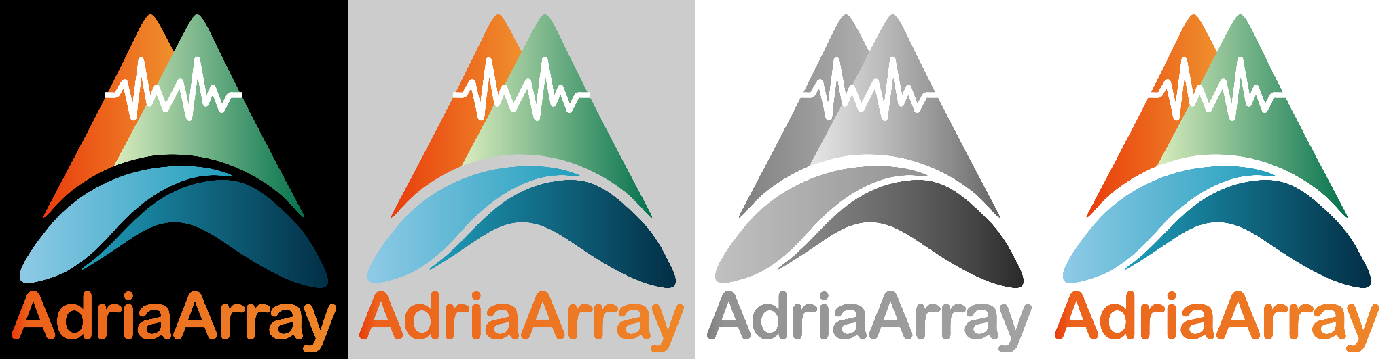**AdriaArray webpage**

The AdriaArray webpage on <https://orfeus.readthedocs.io/en/latest/adria_array_main.html> is the main source of up-to-date information. It is hosted by ORFEUS and maintained with the support of ORFEUS staff. The webpage gives an overview of the initiative, lists the members, the participants (who agreed to have their names displayed there), lists the names of contact persons of the Working Groups and Collaborative Research Groups, gives advice on how to obtain the token to access the seismic data and how to download the data. It also mirrors the maps of the AdriaArray Seismic Network stored in the AdriaArray GitHub repository. Whenever the maps are updated on GitHub, the webpage will display the updated version. The webpage also provides links to various documents describing the technical details of the network and station inventories. It also contains the description of the Collaborative Research Groups with updated information about the progress of their tasks. There is also a section with links to posters and oral presentations given at the AdriaArray workshops over the last four years.

* 1. **AdriaArray GitHub repository**

**Figure 8.** Various versions of the AdriaArray logo. The logo is available for download on the AdriaArray GitHub page.

The AdriaArray GitHub repository on <https://github.com/PetrColinSky/AdriaArray> serves as a place for updated technical documents about the AdriaArray Seismic Network. It contains several folders:

1. The AdA/ folder includes permanent and temporary station inventories as well as the following documents
   1. The document entitled “AdriaArray - seismic network, temporary stations and legend to the maps” [maps-legend.pdf] explains how the AdriaArray network was planned and the maps stored in the AdA/MAPS/ folder.
   2. The document entitled “AdriaArray - explanation to the scripts and files for plotting the maps of stations” [maps-manual.pdf] talks about the scripts and how to produce the maps from the station inventories. This might be useful if you want to modify the scripts to create your own maps. Extracts from this text are given below in this paper. If you are interested in the maps provided in this paper, go to AdA/PAPER/. Additional maps are in AdA/MAPS/. If you want to display station distributions in GoogleEarth, go to AdA/GOOG/ to get the *.kml files.
   3. The document entitled “Technical documentation - stations names and network codes” [TechDocNames.pdf] summarizes the guidelines for the station naming, which is also given in Section 3.4 below.
2. The folder presentations/ contains slides and posters on the AdriaArray Seismic Network presented over the last years.
3. The folder logo/ contains various versions of the AdriaArray logo, see Fig. 8.
   1. **Inventories and maps of stations**

In addition to the information given in the permanent and temporary station inventories, information on the station distribution is also provided in terms of various maps. They cover a range of complexity from very simple ones using only two colors to more complex figures explaining the station distribution in detail. Some of these maps are shown in this paper. However, the AdriaArray GitHub repository contains more versions of the maps. Some of the maps are mirrored on the AdriaArray webpage, see the previous subsections. In Appendix C, we list seismic networks shown in the maps and listed in the inventories. Details about the maps, inventories and tools to generate the maps from the inventories are given in Appendix D.

* 1. **Station names and network codes**

For new AdriaArray temporary stations installed from 2022 onwards, we adopted the PACASE naming convention. The station names should read country + number + version (A/B/..). “A” stands for the first location of the station. If the station is moved later, “A” changes to “B”. Example: BHxyA is the first location of station “xy” in Bosnia and Herzegovina. These station names have 5 characters. In Greece, the “A” has been omitted and station names have only 4 characters. In case of relocating stations in Greece, the “B” is added (GR19 changed to GR19B). The country codes area mixture of IBAN codes, country internet domains, international license plate abbreviations reduced to 2 characters.

For tem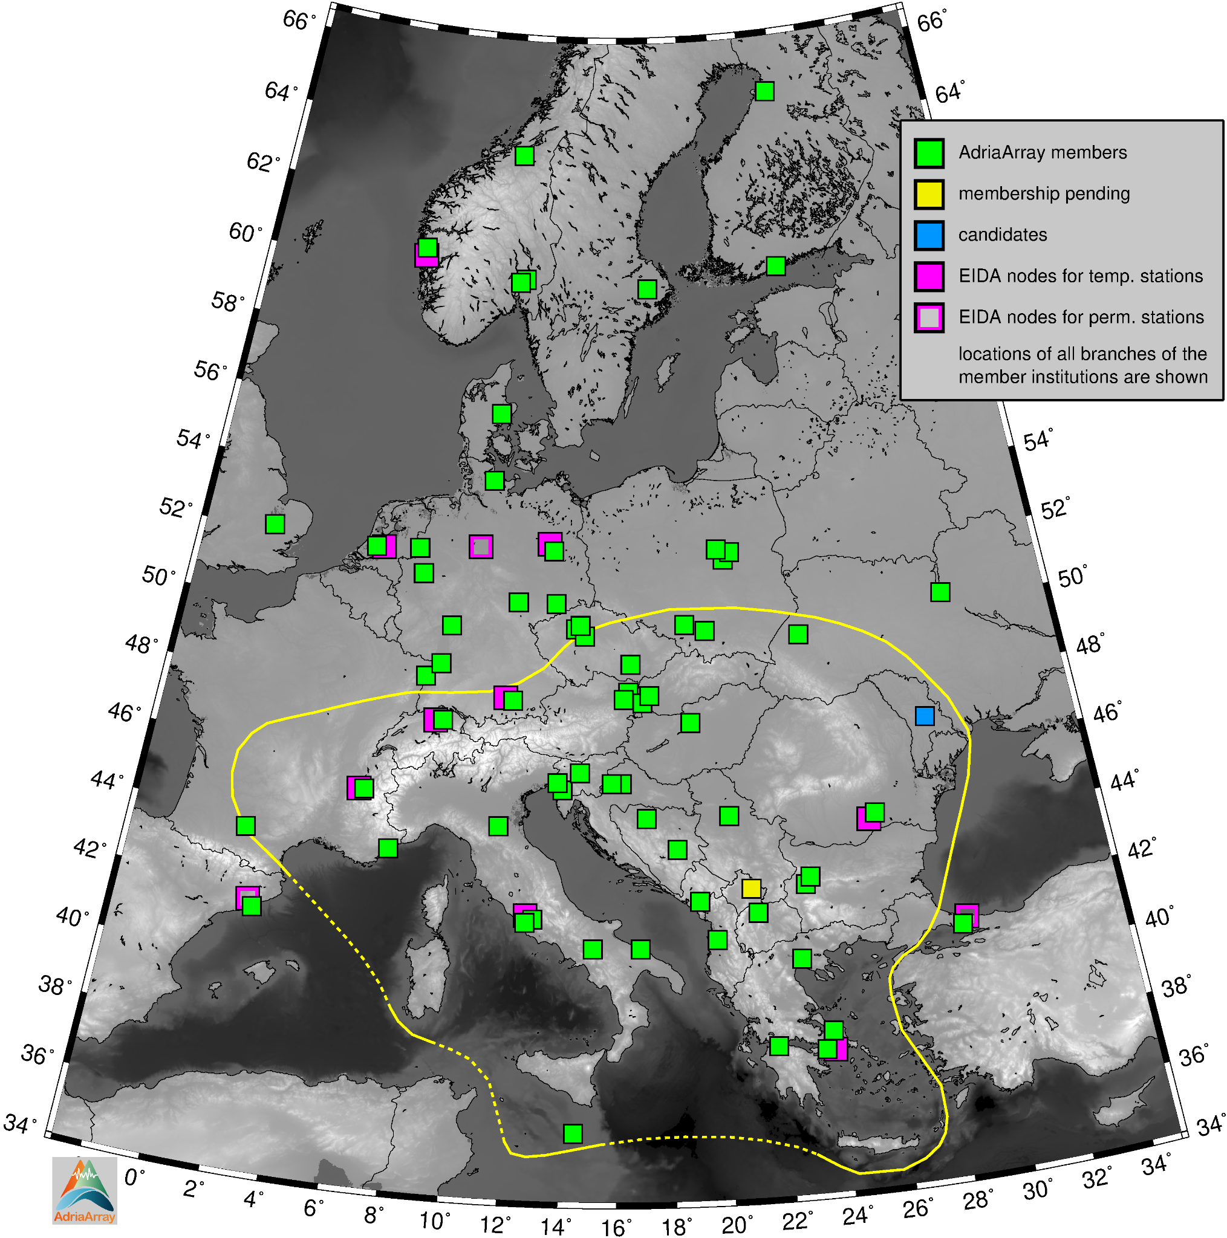porary stations installed before 2022, we retain their original names. For example, if the station is located at a PACASE site, the PACASE name is adopted. For former AlpArray stations, the original AlpArray name is used, starting with “A”, followed by a three-digit number terminated with “A” for the first location of the station, changed subsequently to B/C/ and so on.

In a few cases, a new name has been given to a temporary station located at a site of a former permanent or temporary station. Both names are then included in the inventories and are also shown on the maps in the AdriaArray GitHub repository (see the links in Appendix A). For example in the Po Plain, stations are at the same or very similar locations as the former AlpArray sites, however, they are using the new AdriaArray convention names as ITxyA. On the other hand, stations in north-eastern Italy keep the former AlpArray names, even though these stations were discontinued in 2019 and were newly built in 2023 with different instrumentation.

**Figure 9.** Locations of the AdriaArray member institutions are shown by green squares, including involved branches of

these institutions. Yellow and blue are pending membership and candidates for membership, respectively. EIDA nodes hosting data from both the temporary and permanent stations of the AdriaArray Seismic Network are shown by full magenta squares, EIDA nodes hosting permanent stations are by empty magenta squares.

If broadband stations were installed at sites of permanent short-period or strong-motion stations, the name of the permanent station was generally retained. This recommendation was followed in Albania, Bulgaria, Greece, Kosovo, Montenegro, North Macedonia, Romania, Serbia and Ukraine. In Bosnia and Herzegovina, temporary stations deployed at the permanent sites got new AdriaArray names as the permanent stations were not operational and retaining their name was hence not needed.

New temporary stations got new temporary network codes. Temporary stations inherited from PACASE and AlpArray changed their network codes from Z3 and ZJ to the new AdriaArray network codes. All networks are registered at the Federation of Digital Seismograph Networks (FDSN).

There are two options for using the permanent or temporary network codes for the stations where the temporary broadband installation is at a permanent short-period or strong-motion site. Option 1: For the temporary installation, the same FDSN network code is used as is the one of the permanent station, and the streams differ only by channel name. As a consequence, all channels from this station are fully open without restrictions as the permanent network cannot be embargoed. Option 2: A new FDSN network code as for other temporary stations in the given region is used for the temporary equipment at the permanent site. In this case, the temporary streams 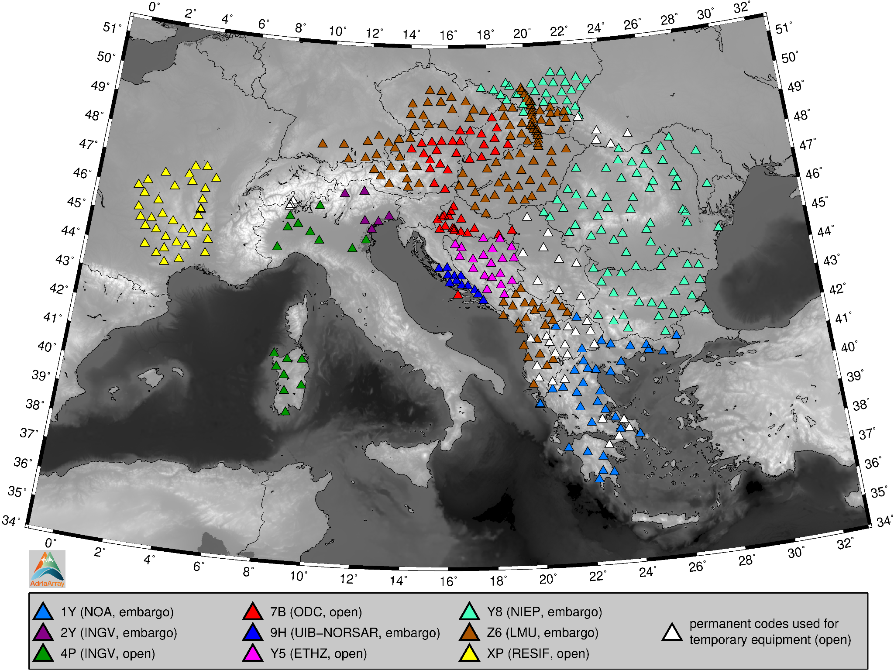could have an embargo. Details about the stations names and network and location codes are given in the document entitled “Technical documentation - stations names and network codes” on the AdriaArray GitHub repository, see Appendix A for the links.

* 1. **Archiving data in EIDA**

Archiving the AdriaArray data in ORFEUS EIDA is crucial for the initiative. EIDA support was at the base of the whole planning from the very beginning since 2019. It allowed us to connect hundreds of new broadband stations to EIDA. Data from the temporary stations are stored at 9 nodes of the EIDA federated infrastructure, see the filled magenta squares in Fig. 9 for the geographical locations and the legend to Fig. 10 for the node names. Specifically, these are: The ORFEUS Data Center (ODC), hosted by the Royal Netherlands Meteorological Institute (KNMI); the Helmholtz Centre Potsdam - German Research Centre for Geosciences (GFZ); Réseau Sismologique et Geodesique Francais (RESIF); Istituto Nazionale di Geofisica e Vulcanologia (INGV), Italy; Schweizerischer Erdbebendienst (SED) at ETH Zurich; National Institute for Earth Physics (NIEP), Romania; Ludwig-Maximilians-Universität München (LMU), Germany; National Observatory of Athens (NOA), Greece, and Universitetet i Bergen (UiB), Norway. Data from permanent stations are in addition to these 9 nodes stored also at 3 other EIDA nodes, which are: Bundesanstalt für Geowissenschaften und Rohstoffe (BGR), Germany; Kandilli Observatory and Earthquake Research Institute (KOERI), Türkiye, and Institut Cartogràfic i Geològic de Catalunya (ICGC), Spain. See the links to the ORFEUS webpage in Appendix A for the contacts to respective EIDA nodes.

**Figure 10.** AdriaArray temporary stations use 9 network codes color-coded in the map. The legend explains to which EIDA

node the particular network is connected. In addition, some temporary equipment uses a permanent network code when deployed at an existing permanent site – this is then considered as an upgrade of the permanent strong-motion, short-period or broadband station with shorter corner period.

Most of the temporary stations streamed data in real-time to EIDA nodes starting with the installation. In 2024, all temporary stations were online and almost all were transmitting data to EIDA. Some stations stream the data directly via SeedLink to the local monitoring centers and EIDA, some stream the data first to the mobile pool operator’s center (also by other proprietary formats, not necessarily SeedLink) and subsequently to the local 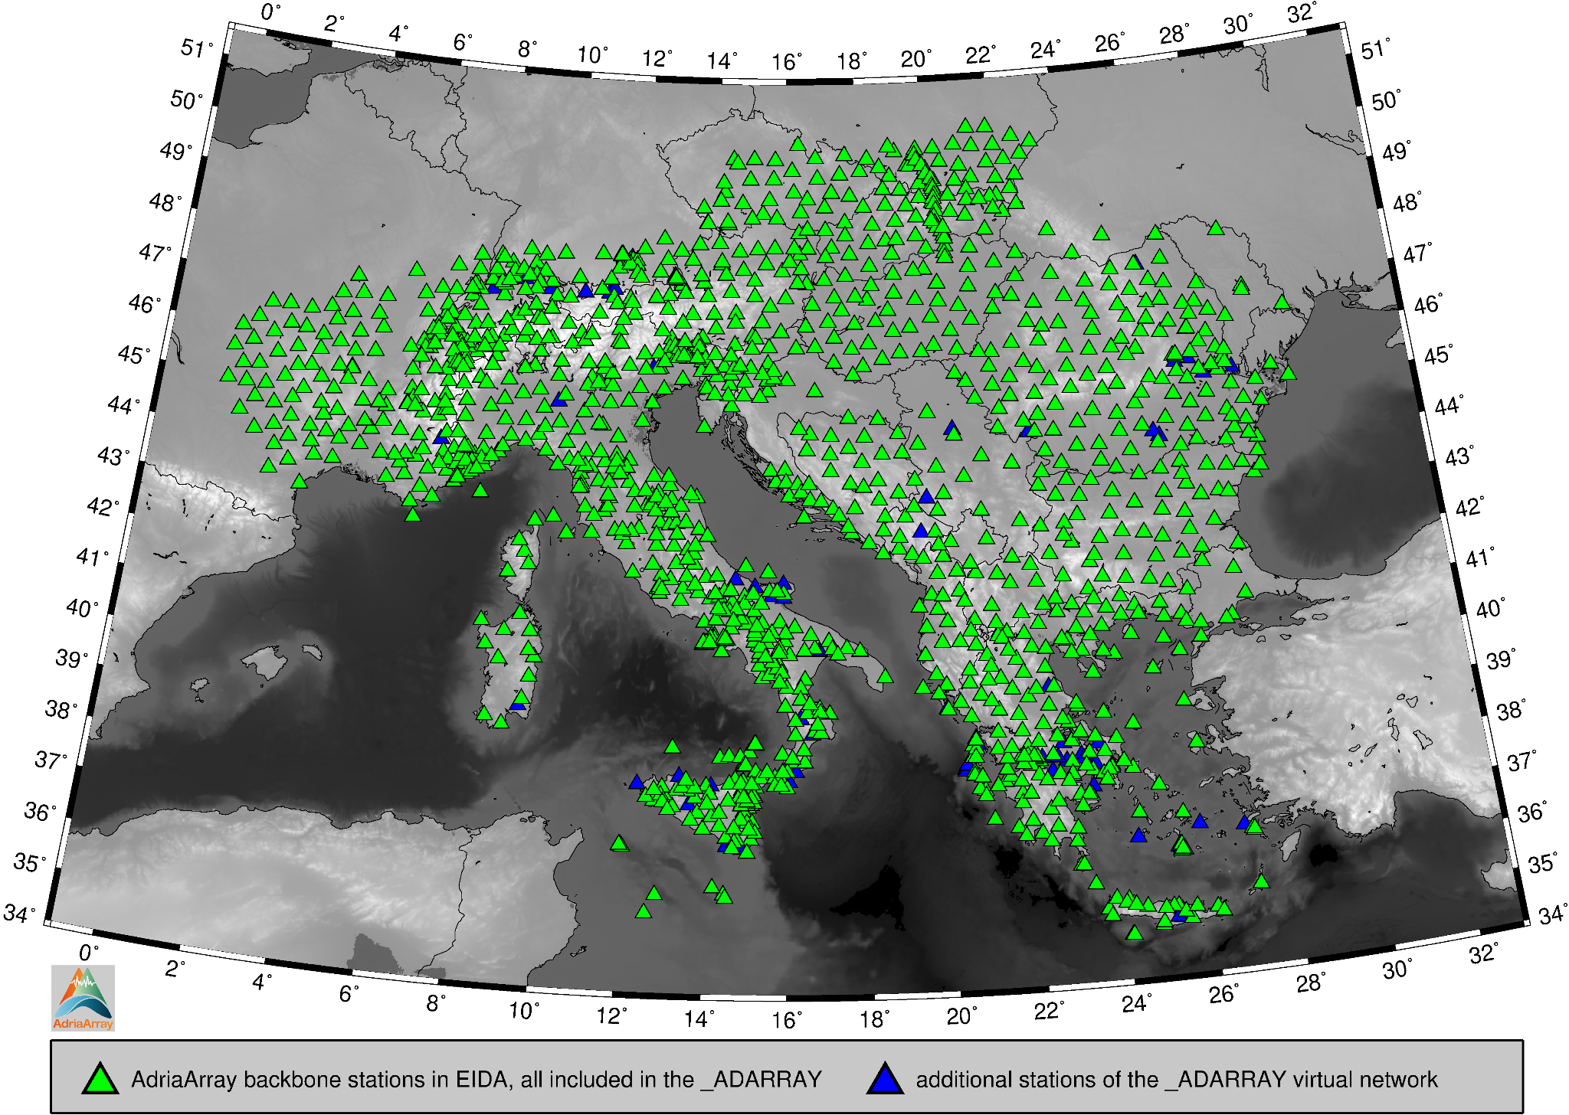monitoring center and also then to EIDA. The online streaming was not a requirement for incorporating the stations to the AdriaArray Seismic Network, but it emerged naturally as the mobile pool operators upgraded their equipment for online data transmission to ease data access and to have better control on the state of health of the stations. Data from the previously offline stations is being backfilled to EIDA. As most of the stations are online, they are not only providing data to EIDA for archiving, but real-time streams are also included in the local operators’ daily monitoring services.

**Figure 11.** The AdriaArray backbone is shown by green triangles. All those stations are included in the AdriaArray virtual

network _ADARRAY. Blue triangles show stations with corner periods between 10 s and less than 30 s, which are included in the _ADARRAY in addition to the backbone stations. Only EIDA-registered stations can be included in the _ADARRAY.

As a rule, a temporary network with a specific network code streams data to one EIDA node only. Several networks may, however, stream data to one node (e.g. INGV). Each network has all its stations either open, or embargoed (see below the explanation of the embargo). Hence, each network code already uniquely shows, in which EIDA node the data from all the stations of this network are stored, and if all these stations are open or embargoed. An overview of the 9 temporary network codes is given in Fig. 10.

EIDA not only stores the data, but also provides support to both local permanent network operators as well as mobile pool operators about the technical solutions to connect the stations, stream the data and maintain and update the metadata. Many ideas about the temporary networks, station names, embargo and open data policies were developed directly with a fundamental support of EIDA personnel.

EIDA is also present at the ORFEUS Forum (see the links below in Appendix A), where messages about the maintenance and temporal unavailability of particular nodes are posted. There is also an EIDA Issue Tracker on GitHub (link in Appendix A), where the users can report data problems.

* 1. **AdriaArray virtual network _ADARRAY**

Broadband stations, covering the AdriaArray region outlined in the maps, form the AdriaArray backbone. The shortest corner period of the backbone is 30 s (see above). To ease the access to AdriaArray data, the virtual _ADARRAY network was created by EIDA. The data of the whole AdriaArray Seismic Network can be downloaded using one command referring to the virtual network. All broadband stations in the region with HH* and BH* channels are included in _ADARRAY. According to the SEED convention, H** and B** channels are assigned for sensors with corner period equal or longer than 10 s. _ADARRAY virtual network hence includes more stations than the AdriaArray backbone as the latter have corner periods of 30 s and longer. The backbone is a subset of _ADARRAY. The relation of the backbone and the virtual network is shown in Fig. 11. All the green triangles, representing the AdriaArray backbone, are included in the virtual _ADARRAY network. Blue triangles show additional stations with corner periods from 10 to 30 s included in _ADARRAY.

**Figure 12.** Virtual _ADARRAY in time and space. Starting dates of stations included in the virtual _ADARRAY network are

used to plot a cumulative number of operating stations over the past 37 years. Orange are permanent and blue are temporary stations added on top of the permanent. The two curves split in the moment when the AlpArray deployment started in March 2015. Then, the difference between the curves increases again in May 2019 when the PACASE deployment began. Since June 2022, the AdriaArray delivered additional 293 temporary stations. Together with the temporary stations continued from PACASE, AdriaArray Seismic Network includes 428 temporary stations currently, out of which 397 are in EIDA and hence included in the _ADARRAY – see the difference between the two curves at the end of the plot in mid 2024. The inserted map shows the distribution of permanent and temporary stations in the AdriaArray region.

Figure 12 shows the cumulative number of operating _ADARRAY stations as a function of time. Assembling this plot 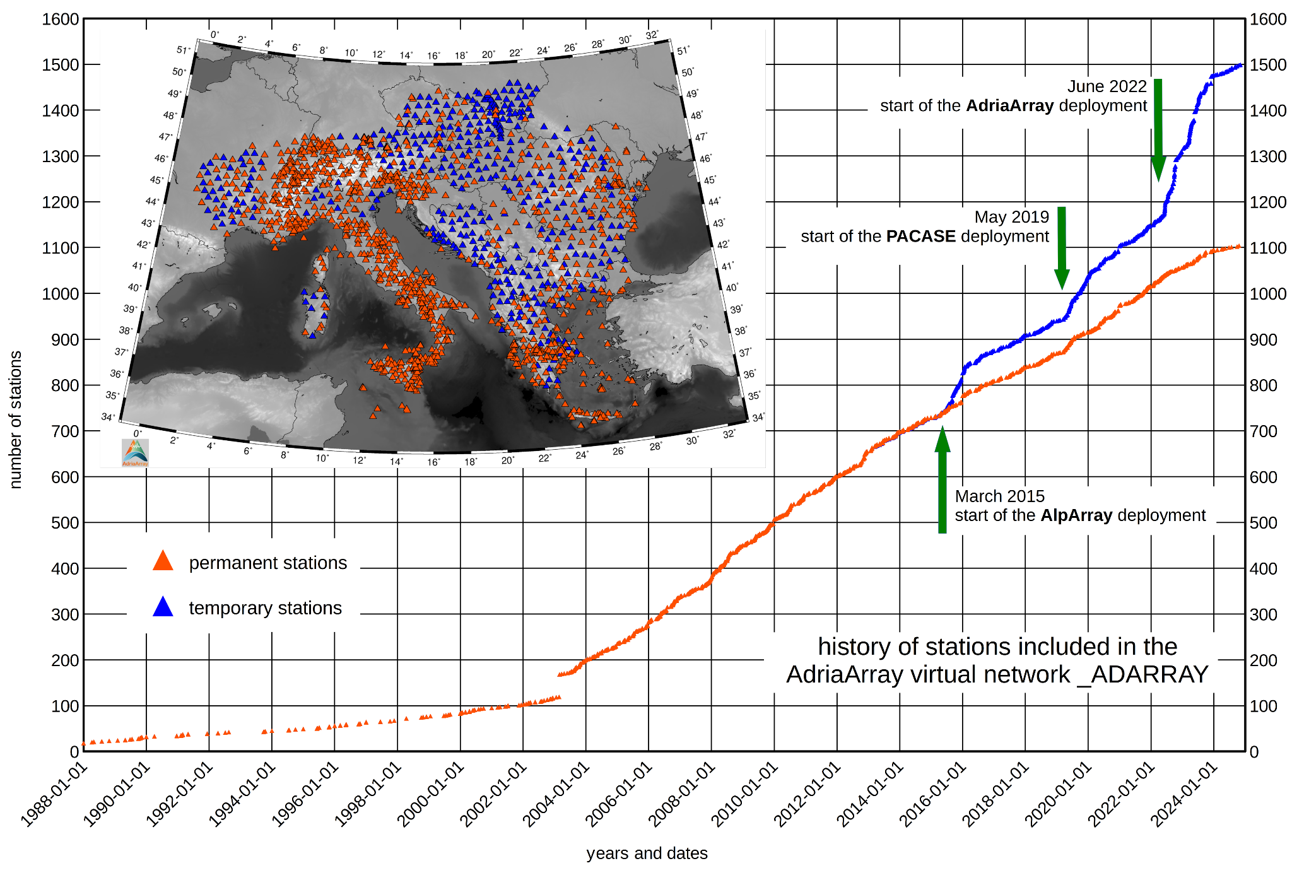required quite complex analysis of the history of each station and the details are given in Appendix E. We see several clear trends in the plot. The number of permanent stations was linearly increasing with time before and after 2003 with strikingly distinct slopes. The jump in 2003 is due to the same startDate of 50 stations of the Italian National Seismic Network (IV). The first temporary stations belonging to AdriaArray now were deployed in the framework of AlpArray in March 2015 (blue dots). 73 of the total 276 temporary AlpArray stations were included in PACASE and then in AdriaArray - see the constant difference between the two curves in 2016 - 2019. In May 2019, the PACASE deployment started, providing additional 62 stations. AdriaArray inherited in total 135 stations from these two previous experiments. Since the start of AdriaArray in June 2022, 293 additional temporary stations have been installed to reach 428 temporary AdriaArray stations operating today, of which 397 are in EIDA and are thus included in _ADARRAY.

* 1. **Station properties and metadata**

One of the important properties of the broadband seismic station is the corner period of its sensor. The corner periods are not easily discoverable from the metadata, as it is not a mandatory parameter. It is often given as a comment in the description of the sensor, or it can be calculated using the transfer function given in terms of poles and zeros. We gathered the information on the corner period of the permanent stations already during the planning phase. Later we added the corner periods of all temporary stations to the station inventory. Figure 13 shows the corner periods of all AdriaArray stations split into five categories. Yellow triangles show dominantly Guralp 30 s sensors, orange triangles depict solely Trillium 40 s sensors. Red, dark red and purple triangles indicate sensors with longer corner periods of various manufacturers.

Station inventories maintained since 2019 for both permanent and temporary stations contain the properties of every station, see the link to the AdriaArray GitHub page below in Appendix A. The corner period is one of the basic parameters, which may also be cross-checked between the inventories and the metadata to detect potential errors. One of the lessons learned from AlpArray is that metadata is often erroneous. For AdriaArray, we started metadata testing from the beginning, even before the temporary deployment campaign started. Data quality testing is described in detail in a separate paper of this special issue (Kolínský et al., 2025).

* 1. 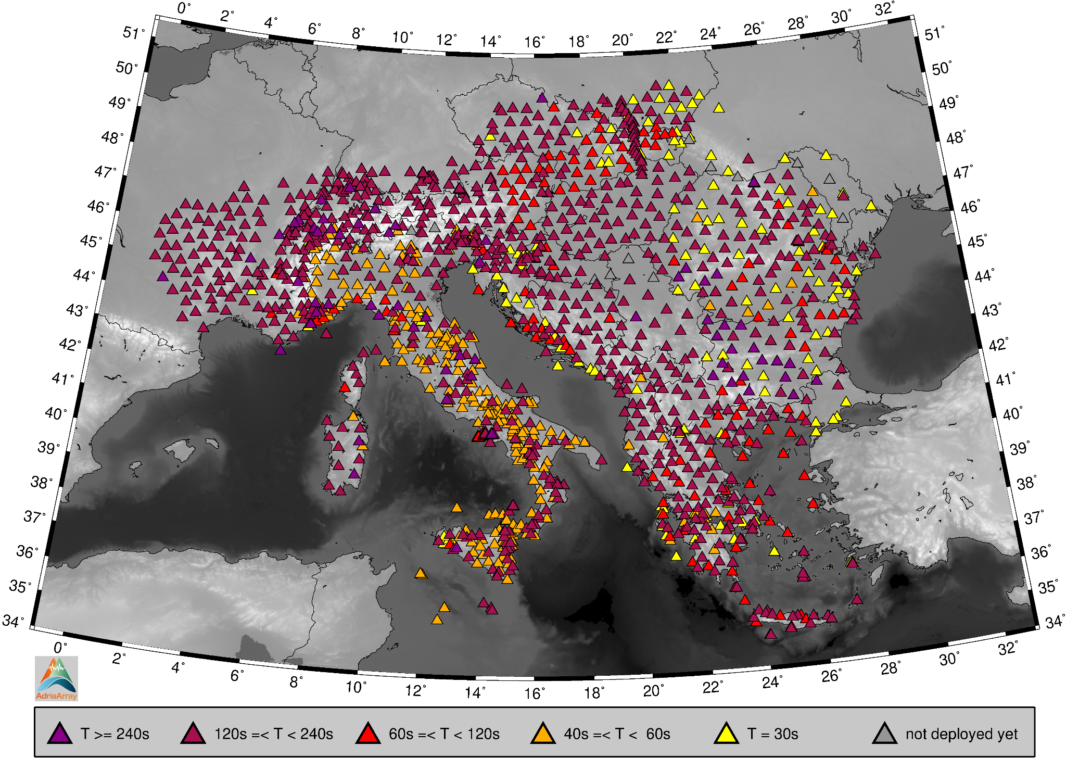**Data download**

AdriaArray data can be downloaded from EIDA. Data of permanent stations and of some temporary stations are freely available. An embargo is applied to most of the temporary stations. An EIDA token is required to access embargoed AdriaArray data. The token acts as login and password while requesting waveforms. The procedure how eligible AdriaArray participants may obtain a token is described on the AdriaArray webpage. Further details on the EIDA Authentication System are given in “EAS User Documentation, Release 0.9b1” by Quinteros and Heinloo (2019).

**Figure 13.** Stations are colored by five categories of their corner periods. The darker the color, the longer the corner period.

The map shows all currently operating broadband stations in the AdriaArray region, permanent and temporary, including stations not in EIDA yet. Grey are the stations to be deployed.

Data and metadata can be accessed via the FDSN web services, provided by ORFEUS EIDA using smart clients (e.g. fdsnws_fetch, wget) or the ObsPy routing client (Megies et al., 2011). Examples of data requests are available on the AdriaArray webpage. There are the following data download options:

1. metadata using webbrowser;
2. waveforms using webbrowser;
3. waveforms using fdsnws_fetch;
4. metadata and waveform using the ORFEUS EIDA web interface;
5. metadata using ObsPy;
6. waveforms using ObsPy;
7. waveforms using the virtual _ADARRAY network including example Python code.

Examples of data downloads are given on the AdriaArray web page and also in the supplementary material of Schlömer et al. (2022).

* 1. **How to cite AdriaArray and the data**

A list of Digital Object Identifiers (DOIs) referring to the contributing networks and/or pools of temporary stations should be given in each journal publication. In the text, a reference to the network code and its name should be given (see Appendix C), and in the references, a full list of DOI quotes as given on the FDSN web page and in this paper should be added.

Publications using the AdriaArray data should include as authors the active participants who contributed substantially to the research. It is recommended that the list of authors is followed by “and the AdriaArray Seismology Group” if accepted by the publisher and allowed by the publication policy of the respective AdriaArray members. In the acknowledgments, the AdriaArray Seismology Group is to be mentioned. When referring to the AdriaArray initiative or to the AdriaArray Seismic Network, it is recommended to add a reference to this paper.

# The AdriaArray Seismology Group

* 1. **Workshops and foundation of the AdriaArray Seismology Group (AdriaArray SG)**

The AdriaArray initiative was proposed at the AlpArray Meeting in Zurich in 2018. The actual preparation of the AdriaArray initiative started in May 2019 when about 20 representatives of several research groups met in Thessaloniki, Greece, to discuss both open scientific questions as well as the general concept. As a result, a working group was formed, to (i) gather information on existing stations in the area and (ii) on temporary stations available for AdriaArray, to (iii) contact operators of permanent networks in the region, to (iv) prepare a suggestion for the station siting, and to (v) discuss data acquisition and archiving.

AdriaArray was built on the expertise from AlpArray, however, the community expanded significantly. The number of institutions providing the temporary stations as well as the number of receiving local network operators increased considerably compared to both AlpArray and PACASE. This meant that not only many individuals, but also tens of institutions did not share the experience from previous experiments. Therefore, we started the coordination with a considerable number of online meetings to introduce the idea and to share experiences with the broader community.

The next AdriaArray meeting, scheduled to take place in Sopron, Hungary, in 2020, had to be cancelled due to the outbreak of the covid pandemic. In November 2020, the community gathered for the ORFEUS - EPOS SP (EPOS Sustainability Phase) - AdriaArray Virtual Workshop. ORFEUS and EPOS have been actively supporting the organization of AdriaArray workshops since then. At the workshop, preliminary plans for the temporary station deployment were presented, together with introducing the local permanent network operators.

Another virtual workshop was held in May 2021 where the allocation of mobile pools to the proposed distribution of temporary stations was presented. In November 2021, still under the pressure of the covid pandemic, we met again virtually at the breakout session of the AlpArray & 4D-MB Scientific Meeting. By this time, the planning of the temporary deployment had taken a stable shape and the community planned to start the fieldwork as soon as the covid threat receded.

The online meeting held on 19 May 2022 marked the official start of the initiative with the establishment of the Steering Committee (SC) for the AdriaArray SG, the election of Thomas Meier as a coordinator of the Steering Committee, and with the signing of the Memorandum of Collaboration by 26 institutions representing the initiators of the AdriaArray SG.

Shortly afterwards, the field campaign was launched in June 2022 with the installation of the first temporary stations in Romania, Bulgaria, and Bosnia and Herzegovina. Thus, May-June 2022 is the milestone not only for the establishment of the AdriaArray SG but also for the start of the deployment.

In October 2022, an ORFEUS – EPOS SP – AdriaArray workshop was organized in Potsdam, Germany. The workshop was attended by about 80 persons, including 25 participants sponsored by EPOS SP. In addition, nearly 100 colleagues registered for online participation. AdriaArray was discussed both at plenary sessions as well as during breakout sessions. Future synergies between AdriaArray, EPOS, and ORFEUS were also discussed. It is interesting to note that many people met in person for the first time after three years of online meetings. Just a week after the workshop in Potsdam, an AdriaArray breakout session was held at the AlpArray meeting in Prague, Czech Republic. The idea about the Collaborative Research Groups was presented and the seismicity working group was established.

The next ORFEUS - EPOS SP - AdriaArray Workshop was held in Dubrovnik, Croatia, in April 2023, locally organized by the University of Zagreb. The workshop was attended by 90 people, including 30 participants supported financially by EPOS SP funds. The discussion on the establishment of technical working groups and Collaborative Research Groups was continued. The workshop was followed by a splinter meeting at EGU 2023, attended by about 30 people onsite and 15 people online, targeting community members who could not travel to Dubrovnik. A summary of the status of the initiative was presented, along with the outcome of the workshop in Dubrovnik, and the final version of the AdriaArray logo – see Fig. 8.

The most recent AdriaArray workshop was held in Sofia, Bulgaria, in March 2024, locally organized by the Bulgarian Geophysical Society, Sofia University and Bulgarian Academy of Sciences. The event was attended by more than 100 people. Collaborative Research Groups (CRG) were already well established and breakout sessions on the respective CRG topics were held. The workshop was financially supported by ORFEUS and CoLiBrI - a Task Force of the International Lithosphere Programme. In addition 12 attendees were sponsored by the workshop fee. Also, similarly as the year before, after the AdriaArray workshop, we convened a splinter meeting during the EGU 2024.

The next AdriaArray meeting will be held in San Servolo (Venice), Italy, in March 2025, locally organized by Istituto Nazionale di Geofisica e Vulcanologia (INGV). The programs of the meetings and workshop and posters and slides from oral presentations can be found on the AdriaArray webpage.

* 1. **Memorandum of Collaboration**

AdriaArray started formally on 19. May 2022 with the establishment of the AdriaArray SC for the AdriaArray SG. 26 members joined the AdriaArray SG on that date and are considered as initiators of AdriaArray. The AdriaArray SG SC consists of representatives (persons) of the members (institutions, teams, groups of institutions, groups of researchers). The representatives of the initiation members approved and signed the Memorandum of Collaboration (MoC) which is to be signed by a representative of any new member when joining the initiative. The MoC focuses on the organizational structure, describes access to and usage of seismic data collected in the framework of the AdriaArray initiative and sets the overall general principles of scientific collaboration. The MoC also describes the procedure of accepting candidates for membership. The MoC is available on the AdriaArray webpage, see the links in Appendix A.

* 1. **Members of the AdriaArray Seismology Group**

AdriaArray SG members are institutions or established research groups, whose representatives signed the Memorandum of Collaboration. Members are accepted by the AdriaArray SG Steering Committee after evaluating their contribution, which, according to the MoC, meets at least one of the following criteria:

1. Operation of any number of portable seismic stations of the broadband seismic backbone network (velocity or strong-motion sensors) or of local experiments (broadband or short-period velocity or strong-motion sensors) within the AdriaArray Seismic Network, preferably with real-time access.
2. Preferably real-time access to data provided by permanent stations in the AdriaArray area of the corresponding institution (or near real-time, if a delay is imposed by technical or policy issues).
3. Significant support for the installation of portable seismic stations.
4. Significant contribution to data transmission, data archiving, quality control or distribution.
5. Development of and / or access to scientific methods, software, data, catalogs or platforms, important for the project and available to all members.
6. Organization and outreach of the AdriaArray initiative.

Figure 9 gives a geographical overview of member institutions of the AdriaArray SG including their branches when located in different cities. After its initiation in May 2022, new members joined the AdriaArray SG in July, October and November 2022 and in January, April, September and November 2023, to reach the current number of 54 members from 30 countries, comprising 64 institutions as some members are composed of several institutions together. Their representatives are listed with affiliations as coauthors of this paper. There are four members of the AdriaArray Seismology Group consisting of several institutions. These four group members are mentioned with affiliations of their representatives at the beginning of the paper. Here we add the full list of the participating institutions of these four group members: (1) The ‘Polish AdriaArray Seismic Group’ consists of the Institute of Geophysics, Polish Academy of Sciences, Warsaw; Institute of Geophysics, University of Warsaw and Institute of Earth Sciences, University of Silesia, Katowice. (2) The ‘Norwegian Broadband Pool’ consists of the Department of Earth Science, University of Bergen; Norwegian Seismic Array (NORSAR), Kjeller; Department of Geosciences, Faculty of Mathematics and Natural Sciences, University of Oslo and Section for Geophysics, Geological Survey of Norway, Trondheim. (3) The ‘Carpathian Project Group’ consists of the Institute of Geological Sciences, Polish Academy of Sciences, Warsaw, Poland; Department of Earth Sciences, Uppsala University, Sweden; Institute for Geosciences, Friedrich-Schiller-University Jena, Germany and Department of Geology and Paleontology, Comenius University in Bratislava, Slovakia. (4) The ‘French consortium Grenoble-Toulouse-Strasbourg’ consists of Institut des Sciences de la Terre, Université Grenoble Alpes; Observatoire Midi Pyrénées, Université de Toulouse and Ecole et Observatoire de Sciences de la Terre, Université de Strasbourg.

* 1. **Participants of the AdriaArray SG**

AdriaArray participants are individuals affiliated with member institutions or groups, coordinated by the member representatives and eligible to get access to embargoed seismic data via individual tokens. The names of all 433 participants of the AdriaArray Seismology Group are given in Appendix F.

* 1. **Data Access**

Members operating permanent and temporary stations share their data and metadata via the ORFEUS EIDA infrastructure that allows access to the data for all AdriaArray SG participants. AdriaArray SG participants get immediate access to the data via Federation of Digital Seismograph Networks (FDSN) web services managed by ORFEUS EIDA. Permanent stations, temporary stations with open access as well as metadata 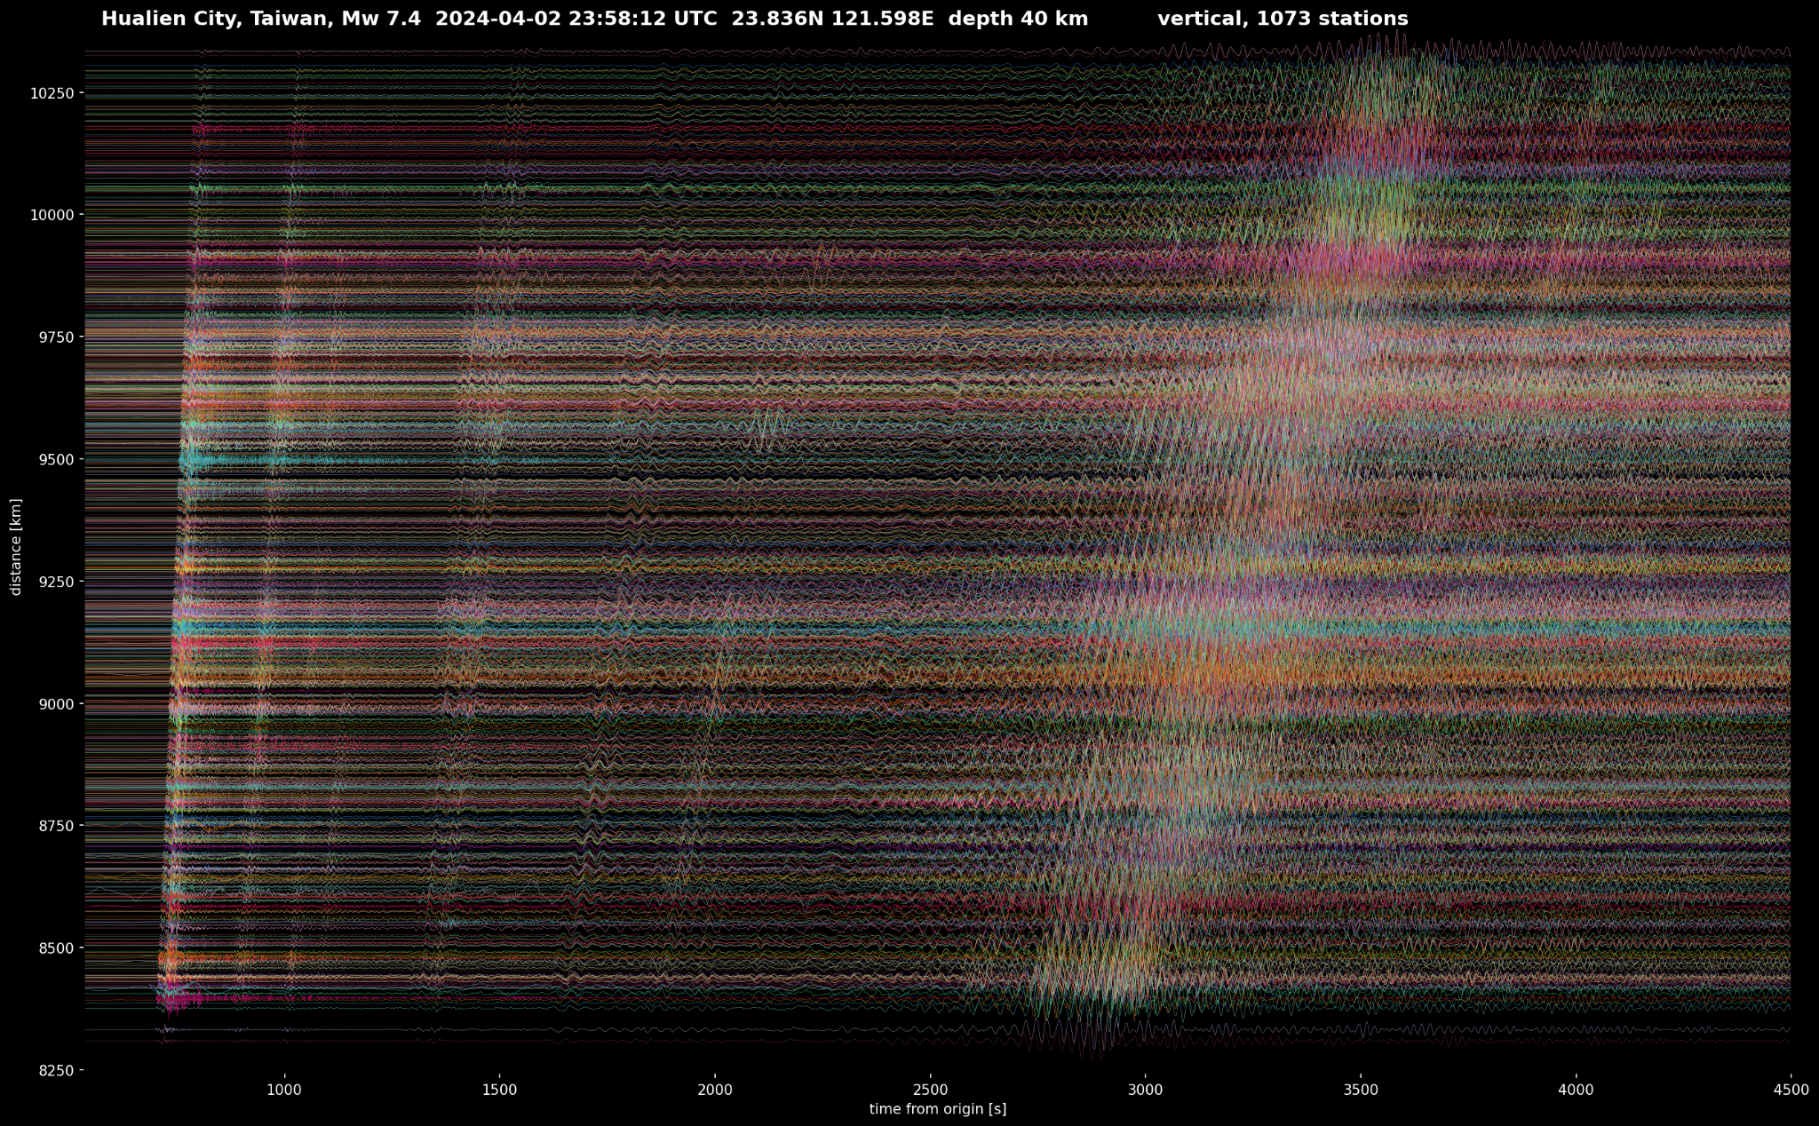(stationXML) of all stations (including embargoed) are publicly available to both the AdriaArray SG participants as well as any non-participants. Data of permanent stations are immediately available for all interested public users according to the ORFEUS EIDA policy. A rolling embargo of two years is applied to the data acquired by temporary AdriaArray stations if requested and agreed by the mobile pool operator and the hosting local permanent network operator. The rolling embargo means that data will become publicly available 2 years after the acquisition. The embargo will be unlocked with a step of one year every January. Accessing the embargoed waveforms requires authentication, provided by tokens assigned to eligible persons (participants) individually. Data of temporary AdriaArray stations delayed due to lack of telemetry and/or due to quality control procedures become accessible to AdriaArray participants via the FDSN web services as soon as possible, but not later than one year after acquisition.

**Figure 14**. Records of the M7.4 event from 2024-04-02 in Taiwan at 1073 broadband stations of the AdriaArray Seismic

Network.

Data acquired by the AdriaArray stations may be accessed also in real-time (e.g. via SeedLink) by authorized users. Real-time access to data streams of permanent stations contributing to AdriaArray is regulated by separate institutional agreements and is not regulated or affected by the MoC. AdriaArray member with seismicity monitoring mandates get real-time access to temporary stations within national boundaries and for temporary stations outside but in proximity of their national boundaries. Institutional agreements on real-time exchange of data of the permanent stations apply also to data of temporary stations in the area of the validity of these agreements.

AdriaArray SG members retain the right to provide their own data (in real-time and/or via EIDA) to non-members. AdriaArray SG members are however not allowed to give non-members access to AdriaArray data provided by other AdriaArray SG members.

A data example for 1073 broadband AdriaArray stations is given in Fig. 14 for the M7.4 earthquake on 2024-04-02 in Taiwan at 23.836°N, 121.598°E. The records are filtered between 2 and 150 s with the transfer function deconvolved.

* 1. **Working groups**

Six working groups on specific topics are formed to support the AdriaArray SG SC:

1. Working Group 1 ‘Station siting’. The main task - planning the temporary stations deployment - has been already accomplished. We now focus on maintaining the station inventories and updating the maps at the AdriaArray GitHub repository.
2. Working Group 2 ‘Technical advice’. Gives advice and guidelines for the station installation, supports the data flow, helps solving the telemetry issues, collaborates closely with ORFEUS EIDA.
3. Working Group 3 ‘Data quality control’. Performs data quality tests of waveform data and metadata, works closely together with the ORFEUS User Advisory Group and EIDA. See a separate paper on Data quality control in this special issue by Kolínský et al. (2025).
4. Working Group 4 ‘Communication and Outreach’. Maintains and updates the AdriaArray webpage, takes care of assigning the access tokens to the eligible participants, takes care of the list of members and participants, organizes webinars.
5. Working Group 5 ‘Scientific Cooperation’. Coordinates the Collaborative Research Groups, see the next subsection.
6. Working Group 6 ‘Early Career Scientists’. Fosters community building and knowledge exchange among Early Career participants.

Contacts to persons coordinating the Working Groups are given on the AdriaArray webpage.

* 1. **Collaborative Research Groups**

According to the Memorandum of Collaboration, scientific work in the framework of AdriaArray is accomplished by so-called Collaborative Research Groups (CRGs). Any CRG needs to include researchers from at least two AdriaArray SG members and from different countries. The research is organized independently by the CRGs. CRGs report on their ongoing work at meetings and workshops of the AdriaArray SG. CRGs are suggested by AdriaArray participants, topics of the CRGs are discussed and agreed upon by the AdriaArray SG SC. Participants may join one or several CRGs. If possible, the individual CRGs are coordinated by an experienced researcher and an early career scientist. Participation in CRGs may change any time upon notice to the coordinators of the CRGs. Working Group 5 of the AdriaArray SG entitled ‘Scientific Cooperation’ (see above) coordinates and supports the establishment of CRGs. First suggestions of the CRGs have been proposed during the international workshops in Potsdam 2022, in Dubrovnik 2023 and at EGU 2023 AdriaArray Splinter meeting. At the Sofia workshop in 2024, the CRGs were already well established. Some CRGs have been restructured since then. Details about the CRGs are given in Appendix G. The names of contact persons, chairs and subgroup leaders of the CRGs can be found on the AdriaArray webpage.

Scientific projects related to the installation of AdriaArray stations, the data analysis and interpretation have been funded and started in several countries including the Czech Republic, Croatia, Denmark, Italy, France, Germany, Norway, Poland, and Switzerland.

# Summary

Following 3 years of preparation, AdriaArray is operational between 2022 and 2025. AdriaArray follows the AlpArray and PACASE experiments and is covering the active margins of the Adriatic Plate and tectonic units to which nappes of Adriatic origin have been accreted including the Calabrian Arc, the Apennines, the Alps, the Dinarides, the Hellenides, the Pannonian Basin and the Carpathians. AdriaArray, a dense plate-scale regional seismic network, covering the most seismically hazardous regions of Europe, provides data for imaging of the crust and upper mantle structure and for the analysis of seismic activity. The network consists of 1068 permanent and 440 temporary broadband stations from 23 mobile pools. The station density varies between 20 km and 60 km allowing for measuring teleseismic broadband wavefields at a regional scale. AdriaArray represents the largest passive seismic experiment that has been carried out in Europe so far. Almost all temporary stations were deployed far from the residence of the mobile pool providers. Data from temporary stations is streamed in real-time to 9 EIDA nodes for archiving. AdriaArray improved the coverage with seismic stations especially in southeastern Europe considerably and fostered the development of the digital seismological infrastructure in Europe. More than 100 permanent stations have been newly incorporated into EIDA, which will remain as a legacy after the AdriaArray experiment is completed. 64 groups and institutions from 30 countries are members of the AdriaArray Seismology Group that is organizing the installation of the stations, the data transfer, data quality checks, and the scientific analysis of the data. Annual workshops have been organized - together with ORFEUS and EPOS - to exchange expertise, knowledge, to discuss research topics and to foster scientific cooperations. Scientific work of the AdriaArray Seismology Group is supported by Collaborative Research Groups involving scientists from different countries focusing on specific research topics. Data of temporary stations are available in real time to seismological services with monitoring mandates and via EIDA for members of the AdriaArray Seismology Group without any restrictions. Data of some temporary stations are available to the public with a rolling embargo of two years. Data from permanent stations and selected temporary stations are immediately available to the public via EIDA. The backbone network is complemented by locally densified and largeN networks in key areas, e.g. in the western Carpathians (Poland, Slovakia, Hungary), along the Dubrovnik fault (Croatia), in the Vrancea region (Romania), in Albania, and in Greece. Data acquired by the AdriaArray initiative will provide the basis for scientific research on lithospheric deformation and geohazards in the region for several years to come. AdriaArray significantly promotes data sharing, knowledge transfer, community and capacity building, particularly with countries in south-eastern Europe.

**Data availability statement.**

Waveform data from all AdriaArray stations are available through ORFEUS EIDA. Data from the permanent stations and from temporary stations with network codes 4P, 7B, Y5 and XP are publicly accessible immediately. Data from temporary stations with network codes 1Y, 2Y, 9H, Y8 and Z6 are accessible to the AdriaArray Seismology Group participants. The rolling embargo allows this data to be publicly available two years after its acquisition. Data from all AdriaArray temporary stations are, however, immediately available for seismological observatories with monitoring and alerting duties within the AdriaArray region.

**Acknowledgements.**

The deployment of stations of the MOBNET pool of the Institute of Geophysics of the Czech Academy of Sciences is supported by the Czech Science Foundation grants No. 21-25710S and No. 23-06370S, as well as by the programme Strategy AV21 funded by the Czech Academy of Sciences. The performance and development of the permanent Czech Regional Seismic Network and MOBNET was supported by the Operational Programme Research, Development and Education of the Ministry of Education, Youth and Sports of the Czech Republic, CzechGeo/EPOS-Sci CZ.02.1.01/0.0/0.0/16_013/0001800 as well as Czech-Geo/EPOS LM2010008 and LM2015079. Access to CESNET storage facilities provided by the project „e-INFRA CZ“ under the programme „Projects of Large Research, Development, and Innovations Infrastructures“ LM2018140), is appreciated.

@EVERYBODY:

* add an acknowledgement to your funding agencies and projects
* also add all bilateral agreements and projects

The AdriaArray logo was designed by Claudia Piromallo and Hana Kampfová Exnerová. Maps were plotted using Generic Mapping Tools (GMT), Wessel et al. (2013). The Python Toolbox ObsPy by Beyreuther et al. (2010) and Megies et al. (2011) was used for data and metadata downloading and pre-processing. Earthquake parameters were taken from EMSC/CSEM, [https://www.emsc-csem.org](https://www.emsc-csem.org/) and from the U.S. Geological Survey Earthquake Lists, Maps, and Statistics, <https://www.usgs.gov/natural-hazards/earthquake-hazards/lists-maps-and-statistics>. The altitude and bathymetry data were plotted using the ETOPO1 Global Relief Model provided by the NOAA Physical Sciences Laboratory, Boulder, Colorado, USA, from their website at <https://www.ngdc.noaa.gov/mgg/global/relief/ETOPO1/data/bedrock/grid_registered/netcdf/>, see also NOAA (2009) and Amante and Eakins (2009). Color scales for topography and seismic hazard maps were modified for this paper using the scales included in the GMT package. We are grateful to all researchers, scientists, experts and engineers contributing to the development of the 2020 European Seismic Hazard Model (ESHM20) shown in Fig. 2. All products of the ESHM20 are licensed under the Creative Commons Attribution 4.0 International License (CC BY): <https://creativecommons.org/licenses/by/4.0/>. We did not make any changes to the ESHM20 model and only replotted the PGA map using the same color scale as in Danciu et al. (2021).

The collaboration between EPOS and AdriaArray is supported since 2019 when Task 4.3 was included in the EPOS SP (EPOS Sustainability Phase) project (Horizon 2020 Grant Agreement no. 871121; <https://cordis.europa.eu/project/id/871121>) with the main goal of supporting “the design, coordination and preparation of a large-scale observational seismology project in the Adria-Balkans-Dinarides region with expected impacts for the broader Euro-Mediterranean Earth Science community”. The task was assigned to ORFEUS, GFZ, NOA and ETHZ, representing EPOS Seismology.

# References

Agurto-Detzel, H., A. Rietbrock, F. Tilmann, E. Dushi, M. Frietsch, B. Heit, S. K. Kufner, M. Lindner, B. Rama, B. Schurr and X. Yuan (2024). The ANTICS Large-N Seismic Deployment in Albania. Submitted to Annals of Geophysics, preprint submitted to EarthArXiv, <https://doi.org/10.31223/X52M6H>.

Amante, C. and B. W. Eakins (2009). ETOPO1 1 Arc-Minute Global Relief Model: Procedures, Data Sources and Analysis, NOAA Technical Memorandum NESDIS NGDC-24, National Geophysical Data Center, NOAA, <https://doi.org/10.7289/V5C8276M>.

Anderson, H., & J. Jackson (1987). Active tectonics of the Adriatic region, Geophysical Journal International, 91(3), 937-983, <https://doi.org/10.1111/j.1365-246X.1987.tb01675.x>.

Andrić, N., K. Vogt, L. Matenco, V. Cvetković, S. A. P. L. Cloetingh, & T. Gerya (2018). Variability of orogenic magmatism during Mediterranean-style continental collisions: A numerical modelling approach, Gondwana Research, 56, 119-134, <https://doi.org/10.1016/j.gr.2017.12.007>.

Aubert, C., G. Scheiblin, A. Paul, H. Pauchet, A. Mordret, V. Baudot, S. Chevrot, N. Cluzel, I. Douste-Bacqué, F. Grimaud, A. Jung, S. Mercier, P. Pawlowski, S. Roussel, T. Souriot, N. Shapiro, M. Sylvander, D. Wolyniec (2025). The MACIV multiscale seismic experiments in the French Massif Central (2023-2027): deployment, data quality and availability, Annals of Geophysics, in preparation.

Battaglia, M., M. H. Murray, E. Serpelloni & R. Bürgmann (2004). The Adriatic region: An independent microplate within the Africa‐Eurasia collision zone, Geophysical Research Letters, 31 L09605, <https://doi.org/10.1029/2004GL019723>.

Beaumont, C., S. Ellis, J. Hamilton, & P. Fullsack (1996). Mechanical model for subduction-collision tectonics of Alpine-type compressional orogens, Geology, 24(8), 675-678, <https://doi.org/10.1130/0091-7613(1996)024<0675:MMFSCT>2.3.CO;2>.

Belinić, T., P. Kolínský, J. Stipčević & the AlpArray Working Group, 2021: Shear-wave velocity structure beneath the Dinarides from the inversion of Rayleigh-wave dispersion, Earth and Planetary Science Letters, 555, 116686, <https://doi.org/10.1016/j.epsl.2020.116686>.

Beyreuther, M., R. Barsch, L. Krischer, T. Megies, Y. Behr & J. Wassermann (2010). ObsPy: a Python toolbox for seismology, Seismol. Res. Lett., 81(3), 530–533, <https://doi.org/10.1785/gssrl.81.3.530>.

Bijwaard, H., & W. Spakman (2000). Non-linear global P-wave tomography by iterated linearized inversion, Geophysical Journal International, 141(1), 71-82, <https://doi.org/10.1046/j.1365-246X.2000.00053.x>.

Borleanu, F. et al. (2025). Romania-AdriaArray temporary broadband seismic stations deployment and data quality control, in submission to Annals of Geophysics.

Busby, R. W., R. L. Woodward, K. A. Hafner, F. L. Vernon & A.M. Frassetto (2018). The Design and Implementation of EarthScope’s USArray Transportable Array in the Conterminous United States and Southern Canada, EarthScope report, 64 pp.

Buttkus, B. (1986). Ten years of the Gräfenberg Array, Geologisches Jahrbuch, Reihe E, 35, 135 pp.

Carminati, E., M. J. R. Wortel, W. Spakman, & R. Sabadini (1998). The role of slab detachment processes in the opening of the western–central Mediterranean basins: some geological and geophysical evidence, Earth and Planetary Science Letters, 160(3-4), 651-665, <https://doi.org/10.1016/S0012-821X(98)00118-6>.

Chevrot, S., A. Villaseñor, M. Sylvander, S. Benahmed, E. Beucler, G. Cougoulat, P. Delmas, M. de Saint Blanquat, J. Diaz, J. Gallart, F. Grimaud, Y. Lagabrielle, G. Manatschal, A. Mocquet, H. Pauchet, A. Paul, C. Péquegnat, O. Quillard, S. Roussel, M. Ruiz & D. Wolyniec (2014). High-resolution imaging of the Pyrenees and Massif Central from the data of the PYROPE and IBERARRAY portable array deployments, J. Geophys. Res. Solid Earth, 119, 6399–6420, <https://doi.org/10.1002/2014JB010953>.

Cocco M., C. Freda, K. Atakan, D. Bailo, K. Saleh-Contell, O. Lange and J. Michálek (2022). The EPOS Research Infrastructure: a federated approach to integrate solid Earth science data and services, Ann. Geophys. 65, <https://doi.org/10.4401/ag-8756>.

Confal, J. M., S. Salimbeni, A. Cavaliere, S. Danesi, I. Molinari, M. Errico, S. Uhlmann, G Hetényi, S. Pondrelli (2025). DIVEnet: a local seismographic network monitoring the lower continental crust drillings for the ICDP-DIVE project, in submission to Annals of Geophysics.

D'Agostino, N., A. Avallone, D. Cheloni, E. D'Anastasio, S. Mantenuto & G. Selvaggi (2008). Active tectonics of the Adriatic region from GPS and earthquake slip vectors, Journal of Geophysical Research: Solid Earth, 113(B12), <https://doi.org/10.1029/2008JB005860>.

Danciu L., S. Nandan, C. Reyes, R. Basili, G. Weatherill, C. Beauval, A. Rovida, S. Vilanova, K. Sesetyan, P.-Y. Bard, F. Cotton, S. Wiemer & D. Giardini (2021). The 2020 update of the European Seismic Hazard Model: Model Overview, EFEHR Technical Report 001, v1.0.0, <https://doi.org/10.12686/a15>.

Díaz, J., A. Villaseñor, J. Gallart, J. Morales, A. Pazos, D. Córdoba, J. Pulgar, J. L. García-Lobón, M. Harnaﬁ & the TopoIberia Seismic Working Group (2009). The IBERARRAY broadband seismic network: a new tool to investigate the deep structure beneath Iberia, ORFEUS Newsl. 8, 2.

Díaz, J. & J. Gallart (2014). Seismic anisotropy from the Variscan core of Iberia to the Western African Craton: New constrains on upper mantle flow at regional scales, Earth and Planetary Science Letters, 394, 48-57, <https://doi.org/10.1016/j.epsl.2014.03.005>.

Díaz, J., J. Gallart, I. Morais, G. Silveira, D. Pedreira, J. A. Pulgar, N. A. Dias, M. Ruiz, J. M. González-Cortina (2015). From the Bay of Biscay to the High Atlas: Completing the anisotropic characterization of the upper mantle beneath the westernmost Mediterranean region, Tectonophysics, 663, 192-202, <https://doi.org/10.1016/j.tecto.2015.03.007>.

El‐Sharkawy, A., T. Meier, S. Lebedev, J. H. Behrmann, M. Hamada, L. Cristiano, C. Weidle & D. Köhn (2020). The slab puzzle of the Alpine‐Mediterranean region: Insights from a new, high‐resolution, shear wave velocity model of the upper mantle, Geochemistry, Geophysics, Geosystems, 21(8), e2020GC008993, <https://doi.org/10.1029/2020GC008993>.

Evangelidis, C. P. (2017). Seismic anisotropy in the Hellenic subduction zone: Effects of slab segmentation and subslab mantle flow, Earth and Planetary Science Letters, 480, 97-106, <https://doi.org/10.1016/j.epsl.2017.10.003>.

Faccenna, C., T. W. Becker, F. P. Lucente, L. Jolivet, & F. Rossetti (2001). History of subduction and back arc extension in the Central Mediterranean, Geophysical Journal International, 145(3), 809-820, <https://doi.org/10.1046/j.0956-540x.2001.01435.x>.

Faccenna, C., T. W. Becker, L. Auer, A. Billi, L. Boschi, J. P. Brun, F. A. Capitanio, F. Funiciello, F. Horváth, L. Jolivet, C. Piromallo, L. Royden, F. Rossetti & E. Serpelloni (2014). Mantle dynamics in the Mediterranean, Rev. Geophys., 52, 283-332, <https://doi.org/10.1002/2013RG000444>.

Friederich, W. & T. Meier (2008). Temporary seismic broadband network acquired data on Hellenic Subduction Zone, Eos. Trans. AGU, 89, 378, <https://doi.org/10.1029/2008EO400002>.

Giacomuzzi, G., M. Civalleri, P. De Gori & C. Chiarabba (2012). A 3D Vs model of the upper mantle beneath Italy: Insight on the geodynamics of central Mediterranean, Earth and Planetary Science Letters, 335, 105-120, <https://doi.org/10.1016/j.epsl.2012.05.004>.

Green, P. E., R. A. Frosch & C. F. Romney (1965). Principles of an experimental large aperture seismic array (LASA), Proceedings of the IEEE, 53, 12, 1821-1833, <https://doi.org/10.1109/PROC.1965.4453>.

Gregersen S., P. Voss & TOR Working Group (2002). Summary of project TOR: delineation of a stepwise, sharp, deep lithosphere transition across Germany-Denmark-Sweden, Tectonophysics 360:61–73. <https://doi.org/10.1016/S0040-1951(02)00347-5>.

Halpaap, F., Rondenay, S., & Ottemöller, L. (2018). Seismicity, deformation, and metamorphism in the Western Hellenic Subduction Zone: New constraints from tomography, Journal of Geophysical Research: Solid Earth, 123(4), 3000-3026, <https://doi.org/10.1002/2017JB015154>.

Handy, M. R., S. M. Schmid, R. Bousquet, E. Kissling, & D. Bernoulli (2010). Reconciling plate-tectonic reconstructions of Alpine Tethys with the geological–geophysical record of spreading and subduction in the Alps, Earth-Science Reviews, 102(3-4), 121-158, <https://doi.org/10.1016/j.earscirev.2010.06.002>.

Handy, M. R., K. Ustaszewski & E. Kissling (2015). Reconstructing the Alps–Carpathians–Dinarides as a key to understanding switches in subduction polarity, slab gaps and surface motion, International Journal of Earth Sciences, 104, 1-26, <https://doi.org/10.1007/s00531-014-1060-3>.

Handy, M. R., J. Giese, S. M. Schmid, J. Pleuger, W. Spakman, K. Onuzi & K. Ustaszewski (2019). Coupled crust‐mantle response to slab tearing, bending, and rollback along the Dinaride‐Hellenide orogen, Tectonics, 38(8), 2803-2828, <https://doi.org/10.1029/2019TC005524>.

Handy, M. R., S. M. Schmid, M. Paffrath, W. Friederich & AlpArray Working Group. (2021). Orogenic lithosphere and slabs in the greater Alpine area–interpretations based on teleseismic P-wave tomography, Solid Earth, 12(11), 2633-2669, <https://doi.org/10.5194/se-12-2633-2021>.

Hein, G., P. Kolínský, I. Bianchi, G. Bokelmann and the AlpArray Working Group (2021). Shear wave splitting in the Alpine region, Geophysical Journal International, 227, 3, 1996–2015, <https://doi.org/10.1093/gji/ggab305>.

Heit, B., L. Cristiano, C. Haberland, F. Tilmann, D. Pesaresi, Y. Jia, H. Hausmann, S. Hemmleb, M. Haxter, T. Zieke, K.-H. Jäckel, A. Schloemer & M. Weber (2021). The SWATH-D Seismological Network in the Eastern Alps, Seismological Research Letters, 92 (3), 1592–1609, <https://doi.org/10.1785/0220200377>.

Hetényi G., J. Plomerová, S. Solarino, M. Scarponi, L. Vecsey, H. Munzarová, V. Babuška, P. Jedlička, J. Kotek, L. Colavitti (2017). IvreaArray - an AlpArray complementary experiment, <https://doi.org/10.5281/zenodo.1038208>.

Hetényi, G., I. Molinari, J. Clinton, G. Bokelmann, I. Bondár, W. C. Crawford, J.‑X. Dessa, C. Doubre, W. Friederich, F. Fuchs, D. Giardini, Z. Gráczer, M. R. Handy, M. Herak, Y. Jia, E. Kissling, H. Kopp, M. Korn, L. Margheriti, T. Meier, M. Mucciarelli, A. Paul, D. Pesaresi, C. Piromallo, T. Plenefisch, J. Plomerová, J. Ritter, G. Rümpker, V. Šipka, D. Spallarossa, C. Thomas, F. Tilmann, J. Wassermann, M. Weber, Z. Wéber, V. Wesztergom, M. Živčić, the AlpArray Seismic Network Team, the AlpArray OBS Cruise Crew & and the AlpArray Working Group (2018). The AlpArray Seismic network: a large-scale European experiment to image the Alpine Orogen, Surv Geophys, 39, 1009–1033, <https://doi.org/10.1007/s10712-018-9472-4>.

Hetényi G., J. Plomerová, I. Bianchi, H. Kampfová Exnerová, G. Bokelmann, M. R. Handy, V. Babuška & the AlpArray-EASI Working Group (2018b). From mountain summits to roots: crustal structure of the Eastern Alps and Bohemian Massif along longitude 13.3°E, Tectonophysics 744, 239–255, <https://doi.org/10.1016/j.tecto.2018.07.001>.

van Hinsbergen, D. J. J., T. H. Torsvik, S. M. Schmid, L. C. Maţenco, M. Maffione, R. L. M. Vissers, D. Gürer, W. Spakman (2020). Orogenic architecture of the Mediterranean region and kinematic reconstruction of its tectonic evolution since the Triassic, Gondwana Research, 81, 79-229, <https://doi.org/10.1016/j.gr.2019.07.009>.

Horváth, F., G. Bada, P. Szafián, G. Tari, A. Ádám & S. Cloetingh (2006). Formation and deformation of the Pannonian Basin: constraints from observational data, Geological Society, London, Memoirs, 32(1), 191-206, <https://doi.org/10.1144/GSL.MEM.2006.032.01.11>.

Kampfová Exnerová, H., L. Dimitrova, T. Nagel, L. Dimova, C. Schiffer, J. Afsali, D. Dimitrov, G. Georgieva, P. Jedlička, P. Kolínský, J. Kotek, C. Neagoe, J. Plomerová, L. Vecsey (2025). Bulgaria, in submission to Annals of Geophysics.

Kästle, E. D., C. Rosenberg, L. Boschi, N. Bellahsen, T. Meier & A. El-Sharkawy (2020). Slab break-offs in the Alpine subduction zone, International Journal of Earth Sciences, 109, 587-603, <https://doi.org/10.1007/s00531-020-01821-z>.

Király, Á., C. Faccenna, & F. Funiciello (2018). Subduction zones interaction around the Adria microplate and the origin of the Apenninic arc, Tectonics, 37(10), 3941-3953, <https://doi.org/10.1029/2018TC005211>.

Kissling, E., & F. Schlunegger (2018). Rollback orogeny model for the evolution of the Swiss Alps, Tectonics, 37(4), 1097-1115, <https://doi.org/10.1002/2017TC004762>.

Kolínský, P., J. Stampa, L. Vecsey, F. Eckel et al. (2025). Methods for data and metadata quality tests of large dense seismic networks - focus on AdriaArray, Annals of Geophysics, submitted.

Le Breton, E., M. R. Handy, G. Molli, & K. Ustaszewski (2017). Post‐20 Ma motion of the Adriatic Plate: New constraints from surrounding orogens and implications for crust‐mantle decoupling, Tectonics, 36(12), 3135-3154, <https://doi.org/10.1002/2016TC004443>.

Le Pichon, X., & J. Angelier (1979). The Hellenic arc and trench system: a key to the neotectonic evolution of the eastern Mediterranean area, Tectonophysics, 60(1-2), 1-42, <https://doi.org/10.1016/0040-1951(79)90131-8>.

Lippitsch, R., E. Kissling, & J. Ansorge (2003). Upper mantle structure beneath the Alpine orogen from high‐resolution teleseismic tomography, Journal of Geophysical Research: Solid Earth, 108(B8), <https://doi.org/10.1029/2002JB002016>.

Mader, S. & J. R. R. Ritter (2021). The StressTransfer Seismic Network—An Experiment to Monitor Seismically Active Fault Zones in the Northern Alpine Foreland of Southwestern Germany, Seismol. Res. Lett. 92, 1773–1787, <https://doi.org/10.1785/0220200357>.

Malinverno, A., & W. B. F. Ryan (1986). Extension in the Tyrrhenian Sea and shortening in the Apennines as result of arc migration driven by sinking of the lithosphere, Tectonics, 5(2), 227-245, <https://doi.org/10.1029/TC005i002p00227>.

McKenzie, D. (1972). Active tectonics of the Mediterranean region, Geophysical Journal International, 30(2), 109-185, <https://doi.org/10.1111/j.1365-246X.1972.tb02351.x>.

Megies T., M. Beyreuther, R. Barsch, L. Krischer & J. Wassermann (2011). ObsPy - What can it do for data centers and observatories?, Ann Geophys 54(1), 47–58, <https://doi.org/10.4401/ag-4838>.

Meltzer, A., R. Carlson, T. Dixon, G. Ekström, M. Gurnis, G. Humphreys, K. Karlstrom, A. Levander, R. Rudnick, P. Shearer, P. Silver, R. van der Hilst & P. Zeitler (1999). USArray – A Synoptic Investigation of the Structure, Dynamics, and Evolution of the North American Continent [White Paper], 34 pp.

Molinari, I., I. Dasović, J. Stipčević, V. Šipka, D. Jarić, E. Kissling, J. Clinton, S. Salimbeni, S. Prevolnik, D. Giardini, S. Wiemer, the AlpArray-CASE Field Team & the AlpArray-CASE Working Group (2018). Investigation of the central Adriatic lithosphere structure with the AlpArray-CASE seismic experiment, Geofizika, 35, <https://doi.org/10.15233/gfz.2018.35.6>.

NOAA National Geophysical Data Center (2009). ETOPO1 1 Arc-Minute Global Relief Model, NOAA National Centers for Environmental Information, accessed in February 2013.

Nolet, G., B. Dost & H. Paulssen (1986). Intermediate wavelength seismology and the NARS experiment, Ann. Geophysicae, 4, 305-314.

Obermann, A., M. Genjac-Zukić, S. Cvijić-Amulić, P. Graf, D. Jozinović, A. Krehić (2025). Earthquakes in Bosnia and Herzegovina from 2022 to 2024 recorded on the Bosnian Adria Array temporary network, in submission to Annals of Geophysics.

Oliver, J. & L. Murphy (1971). WWNSS: Seismology's Global Network of Observing Stations, Science, 174, 254-261, <https://doi.org/10.1126/science.174.4006.254>.

Özbakır, A. D., R. Govers & A. Fichtner (2020). The Kefalonia Transform Fault: A STEP fault in the making, Tectonophysics, 787, 228471, <https://doi.org/10.1016/j.tecto.2020.228471>.

Papazachos, B. C., & P. E. Comninakis (1971). Geophysical and tectonic features of the Aegean arc, Journal of Geophysical Research, 76(35), 8517-8533, <https://doi.org/10.1029/JB076i035p08517>.

Pesaresi, D., N. Horn, J. Pahor (2025). GA-OGS-ARSO Transfrontier CE3RN AdriaArray Seismicity Experiment (GOAT-CASE) installations and first results, Annals of Geophysics, in preparation.

Piromallo, C., & A. Morelli (2003). P wave tomography of the mantle under the Alpine‐Mediterranean area. Journal of Geophysical Research: Solid Earth, 108(B2), 2065, <https://doi.org/10.1029/2002JB001757>.

Plomerová et al. (2025). MOBNET, Annals of Geophysics, submitted.

Pondrelli, S., S. Salimbeni, P. Baccheschi, J. M. Confal & L. Margheriti (2023). Peeking inside the mantle structure beneath the Italian region through SKS shear wave splitting anisotropy: a review, Annals of Geophysics, <https://doi.org/10.4401/ag-8872>.

Quinteros, J. & A. Heinloo (2019). EAS User Documentation - Release 0.9b1, report, <https://geofon.gfz-potsdam.de/eas/EIDAAuthenticationService.pdf>.

von Rebeur-Paschwitz, E. (1895). Vorschläge zur Errichtung eines internationalen Systems von Erdbeben-Stationen, Beiträge zur Geophysik, 2, 773–782.

Rosenbaum, G., & G. S. Lister (2004). Formation of arcuate orogenic belts in the western Mediterranean region, in Orogenic curvature: Integrating paleomagnetic and structural analyses, A. J. Sussman and A. B. Weil (Editors), 383, 41-56, [https://doi.org/10.1130/0-8137-2383-3(2004)383[41:FOAOBI]2.0.CO;2](https://doi.org/10.1130/0-8137-2383-3(2004)383%5B41:FOAOBI%5D2.0.CO;2).

Rosenberg, C. L., & E. Kissling (2013). Three-dimensional insight into Central-Alpine collision: Lower-plate or upper-plate indentation?, Geology, 41(12), 1219-1222, <https://doi.org/10.1130/G34584.1>.

Royden, L. H., & D. J. Papanikolaou (2011). Slab segmentation and late Cenozoic disruption of the Hellenic arc, Geochemistry, Geophysics, Geosystems, 12(3), <https://doi.org/10.1029/2010GC003280>.

Salaün, G., H. A. Pedersen, A. Paul, V. Farra, H. Karabulut, D. Hatzfeld, C. Papazachos, D. M. Childs, C. Pequegnat, and SIMBAAD Team (2012). High-resolution surface wave tomography beneath the Aegean-Anatolia region: constraints on upper-mantle structure, Geophysical Journal International, 190, 406–420, <https://doi.org/10.1111/j.1365-246X.2012.05483.x>.

Salimbeni, S., S. Pondrelli, I. Molinari, J. Stipčević, S. Prevolnik, I. Dasović & AlpArray-CASE working group (2022). Seismic anisotropy across Adria plate, from the Apennines to the Dinarides, Frontiers in Earth Science, 10, 881138, <https://doi.org/10.3389/feart.2022.881138>.

Schlömer A., J. Wassermann, W. Friederich, M. Korn, T. Meier, G. Rümpker, C. Thomas, F. Tilmann & J. Ritter (2022). UNIBRA/DSEBRA: the German seismological broadband array and its contribution to Alparray - deployment and performance, Seismol Res Lett 93(4), 2077–2095, <https://doi.org/10.1785/0220210287>.

Schlömer, A., G. Hetényi, J. Plomerová, L. Vecsey, M. Bielik, G. Bokelmann, K. Csicsay, W. Czuba, L. Fojtíková, W. Friederich, F. Fuchs, M. Grad, T. Janik, H. Kampfová Exnerová, P. Kolínský, S. Malinowski, T. Meier, M. Mendecki, J. Papčo, P. Środa, E. Szűcs, B. Süle, M. Timkó, A. Gyarmati, Z. Wéber, V. Wesztergom, H. Žlebčíková & the AlpArray-PACASE Working Group (2024). The Pannonian-Carpathian-Alpine seismic experiment (PACASE): network description and implementation, Acta Geod Geophys, <https://doi.org/10.1007/s40328-024-00439-w>.

Schlunegger, F., & S. Willett (1999). Spatial and temporal variations in exhumation of the central Swiss Alps and implications for exhumation mechanisms, Geological Society, London, Special Publications, 154(1), 157-179, <https://doi.org/10.1144/GSL.SP.1999.154.01.07>.

Schmid, S. M., O. A. Pfiffner, N. Froitzheim, G. Schönborn & E. Kissling (1996). Geophysical‐geological transect and tectonic evolution of the Swiss‐Italian Alps, Tectonics, 15(5), 1036-1064, <https://doi.org/10.1029/96TC00433>.

Schmid, S. M., B. Fügenschuh, A. Kounov, L. Maţenco, P. Nievergelt, R. Oberhänsli, J. Pleuger, S. Schefer, R. Schuster, B. Tomljenović, K. Ustaszewski, D. J. J. van Hinsbergen (2020). Tectonic units of the Alpine collision zone between Eastern Alps and western Turkey, Gondwana Research, 78, 308-374, <https://doi.org/10.1016/j.gr.2019.07.005>.

Schweitzer, J. & T. Lay (2019). IASPEI: Its origins and the promotion of global seismology, History of Geo- and Space Sciences, 10, 173–180, <https://doi.org/10.5194/hgss-10-173-2019>.

Somers, H. & E. B. Manchee (1966). Selectivity of the Yellowknife Seismic Array, Geophys. J. R. astr. Soc., 10, 401-412, <https://doi.org/10.1111/j.1365-246X.1966.tb03067.x>.

Soni, T., C. Schiffer, S. Mazur, M. Mikołajczak, J. Müller, T. Potočný, J. Bazarnik, A. Hoffmann, B. Süle, U. Wegler, L. Fojtíková, J. Majka (2025). A dense seismological profile through the western Carpathians - new insights into Earth's structure, geodynamic evolution and seismicity, Annals of Geophysics, in preparation.

Subašić, S., S. Prevolnik, D. Herak & M. Herak (2017). Observations of SKS splitting beneath the Central and Southern External Dinarides in the Adria-Eurasia convergence zone, Tectonophysics, 705, 93-100, <https://doi.org/10.1016/j.tecto.2017.03.027>.

Suckale, J., S. Rondenay, M. Sachpazi, M. Charalampakis, A. Hosa & L. H. Royden (2009). High-resolution seismic imaging of the western Hellenic subduction zone using teleseismic scattered waves, Geophysical Journal International, 178(2), 775-791, <https://doi.org/10.1111/j.1365-246X.2009.04170.x>.

Sutton, G. H. & F. K. Duennebier (1987). Optimum design of Ocean bottom seismometers, Marine Geophysical Researches 9, 47–65, <https://doi.org/10.1007/BF00338250>.

Šumanovac, F., S. Markušić, T. Engelsfeld, K. Jurković & J. Orešković (2017). Shallow and deep lithosphere slabs beneath the Dinarides from teleseismic tomography as the result of the Adriatic lithosphere downwelling, Tectonophysics, 712, 523-541, <https://doi.org/10.1016/j.tecto.2017.06.018>.

Timkó, M., A. El-Sharkawy, L. Wiesenberg, L. Fodor, Z. Wéber, S. Lebedev, F. Eckel, T. Meier & the AlpArray Working Group (2024). Crustal and upper mantle 3-D Vs structure of the Pannonian region from joint earthquake and ambient noise Rayleigh wave tomography, Geophysical Journal International, 239, 2, 1313–1334, <https://doi.org/10.1093/gji/ggae314>.

Thybo, H., N. Bulut, M. Grund, A. Mauerberger, A. Makushkina, I. M. Artemieva, N. Balling, O. Gudmundsson, V. Maupin, L. Ottemøller, J. Ritter & F. Tilmann (2021). ScanArray—A Broadband Seismological Experiment in the Baltic Shield, Seismol. Res. Lett. 92, 2811–2823, <https://doi.org/10.1785/0220210015>.

U. S. Geological Survey, 2020, Earthquake Lists, Maps, and Statistics, accessed in July, 2024 at URL <https://www.usgs.gov/natural-hazards/earthquake-hazards/lists-maps-and-statistics>.

Ustaszewski, K., A. Kounov, S. M. Schmid, U. Schaltegger, E. Krenn, W. Frank & Fügenschuh, B. (2010). Evolution of the Adria‐Europe plate boundary in the northern Dinarides: From continent‐continent collision to back‐arc extension, Tectonics, 29(6), <https://doi.org/10.1029/2010TC002668>.

Wessel, P., W. H. F. Smith, R. Scharroo, J. Luis & F. Wobbe (2013). Generic Mapping Tools: improved version released, EOS, Trans. Am. Geophys. Un., 94(45), 409–410, <https://doi.org/10.1002/2013EO450001>.

Wilde-Piórko, M., W. H. Geissler, J. Plomerová, M. Grad, V. Babuška, E. Brückl, J. Cyziene, W. Czuba, R. England, E. Gaczyński, R. Gaždová, S. Gregersen, A. Guterch, W. Hanka, E. Hegedűs, B. Heuer, P. Jedlička, J. Lazauskiene, G. R. Keller, R. Kind, K. Klinge, P. Kolínský, K. Komminaho, E. Kozlovskaya, F. Krüger, T. Larsen, M. Majdański, J. Málek, G. Motuza, O. Novotný, R. Pietrasiak, T. Plenefisch, B. Růžek, S. Sliaupa, P. Środa, M. Świeczak, T. Tiira, P. Voss, P. Wiejacz (2008). PASSEQ 2006-2008: Passive seismic experiment in Trans-European Suture Zone, Stud. Geophys. Geod., 52 (3), 439-448, <https://doi.org/10.1007/s11200-008-0030-2>.

Wortel, M. J. R. & W. Spakman (2000). Subduction and slab detachment in the Mediterranean-Carpathian region, Science, 290 (5498), 1910-1917, [https​://doi.org/10.1126/science.290.5498.1910](http://doi.org/10.1126/science.290.5498.1910).

Zhao L., A. Paul, S. Guillot, S. Solarino, M. G. Malusà, T. Zheng, C. Aubert, S. Salimbeni, T. Dumont, S. Schwartz, R. Zhu & Q. Wang (2015). First seismic evidence for continental subduction beneath the Western Alps, Geology 43, 815–818, [https​://doi.org/10.1130/G3683​3.1](http://doi.org/10.1130/G3683​3.1).

Zhao, L., A. Paul, M. G. Malusà, X. Xu, T. Zheng, S. Solarino, S. Guillot, S. Schwartz, T. Dumont, S. Salimbeni, C. Aubert, S. Pondrelli, Q. Wang and R. Zhu (2016a). Continuity of the Alpine slab unraveled by high‐resolution P wave tomography, Journal of Geophysical Research: Solid Earth, 121(12), 8720-8737, <https://doi.org/10.1002/2016JB013310>.

1Y - Friederich, W., Ch. Evangelidis, C. Papazachos, E. Sokos, G. Kaviris & D. Cernih (2022). AdriaArray Temporary Network: Greece, North Macedonia [Data set]. International Federation of Digital Seismograph Networks. <https://doi.org/10.7914/y0t2-3b67>.

2Y - Pesaresi, D. & G. Rossi. (2022). AdriaArray Temporary Network: Italy - northeast [Data set]. International Federation of Digital Seismograph Networks. <https://doi.org/10.7914/1p36-6t87>.

4P - has no DOI - AdriaArray Temporary Network: Italy - north, south.

5N - Mader, S. & J. R. R. Ritter. (2018). StressTransfer [Data set]. International Federation of Digital Seismograph Networks. <https://doi.org/10.7914/SN/5N_2018>.

7B - has no DOI - AdriaArray Temporary Network: Austria, Croatia, Slovakia.

8X - AlpArray Seismic Network. (2016). Central Adriatic Seismic Experiment (CASE) - AlpArray. AlpArray Working Group. <https://doi.org/10.12686/alparray/8x_2016>.

9H - has no DOI - CRONOS - Croatia/Norway Contribution to AdriaArray Temporary Network (CRONOS).

9O - Silvia PONDRELLI, & György Hetényi. (2021). DIVEnet [Data set]. International Federation of Digital Seismograph Networks. <https://doi.org/10.7914/ffna-qf89>.

AC - Institute of GeoSciences, Polytechnic University of Tirana. (2002). Albanian Seismological Network [Data set]. International Federation of Digital Seismograph Networks. <https://doi.org/10.7914/SN/AC>.

BE - Royal Observatory of Belgium. (1985). Belgian Seismic Network [Data set]. International Federation of Digital Seismograph Networks. <https://doi.org/10.7914/SN/BE>.

BN - Blacknest. (1960). UK-Net, Blacknest Array [Data set]. International Federation of Digital Seismograph Networks. <https://doi.org/10.7914/nz1t-5w85>.

BQ - Department of Geosciences, Bensberg Observatory, University of Cologne. (2016). Bensberg Earthquake Network [Data set]. International Federation of Digital Seismograph Networks. <https://doi.org/10.7914/SN/BQ>.

BS - National Institute of Geophysics, Geodesy and Geography - BAS. (1980). National Seismic Network of Bulgaria [Data set]. International Federation of Digital Seismograph Networks. <https://doi.org/10.7914/SN/BS>.

BW - Department of Earth and Environmental Sciences, Geophysical Observatory, University of Munchen. (2001). BayernNetz [Data set]. International Federation of Digital Seismograph Networks. <https://doi.org/10.7914/SN/BW>.

C4 - CERN. (2016). CERN Seismic Network. ETH Zurich. <https://doi.org/10.12686/sed/networks/c4>.

CA - Institut Cartogràfic i Geològic de Catalunya. (1984). Catalan Seismic Network [Data set]. International Federation of Digital Seismograph Networks. <https://doi.org/10.7914/SN/CA>.

CH - Swiss Seismological Service (SED) At ETH Zurich. (1983). National Seismic Networks of Switzerland. ETH Zurich. <https://doi.org/10.12686/sed/networks/ch>.

CL - Corinth Rift Laboratory Team And RESIF Datacenter. (2013). CL - Corinth Rift Laboratory Seismological Network (CRLNET) [Data set]. RESIF - Réseau Sismologique et géodésique Français. <https://doi.org/10.15778/RESIF.CL>.

CQ - Geological Survey Department Cyprus. (2013). Cyprus Broadband Seismological Network [Data set]. International Federation of Digital Seismograph Networks. <https://doi.org/10.7914/SN/CQ>.

CR - University of Zagreb. (2001). Croatian Seismograph Network [Data set]. International Federation of Digital Seismograph Networks. <https://doi.org/10.7914/SN/CR>.

CZ - Charles University in Prague (Czech), Institute of Geonics, Institute of Geophysics, Academy of Sciences of the Czech Republic, Institute of Physics of the Earth Masaryk University (Czech), & Institute of Rock Structure and Mechanics. (1973). Czech Regional Seismic Network [Data set]. International Federation of Digital Seismograph Networks. <https://doi.org/10.7914/SN/CZ>.

DZ - has no DOI - REALSAS Research Center of Astronomy, Astrophysics & Geophysics (CRAAG), Algeria.

EB - Observatori de l'Ebre, Tarragona. (2009). Ebre Observatory Regional Seismic Network [Data set]. International Federation of Digital Seismograph Networks. <https://doi.org/10.7914/SN/EB>.

EG - Aristotle University of Thessaloniki. (1993). EUROSEISTEST Strong Motion Network [Data set]. International Federation of Digital Seismograph Networks. <https://doi.org/10.7914/SN/EG>.

ES - Instituto Geografico Nacional, Spain. (1999). Spanish Digital Seismic Network [Data set]. International Federation of Digital Seismograph Networks. <https://doi.org/10.7914/SN/ES>.

FO - has no DOI - French Associated Seismological Network (France Other).

FR - RESIF. (1995). RESIF-RLBP French Broad-band network, RESIF-RAP strong motion network and other seismic stations in metropolitan France [Data set]. RESIF - Réseau Sismologique et géodésique Français. <https://doi.org/10.15778/RESIF.FR>.

G - Institut de physique du globe de Paris (IPGP), & École et Observatoire des Sciences de la Terre de Strasbourg (EOST). (1982). GEOSCOPE, French Global Network of broad band seismic stations. Institut de physique du globe de Paris (IPGP), Université de Paris. <https://doi.org/10.18715/GEOSCOPE.G>.

GB - British Geological Survey. (1970). Great Britain Seismograph Network [Data set]. International Federation of Digital Seismograph Networks. <https://doi.org/10.7914/av8j-nc83>.

GE - GEOFON Data Centre. (1993). GEOFON Seismic Network [Data set]. Deutsches GeoForschungsZentrum GFZ. <https://doi.org/10.14470/TR560404>.

GQ - has no DOI - German Strong Earthquake Network, Federal Institute for Geosciences and Natural Resources (BGR), Germany.

GR - Federal Institute for Geosciences and Natural Resources. (1976). German Regional Seismic Network (GRSN). Bundesanstalt für Geowissenschaften und Rohstoffe. <https://doi.org/10.25928/mbx6-hr74>.

GU - University of Genoa. (1967). Regional Seismic Network of North Western Italy [Data set]. International Federation of Digital Seismograph Networks. <https://doi.org/10.7914/SN/GU>.

GX - has no DOI - GFZ Affiliated Stations, Deutsches GeoForschungsZentrum GFZ (GFZ Potsdam), Germany.

HA - University of Athens. (2008). Hellenic Seismological Network, University of Athens, Seismological Laboratory [Data set]. International Federation of Digital Seismograph Networks. <https://doi.org/10.7914/SN/HA>.

HC - Technological Educational Institute of Crete. (2006). Seismological Network of Crete [Data set]. International Federation of Digital Seismograph Networks. <https://doi.org/10.7914/SN/HC>.

HI - (ITSAK) Institute of Engineering Seismology Earthquake Engineering. (1981). ITSAK Strong Motion Network [Data set]. International Federation of Digital Seismograph Networks. <https://doi.org/10.7914/SN/HI>.

HL - National Observatory of Athens, Institute of Geodynamics, Athens. (1975). National Observatory of Athens Seismic Network [Data set]. International Federation of Digital Seismograph Networks. <https://doi.org/10.7914/SN/HL>.

HP - University of Patras. (2000). University of Patras, Seismological Laboratory [Data set]. International Federation of Digital Seismograph Networks. <https://doi.org/10.7914/SN/HP>.

HS - Hessian Agency for Nature Conservation, Environment and Geology. (2012). Hessischer Erdbebendienst [Data set]. International Federation of Digital Seismograph Networks. <https://doi.org/10.7914/SN/HS>.

HT - Aristotle University of Thessaloniki. (1981). Aristotle University of Thessaloniki Seismological Network [Data set]. International Federation of Digital Seismograph Networks. <https://doi.org/10.7914/SN/HT>.

HU - Kövesligethy Radó Seismological Observatory (Geodetic And Geophysical Institute, Research Centre For Astronomy And Earth Sciences, Hungarian Academy Of Sciences (MTA CSFK GGI KRSZO)). (1992). Hungarian National Seismological Network [Data set]. GFZ Data Services. <https://doi.org/10.14470/UH028726>.

IB - Institute Earth Sciences "Jaume Almera" CSIC (ICTJA Spain). (2007). IberArray [Data set]. International Federation of Digital Seismograph Networks. <https://doi.org/10.7914/SN/IB>.

IU - Albuquerque Seismological Laboratory/USGS. (2014). Global Seismograph Network (GSN - IRIS/USGS) [Data set]. International Federation of Digital Seismograph Networks. <https://doi.org/10.7914/SN/IU>.

IV - Istituto Nazionale di Geofisica e Vulcanologia (INGV). (2005). Rete Sismica Nazionale (RSN) [Data set]. Istituto Nazionale di Geofisica e Vulcanologia (INGV). <https://doi.org/10.13127/sd/x0fxnh7qfy>.

IX - has no DOI - Irpinia Seismic Network (ISNet).

IY - Universita Della Calabria, Italy. (1981). Rete Sismica Unical [Data set]. International Federation of Digital Seismograph Networks. <https://doi.org/10.7914/SN/IY>.

KO - Kandilli Observatory And Earthquake Research Institute, Boğaziçi University. (1971). Kandilli Observatory And Earthquake Research Institute (KOERI) [Data set]. International Federation of Digital Seismograph Networks. <https://doi.org/10.7914/SN/KO>.

LC - Laboratorio Subterraneo de Canfranc. (2011). LSC (Laboratorio Subterraneo Canfranc) [Data set]. International Federation of Digital Seismograph Networks. <https://doi.org/10.7914/SN/LC>.

LE - Erdbebendienst Südwest Baden-Württemberg and Rheinland-Pfalz. (2009). Erdbebendienst Südwest [Data set]. International Federation of Digital Seismograph Networks. <https://doi.org/10.7914/SN/LE>.

M1 - Institute Of Physics Of The Earth Masaryk University Brno (IPE). (2017). MOravia NETwork (MONET) [Data set]. GFZ Data Services. <https://doi.org/10.14470/Z6115722>.

MD - Geological and Seismological Institute of Moldova. (2007). Moldova Digital Seismic Network [Data set]. International Federation of Digital Seismograph Networks. <https://doi.org/10.7914/SN/MD>.

ME - Sector for Seismology, Institute of Hydrometeorology and Seismology of Montenegro. (1982). Montenegrin Seismic Network [Data set]. International Federation of Digital Seismograph Networks. <https://doi.org/10.7914/SN/ME>.

MK - Seismological Observatory at the Faculty of Natural Sciences and Mathematics, Ss. Cyril and Methodius University, Skopje, Republic of Macedonia. (1966). Seismological network of the Republic of North Macedonia [Data set]. International Federation of Digital Seismograph Networks. <https://doi.org/10.7914/v6tz-xh04>.

ML - University of Malta. (2014). Malta Seismic Network [Data set]. International Federation of Digital Seismograph Networks. <https://doi.org/10.7914/SN/ML>.

MN - MedNet Project Partner Institutions. (1990). Mediterranean Very Broadband Seismographic Network (MedNet) [Data set]. Istituto Nazionale di Geofisica e Vulcanologia (INGV). <https://doi.org/10.13127/sd/fbbbtdtd6q>.

MT - French Landslide Observatory – Seismological Datacenter / RESIF. (2006). Observatoire Multi-disciplinaire des Instabilités de Versants (OMIV) [Data set]. RESIF - Réseau Sismologique et géodésique Français. <https://doi.org/10.15778/RESIF.MT>.

NI - OGS (Istituto Nazionale di Oceanografia e di Geofisica Sperimentale) and University of Trieste. (2002). North-East Italy Broadband Network [Data set]. International Federation of Digital Seismograph Networks. <https://doi.org/10.7914/SN/NI>.

NL - KNMI. (1993). Netherlands Seismic and Acoustic Network. Royal Netherlands Meteorological Institute (KNMI). <https://doi.org/10.21944/e970fd34-23b9-3411-b366-e4f72877d2c5>.

NR - Utrecht University (UU Netherlands). (1983). NARS [Data set]. International Federation of Digital Seismograph Networks. <https://doi.org/10.7914/SN/NR>.

OE - ZAMG - Zentralanstalt für Meterologie und Geodynamik. (1987). Austrian Seismic Network [Data set]. International Federation of Digital Seismograph Networks. <https://doi.org/10.7914/SN/OE>.

OT - University of Bari "Aldo Moro". (2013). OTRIONS [Data set]. International Federation of Digital Seismograph Networks. <https://doi.org/10.7914/SN/OT>.

OX - Istituto Nazionale di Oceanografia e di Geofisica Sperimentale - OGS. (2016). North-East Italy Seismic Network [Data set]. FDSN. <https://doi.org/10.7914/SN/OX>.

PL - has no DOI - Polish Seismological Network, Polish Academy of Sciences, Polskiej Akademii Nauk (PAN), Poland.

RA - RESIF. (1995). RESIF-RAP French Accelerometric Network [Data set]. RESIF - Réseau Sismologique et géodésique Français. <https://doi.org/10.15778/RESIF.RA>.

RD - RESIF. (2018). CEA/DASE broad-band permanent network in metropolitan France [Data set]. RESIF - Réseau Sismologique et géodésique Français. <https://doi.org/10.15778/RESIF.RD>.

RF - University of Trieste. (1993). Friuli Venezia Giulia Accelerometric Network [Data set]. International Federation of Digital Seismograph Networks. <https://doi.org/10.7914/SN/RF>.

RN - Ruhr University Bochum. (2007). RuhrNet - Seismic Network of the Ruhr-University Bochum [Data set]. Federal Institute for Geosciences and Natural Resources (BGR, Germany). <https://doi.org/10.7914/SN/RN>.

RO - National Institute for Earth Physics (NIEP Romania). (1994). Romanian Seismic Network [Data set]. International Federation of Digital Seismograph Networks. <https://doi.org/10.7914/SN/RO>.

SI - has no DOI - Province Südtirol, ZAMG - Central Institute for Meteorology and Geodynamics, Austria.

SJ - Seismological Survey of Serbia. (1906). Serbian Seismological Network [Data set]. International Federation of Digital Seismograph Networks. <https://doi.org/10.7914/SN/SJ>.

SK - ESI SAS; Former GPI SAS (Geophysical Institute Of The Slovak Academy Of Sciences). (2004). National Network of Seismic Stations of Slovakia [Data set]. GFZ Data Services. <https://doi.org/10.14470/FX099882>.

SL - Slovenian Environment Agency. (1990). Seismic Network of the Republic of Slovenia [Data set]. International Federation of Digital Seismograph Networks. <https://doi.org/10.7914/SN/SL>.

ST - Geological Survey-Provincia Autonoma di Trento. (1981). Trentino Seismic Network [Data set]. International Federation of Digital Seismograph Networks. <https://doi.org/10.7914/SN/ST>.

SX - University of Leipzig. (2001). SXNET Saxon Seismic Network [Data set]. International Federation of Digital Seismograph Networks. <https://doi.org/10.7914/SN/SX>.

TH - Institut für Geowissenschaften, Friedrich-Schiller-Universitaet Jena. (2009). Thüringer Seismologisches Netz [Data set]. International Federation of Digital Seismograph Networks. <https://doi.org/10.7914/SN/TH>.

TT - has no DOI - Seismic Network of Tunisia, Institut National de la Météorologie, Tunis, Tunisia.

TU - Disaster and Emergency Management Authority. (1990). Turkish National Seismic Network [Data set]. Department of Earthquake, Disaster and Emergency Management Authority. <https://doi.org/10.7914/SN/TU>.

TV - has no DOI - INGV experiments network, Istituto Nazionale di Geofisica e Vulcanologia (INGV), Italy.

UD - Main Center of Special Monitoring. (2010). Seismic Network Main Center of Special Monitoring [Data set]. International Federation of Digital Seismograph Networks. <https://doi.org/10.7914/SN/UD>.

VD - CNR IMAA Consiglio Nazionale delle Ricerche (Italy). (2019). High Agri Valley geophysical Observatory [Data set]. International Federation of Digital Seismograph Networks. <https://doi.org/10.7914/SN/VD>.

VM - Istituto Nazionale di Geofisica e Vulcanologia (INGV). (2023). Seismic Data acquired by Marche Seismic Network (MSN) [Data set]. Istituto Nazionale di Geofisica e Vulcanologia (INGV). <https://doi.org/10.13127/sd/z7hoi9u3ix>.

VR - European Gravitational Observatory. (2019). Virgo Interferometric Antenna for Gravitational Waves Detection [Data set]. International Federation of Digital Seismograph Networks. <https://doi.org/10.7914/SN/VR>.

WB - Institute of Geophysics, Academy of Sciences of the Czech Republic. (1991). West Bohemia Local Seismic Network [Data set]. International Federation of Digital Seismograph Networks. <https://doi.org/10.7914/SN/WB>.

WM - San Fernando Royal Naval Observatory (ROA), Universidad Complutense De Madrid (UCM), Helmholtz-Zentrum Potsdam Deutsches GeoForschungsZentrum (GFZ), Universidade De Évora (UEVORA, Portugal), & Institute Scientifique Of Rabat (ISRABAT, Morocco). (1996). The Western Mediterranean BB seismic Network [Data set]. Deutsches GeoForschungsZentrum GFZ. <https://doi.org/10.14470/JZ581150>.

WS - has no DOI - Seismic Network of Republika Srpska, Republicki Hidrometeorološki Zavod, Serbia.

X3 - has no DOI - AlbaNian TectonIcs of Continental Subduction (ANTICS).

X7 - Chevrot, S., Sylvander, M., & RESIF. (2017). Seismic network X7:PYROPE PYRenean Observational Portable Experiment (RESIF-SISMOB) [Data set]. RESIF - Réseau Sismologique et géodésique Français. <https://doi.org/10.15778/RESIF.X72010>.

XK - Hetényi G., Plomerová J., Solarino S., Scarponi M., Vecsey L., Munzarová H., Babuška V., Jedlička P., Kotek J., Colavitti L. (2017). IvreaArray - An AlpArray Complementary Experiment [Data set]. Zenodo. <https://doi.org/10.5281/zenodo.1038209>.

XP - Paul, A., Mordret, A., Aubert, C., Chevrot, S., Sylvander, M., Pauchet, H., & RESIF. (2026). MACIV-BB temporary experiment to carry out a seismic tomography of the crustal and mantle structures of the Massif Central, France (RESIF-SISMOB) [Data set]. RESIF - Réseau Sismologique et géodésique Français. <https://doi.org/10.15778/RESIF.XP2023>.

XT_2014 - AlpArray Seismic Network. (2014). Eastern Alpine Seismic Investigation (EASI) - AlpArray Complimentary Experiment. AlpArray Working Group. <https://doi.org/10.12686/alparray/xt_2014>.

XT_2018 - Zhao, L., Paul, A., Solarino, S., & RESIF. (2018). Seismic network XT: CIFALPS-2 temporary experiment (China-Italy-France Alps seismic transect #2 [Data set]. RESIF - Réseau Sismologique et géodésique Français. <https://doi.org/10.15778/RESIF.XT2018>.

Y5 - Obermann, A., Jozinović, D., Cvijic, S., Krehić, A., & Swiss Seismological Service (SED) at ETH Zurich. (2022). Swiss Contribution to AdriaArray Temporary Network. ETH Zurich. <https://doi.org/10.12686/SED/NETWORKS/Y5>.

Y8 - Neagoe, C. (2022). AdriaArray Temporary Network: Bulgaria, Moldova, Poland, Romania, Ukraine [Data set]. International Federation of Digital Seismograph Networks. <https://doi.org/10.7914/b1sc-0n71>.

YP - Zhao, L., A. Paul, S. Solarino, & RESIF. (2016b). Seismic network YP: CIFALPS temporary experiment (China-Italy-France Alps seismic transect) [Data set]. RESIF - Réseau Sismologique et géodésique Français. <https://doi.org/10.15778/RESIF.YP2012>.

Z3 - AlpArray Seismic Network. (2015). AlpArray Seismic Network (AASN) temporary component. AlpArray Working Group. <https://doi.org/10.12686/alparray/z3_2015>.

Z6 - Schlömer, A., J. Wassermann, J. Plomerová, L. Vecsey, B. Süle, Z. Wéber, A. Xhahysa, B. Rama, M. Tomanovic, J. Dedic, S. Mustafa, L. Fojtikova, K. Csicsay, J. Müller, M. van Laaten, U. Wegler, & T. Meier. (2022). AdriaArray Temporary Network: Albania, Austria, Czech Rep., Germany, Hungary, Kosovo, Montenegro, Slovakia [Data set]. International Federation of Digital Seismograph Networks. <https://doi.org/10.7914/2cat-tq59>.

ZJ - Hetényi, G., J. Plomerová, M. Bielik, G. Bokelmann, K. Csicsay, W. Czuba, T. Meier, P. Šroda, Z. Wéber, V. Wesztergom & H. Žlebčíková. (2019). Pannonian-Carpathian-Alpine Seismic Experiment [Data set]. International Federation of Digital Seismograph Networks. <https://doi.org/10.7914/SN/ZJ_2019>.

ZS - Heit, B., M. Weber, F. Tilmann, C. Haberland, Y. Jia, C. Carraro, G. Walcher, A. Franceschini & D. Pesaresi. (2017). The Swath-D Seismic Network in Italy and Austria [Data set]. GFZ Data Services. <https://doi.org/10.14470/MF7562601148>.

# Appendix A - List of related links

The main source of updated information about AdriaArray is its webpage hosted on the ORFEUS ReadTheDocs system <https://orfeus.readthedocs.io/en/latest/adria_array_main.html>. Station inventories, technical documentation and maps in three formats are stored and updated on the AdriaArray GitHub repository <https://github.com/PetrColinSky/AdriaArray>. The readme.md file guides you through the folders there. The Memorandum of Collaboration can be downloaded from <https://docs.google.com/document/d/1touURp1zYgw1EKjCikhQLY17_T-DX-UDpJHjrKTNybg/edit?usp=sharing>. List of the AdriaArray temporary networks is given on the FDSN webpage <https://www.fdsn.org/networks/?search=adriaarray>. The guidelines for the fieldwork and station deployment is given in the document titled ”Best practice for field work, data management and QC of temporary deployments” by Heit et al. <https://polybox.ethz.ch/index.php/s/EreWWnfm2gQoLdD>. Some of the material is part of the paper by Heit et al. (2021). The EIDA Authentication System is described in the document by Quinteros & Heinloo (2019) <https://geofon.gfz-potsdam.de/eas/EIDAAuthenticationService.pdf>. An overview of the EIDA webservices is to be found on the ORFEUS page <https://www.orfeus-eu.org/data/eida/webservices/>. The EIDA Issue tracker can be used for reporting any issues with data download and archiving <https://github.com/EIDA/userfeedback>. ORFEUS has its Forum <https://forum.orfeus-eu.org/>, where also the public AdriaArray category resides <https://forum.orfeus-eu.org/c/adriaarray/40>. PGA values of the ESHM20 can be obtained from the webpage of the European Facilities for Earthquake Hazard and Risk (EFEHR) <http://hazard.efehr.org/en/hazard-data-access/hazard-maps/>. The PGA values for the particular map shown in Fig. 2 were obtained with the following webservice command: [http://appsrvr.share-eu.org:8080/share/map?id=81&lon1=-2&lat1=33&lon2=34&lat2=52.5&imt=PGA&hmapexceedprob=0.0021030&hmapexceedyears=1&soiltype=rock_vs30_800ms-1&aggregationtype=arithmetic&aggregationlevel=0](http://appsrvr.share-eu.org:8080/share/map?id=81&lon1=-2&lat1=33&lon2=34&lat2=52.5&imt=PGA&hmapexceedprob=0.0021030&hmapexceedyears=1&soiltype=rock_vs30_800ms-1&aggregationtype=arithmetic&aggregationlevel=0.5).

# Appendix B - List of mobile pools

The mobile pools, institutions supporting the logistics, data transmission, field deployment and maintenance of the temporary stations are as follows: Stations in France were provided by the Resif-Sismob pool and operated by the Institut des Sciences de la Terre, Université Grenoble Alpes, Observatoire Midi Pyrénées, Université de Toulouse and Ecole et Observatoire de Sciences de la Terre, Université de Strasbourg, France (Aubert et al., 2025). Stations in Sardinia are provided by the Geophysical Instrument Pool Potsdam (GIPP), Germany, the logistics is supported by the Institute for Geosciences, University of Kiel, Germany, and the deployment was accomplished by the Istituto Nazionale di Geofisica e Vulcanologia (INGV), Pisa, and by the Department of Sciences, Roma Tre University, Rome, Italy. Stations in northern Italy are provided and operated by the INGV, Bologna, Italy. In the Po Plain, there are stations from the Faculty of Geo-Information Science and Earth Observation (ITC), University of Twente, Enschede, the Netherlands, deployed and operated jointly with the INGV Bologna, Italy. Stations in north-eastern Italy were deployed and operated by the Centre for Seismological Research, National Institute of Oceanography and Applied Geophysics (OGS), Trieste, Italy (Pesaresi et al., 2025). Stations in Germany, western Austria and western Hungary come from the DSEBRA pool (Deutsches Seismologisches Breitband Array) and are operated by the Institute for Geosciences, University of Kiel, Germany. Data transmission from these stations is supported by the Department of Earth Sciences, University of Cambridge, Great Britain. Stations in the Czech Republic, eastern Slovakia, southern Romania and eastern Bulgaria are from the MOBNET pool of the Institute of Geophysics of the Czech Academy of Sciences, Prague, Czech Republic (Plomerová et al., 2025). In Slovakia, their operation is supported by the Earth Science Institute of the Slovak Academy of Sciences, Bratislava. In Romania, the deployment and maintenance is supported by the National Institute for Earth Physics (NIEP), Magurele, and in Bulgaria by the National Institute of Geophysics, Geodesy and Geography, Bulgarian Academy of Sciences, Sofia, and by the Department of Meteorology and Geophysics, Faculty of Physics, Sofia University. Stations in Poland are deployed and operated jointly by the Institute of Geophysics, Polish Academy of Sciences, Warsaw, by the Institute of Geophysics, University of Warsaw and by the Institute of Earth Sciences, University of Silesia, Katowice, Poland. The dense linear profile of stations (local experiment) transecting the Carpathians from Poland across Slovakia to Hungary is composed of stations from the Institute for Geosciences, Friedrich-Schiller-University Jena, Germany, and from the GIPP (Soni et al., 2025). The profile is operated jointly by the Friedrich-Schiller-University Jena, by the Institute of Geological Sciences, Polish Academy of Sciences, Warsaw, by the Department of Earth Sciences, Uppsala University, Sweden, and by the Department of Geology and Paleontology, Comenius University in Bratislava, Slovakia. Stations in eastern Austria and western Slovakia are deployed and operated by the Department of Meteorology and Geophysics, University of Vienna, Austria, and the data transmission is secured with the support of GeoSphere Austria (formerly Zentralanstalt für Meteorologie und Geodynamik - ZAMG), Vienna. Stations in eastern Hungary are deployed and operated by the Institute of Earth Physics and Space Science, Sopron and Budapest, Hungary. Sensors for the stations in Ukraine come from Géoazur, Université Côte d’Azur, France, and the digitizers are provided by the GIPP. Stations are deployed and operated by the Subbotin Institute of Geophysics of the National Academy of Sciences of Ukraine, Kyiv and Lviv, Ukraine. Temporary stations in the northern part of Croatia are deployed and operated by the Croatian Seismological Survey, Zagreb. Stations along the Adriatic coast in Croatia deployed in the framework of the CRONOS project, and forming the local experiment with denser station distribution than the backbone elsewhere, are from the Norwegian Broadband Pool (Department of Earth Science, University of Bergen; Norwegian Seismic Array (NORSAR), Kjeller; Department of Geosciences, Faculty of Mathematics and Natural Sciences, University of Oslo and Section for Geophysics, Geological Survey of Norway, Trondheim) and are operated jointly with the Andrija Mohorovičić Geophysical Institute, Department of Geophysics, Faculty of Science, University of Zagreb, Croatia. Stations in Bosnia and Herzegovina are from the Federal Institute of Technology (ETH), Zurich, Switzerland, and are deployed and operated jointly with the Republic Hydrometeorological Service, Banja Luka, Republika Srpska and with the Hydrometeorological Institute of Federation of Bosnia and Herzegovina, Sarajevo (Obermann et al., 2025). Stations in Serbia come from the GIPP and are deployed and operated by the Seismological Survey of Serbia, Belgrade with logistical support by the University of Kiel, Germany. In western Romania, the temporary stations are provided by the Sodankylä Geophysical Observatory, University of Oulu, Finland, some of them equipped with digitizers from the University of Vienna, Austria. In northern Romania, the stations are provided by the Institute of Seismology, University of Helsinki, Finland, deployed and operated by NIEP. Four of the stations from Helsinki in the Vrancea region are operated by the Institute of Rock structure and Mechanics, Academy of Sciences of the Czech Republic, which in addition also operates another four stations provided by the GIPP in the same region. In southwestern Romania and western Bulgaria, there are stations from the Department of Geoscience, Aarhus University, Denmark, deployed jointly by the Institute of Geology, Faculty of Geosciences, Geoengineering and Mining, Technische Universität Bergakademie Freiberg, Germany, and by the Department of Earth Sciences, Uppsala University, Sweden. All stations in Romania are maintained with the help of NIEP (Borleanu et al., 2025). All stations in Bulgaria are maintained with the help of the National Institute of Geophysics, Geodesy and Geography, Bulgarian Academy of Sciences, Sofia, and with the Department of Meteorology and Geophysics, Faculty of Physics, Sofia University, Bulgaria, see also above (Kampfová Exnerová et al., 2025). NIEP also provides stations for Moldova. Temporary stations in Montenegro, Kosovo and Albania are from the DSEBRA pool, operated by the Department of Earth and Environmental Sciences, Ludwig-Maximilian University Munich, Germany, and deployed with support of the Sector of Seismology, Institute of Hydrometeorology and Seismology of Montenegro, Podgorica, of the Geological Survey of Kosovo, Pristina, and by the Department of Seismology, Institute of Geosciences, Polytechnic University of Tirana, Albania, respectively. In Albania, additional stations are from the Geophysical Institute, Karlsruhe Institute of Technology (KIT), Germany, which also operated the ANTICS largeN array in Albania, again supported by the University of Tirana. In North Macedonia and Greece, stations are from the DSEBRA pool operated by the Institute for Geology, Mineralogy and Geophysics, Ruhr University Bochum, Germany, with some equipment at four stations in North Macedonia provided by the Faculty of Geosciences and Geography, Goethe University Frankfurt, Germany. In North Macedonia, the operation is supported by the Seismological Observatory, Faculty of Natural Sciences and Mathematics, St. Cyril and Methodius University in Skopje, and in Greece by the Institute of Geodynamics, National Observatory of Athens, by the Seismological Laboratory, National and Kapodistrian University of Athens, by the Geophysical Laboratory, Aristotle University of Thessaloniki, and by the Laboratory of Seismology, Department of Geology, University of Patras, Greece. In Montenegro and Kosovo, some of the existing stations operated by the local network operators were incorporated to the AdriaArray Seismic Network as temporary ones, see the respective colors for the “Montenegro Pool” and “Kosovo Pool” in Fig. 6.

# Appendix C - List of seismic networks

We list here the networks inside as well as outside of the AdriaArray region appearing in the map cut-offs throughout the paper or discussed in the text, as they are listed in FDSN: **1Y** - AdriaArray Temporary Network: Greece, North Macedonia (Friederich, W., et a., 2022). **2Y** - AdriaArray Temporary Network: Italy - northeast (Pesaresi & Rossi, 2022). **4P** - AdriaArray Temporary Network: Italy - north, south. **5N** - StressTransfer (Mader & Ritter, 2018). **7B** - AdriaArray Temporary Network: Austria, Croatia, Slovakia. **8X** - Central Adriatic Seismic Experiment (CASE) (AlpArray Seismic Network, 2016). **9H** - CRONOS - Croatia/Norway Contribution to AdriaArray Temporary Network. **9O** - DIVEnet (Pondrelli & Hetényi, 2021). **AC** - Albanian Seismological Network (Institute of GeoSciences, Polytechnic University of Tirana, 2002). **BE** - Belgian Seismic Network (Royal Observatory of Belgium, 1985). **BN** - UK-Net, Blacknest Array (Blacknest, 1960). **BQ** - Bensberg Earthquake Network (Department of Geosciences, Bensberg Observatory, University of Cologne, 2016). **BS** - National Seismic Network of Bulgaria (National Institute of Geophysics, Geodesy and Geography - BAS, 1980). **BW** - BayernNetz (Department of Earth and Environmental Sciences, Geophysical Observatory, University of Munchen, 2001). **C4** - CERN Seismic Network (CERN, (2016). **CA** - Catalan Seismic Network (Institut Cartogràfic i Geològic de Catalunya, 1984). **CH** - National Seismic Networks of Switzerland (Swiss Seismological Service (SED) At ETH Zurich, 1983). **CL** - Corinth Rift Laboratory Seismological Network (Corinth Rift Laboratory Team And RESIF Datacenter, 2013). **CQ** - Cyprus Broadband Seismological Network (Geological Survey Department Cyprus, 2013). **CR** - Croatian Seismograph Network (University of Zagreb, 2001). **CZ** - Czech Regional Seismic Network (Charles University in Prague, Institute of Geonics, Institute of Geophysics, Academy of Sciences of the Czech Republic, Institute of Physics of the Earth Masaryk University & Institute of Rock Structure and Mechanics, 1973). **DZ** - REALSAS Research Center of Astronomy, Astrophysics & Geophysics (CRAAG), Algeria. **EB** - Ebre Observatory Regional Seismic Network (Observatori de l'Ebre, Tarragona, 2009). **EG** - EUROSEISTEST Strong Motion Network (Aristotle University of Thessaloniki, 1993). **ES** - Spanish Digital Seismic Network (Instituto Geografico Nacional, Spain, 1999). **FO** - French Associated Seismological Network. **FR** - RESIF-RLBP French Broad-band network, RESIF-RAP strong motion network and other seismic stations in metropolitan France (RESIF, 1995). **G** - GEOSCOPE, French Global Network of broad band seismic stations (Institut de physique du globe de Paris (IPGP), & École et Observatoire des Sciences de la Terre de Strasbourg (EOST), 1982). **GB** - Great Britain Seismograph Network (British Geological Survey, 1970). **GE** - GEOFON Seismic Network (GEOFON Data Centre, 1993). **GQ** - German Strong Earthquake Network, Federal Institute for Geosciences and Natural Resources (BGR), Germany. **GR** - German Regional Seismic Network (GRSN) (Federal Institute for Geosciences and Natural Resources, 1976). **GU** - Regional Seismic Network of North Western Italy (University of Genoa, 1967). **GX** - GFZ Affiliated Stations, Deutsches GeoForschungsZentrum GFZ (GFZ Potsdam), Germany. **HA** - Hellenic Seismological Network (University of Athens, 2008). **HC** - Seismological Network of Crete (Technological Educational Institute of Crete, 2006). **HI** - ITSAK Strong Motion Network ((ITSAK) Institute of Engineering Seismology Earthquake Engineering, 1981). **HL** - National Observatory of Athens Seismic Network (National Observatory of Athens, Institute of Geodynamics, Athens, 1975). **HP** - University of Patras, Seismological Laboratory (University of Patras, 2000). **HS** - Hessischer Erdbebendienst (Hessian Agency for Nature Conservation, Environment and Geology, (2012). **HT** - Aristotle University of Thessaloniki Seismological Network (Aristotle University of Thessaloniki, 1981). **HU** - Hungarian National Seismological Network (Kövesligethy Radó Seismological Observatory (Geodetic And Geophysical Institute, Research Centre For Astronomy And Earth Sciences, Hungarian Academy Of Sciences (MTA CSFK GGI KRSZO)), 1992). **IB** - IberArray (Institute Earth Sciences "Jaume Almera" CSIC (ICTJA) Spain, 2007). **IU** - Global Seismograph Network (GSN - IRIS/USGS) (Albuquerque Seismological Laboratory/USGS, 2014). **IV** - Rete Sismica Nazionale (RSN) (Istituto Nazionale di Geofisica e Vulcanologia (INGV), 2005). **IX** - Irpinia Seismic Network (ISNet). **IY** - Rete Sismica Unical (Universita Della Calabria, Italy, 1981). **KO** - Kandilli Observatory And Earthquake Research Institute (KOERI) (Kandilli Observatory And Earthquake Research Institute, Boğaziçi University, 1971). **LC** - LSC (Laboratorio Subterraneo Canfranc) (Laboratorio Subterraneo de Canfranc, 2011). **LE** - Erdbebendienst Südwest (Erdbebendienst Südwest Baden-Württemberg and Rheinland-Pfalz, 2009). **M1** - MOravia NETwork (MONET) (Institute Of Physics Of The Earth Masaryk University Brno (IPE), 2017). **MD** - Moldova Digital Seismic Network (Geological and Seismological Institute of Moldova, 2007). **ME** - Montenegrin Seismic Network (Sector for Seismology, Institute of Hydrometeorology and Seismology of Montenegro, 1982). **MK** - Seismological network of the Republic of North Macedonia (Seismological Observatory at the Faculty of Natural Sciences and Mathematics, Ss. Cyril and Methodius University, Skopje, Republic of Macedonia, 1966). **ML** - Malta Seismic Network (University of Malta, 2014). **MN** - Mediterranean Very Broadband Seismographic Network (MedNet) (MedNet Project Partner Institutions, 1990). **MT** - Observatoire Multi-disciplinaire des Instabilités de Versants (OMIV) (French Landslide Observatory – Seismological Datacenter / RESIF, 2006). **NI** - North-East Italy Broadband Network (OGS (Istituto Nazionale di Oceanografia e di Geofisica Sperimentale) and University of Trieste, 2002). **NL** - Netherlands Seismic and Acoustic Network (Royal Netherlands Meteorological Institute (KNMI), 1993). **NR** - NARS (Utrecht University (UU Netherlands), 1983). **OE** - Austrian Seismic Network (ZAMG - Zentralanstalt für Meteorologie und Geodynamik, 1987). **OT** - OTRIONS (University of Bari "Aldo Moro", 2013). **OX** - North-East Italy Seismic Network (Istituto Nazionale di Oceanografia e di Geofisica Sperimentale - OGS, 2016). **PL** - Polish Seismological Network, Polish Academy of Sciences, Polskiej Akademii Nauk (PAN), Poland. **RA** - RESIF-RAP French Accelerometric Network (RESIF, 1995). **RD** - CEA/DASE broad-band permanent network in metropolitan France (RESIF, 2018). **RF** - Friuli Venezia Giulia Accelerometric Network (University of Trieste, 1993). **RN** - RuhrNet - Seismic Network of the Ruhr-University Bochum (Ruhr University Bochum, 2007). **RO** - Romanian Seismic Network (National Institute for Earth Physics (NIEP Romania), 1994). **SI** - Province Südtirol, ZAMG - Central Institute for Meteorology and Geodynamics, Austria. **SJ** - Serbian Seismological Network (Seismological Survey of Serbia, 1906). **SK** - National Network of Seismic Stations of Slovakia (ESI SAS; Former GPI SAS (Geophysical Institute Of The Slovak Academy Of Sciences), 2004). **SL** -Seismic Network of the Republic of Slovenia (Slovenian Environment Agency, 1990). **ST** - Trentino Seismic Network (Geological Survey-Provincia Autonoma di Trento, 1981). **SX** - SXNET Saxon Seismic Network (University of Leipzig, 2001). **TH** - Thüringer Seismologisches Netz (Institut für Geowissenschaften, Friedrich-Schiller-Universität Jena, 2009). **TT** - Seismic Network of Tunisia, Institut National de la Météorologie, Tunis, Tunisia. **TU** - Turkish National Seismic Network (Disaster and Emergency Management Authority, 1990). **TV** - INGV experiments network, Istituto Nazionale di Geofisica e Vulcanologia (INGV), Italy. **UD** - Seismic Network Main Center of Special Monitoring (Main Center of Special Monitoring, 2010). **VD** - High Agri Valley geophysical Observatory (CNR IMAA Consiglio Nazionale delle Ricerche (Italy), 2019). **VM** - Seismic Data acquired by Marche Seismic Network (MSN) (Istituto Nazionale di Geofisica e Vulcanologia (INGV), 2023). **VR** - Virgo Interferometric Antenna for Gravitational Waves Detection (European Gravitational Observatory, 2019). **WB** - West Bohemia Local Seismic Network (Institute of Geophysics, Academy of Sciences of the Czech Republic, 1991). **WM** - The Western Mediterranean BB seismic Network (San Fernando Royal Naval Observatory (ROA), Universidad Complutense De Madrid (UCM), Helmholtz-Zentrum Potsdam Deutsches GeoForschungsZentrum (GFZ), Universidade De Évora (UEVORA, Portugal), & Institute Scientifique Of Rabat (ISRABAT, Morocco), 1996). **WS** - Seismic Network of Republika Srpska (Republicki Hidrometeorološki Zavod, Serbia). **X3** - AlbaNian TectonIcs of Continental Subduction (ANTICS). **X7** - PYROPE PYRenean Observational Portable Experiment (RESIF-SISMOB) (Chevrot, S., Sylvander, M., & RESIF., 2017). **XK** - Ivrea - AlpArray Complementary Experiment. **XP** - MACIV-BB temporary experiment to carry out a seismic tomography of the crustal and mantle structures of the Massif Central, France (RESIF-SISMOB) (Paul et al., 2026). **XT_2014** - Eastern Alpine Seismic Investigation (EASI) - AlpArray Complementary Experiment (AlpArray Seismic Network, AlpArray Working Group, 2014). **XT_2018** - Seismic network XT: CIFALPS-2 temporary experiment (China-Italy-France Alps seismic transect #2 (Zhao et al., 2018). **Y5** - Swiss Contribution to AdriaArray Temporary Network (Obermann et al., 2022). **Y8** - AdriaArray Temporary Network: Bulgaria, Moldova, Poland, Romania, Ukraine (Neagoe, 2022). **YP** - Seismic network YP: CIFALPS temporary experiment (China-Italy-France Alps seismic transect) (Zhao et al., 2016b). **Z3** - AlpArray Seismic Network (AASN) temporary component (AlpArray Seismic Network, AlpArray Working Group, 2015). **Z6** - AdriaArray Temporary Network: Albania, Austria, Czech Rep., Germany, Hungary, Kosovo, Montenegro, Slovakia (Schlömer et al., 2022). **ZJ** - Pannonian-Carpathian-Alpine Seismic Experiment (Hetényi et al., 2019). **ZS** - The Swath-D Seismic Network in Italy and Austria (Heit et al., 2017).

# Appendix D – Details about inventories and maps of stations

The maps of AdriaArray stations are distilled from two tables (permanent and temporary, see the files [InventoryPermanent.ods] and [InventoryTemporary.ods] in the AdA/ folder on GitHub). There is a Python script, which runs on both the permanent-station and temporary-station sheets and groups the stations according to selected properties to text files, which are later plotted by the Generic Mapping Tools (GMT, Wessel et al., 2013) with another script. There are 18 maps (including one for GNSS stations) showing different station properties and their combinations in the AdA/MAPS/ folder. There is also a map showing the institutions, similarly as in Fig. 9 in this paper. The Python script also produces *.kml files for GoogleEarth. Details about the scripts and files are to be found in the accompanying document [maps-manual.pdf] at Github. Station colors used in the GMT maps are reflected in the *.kml files, and hence, besides the GMT, one can reproduce almost the same layout of maps in GoogleEarth. In addition, the folder AdA/PAPER/ includes all the maps from this paper.

Whenever there is an update of either any permanent or temporary station, we make the corresponding entry in the inventory sheets [InventoryPermanent.ods] and [InventoryTemporary.ods]. We run the Python script [extract.py] on these updated sheets and then also the GMT script [plotAdA.sh] which plots the maps. After that, the maps, as well as all other updated files, are pushed to GitHub. AdriaArray webpage links to the GitHub repository so that the maps on the AdriaArray webpage are always the most recent ones.

Beside the obvious purpose to share the information about the station distribution, their corner periods, about who operates them, if they send data to EIDA and so on, the reason to share the inventories, scripts and input files is to allow everybody to plot his own maps. By modification of the GMT script using the already prepared text files, different combinations of properties can be plotted into a new map. By modification of the Python script, files with different properties can be produced and then plotted, both for GMT as well as for GoogleEarth. Often, the research will focus on a particular region which can again be easily reflected in modification of the GMT script. Provided files and scripts can be freely used for any purpose, as well as obviously one can use his own tools to process and plot the information from the inventory sheets.

The two inventories of stations have almost the same structure to store the information about the permanent and temporary stations. The permanent sheet includes stations between 1° west and 33° east and between 34° - 51.5° north, meaning, way far around the AdriaArray region. There are two reasons for that: first, the outline of the experiment was not set beforehand, but emerged as a result of covering the region with available temporary stations and hence permanent stations were added or removed from the AdriaArray region when the outline moved (see the section about the AdriaArray Seismic Network planning). Second, using the AdriaArray stations for research does not exclude the use of permanent stations outside of the AdriaArray region, so in some of the maps, all the permanent stations are shown and hence they need to be included in the repository. The meaning of the outline is to show the area, where the backbone coverage is homogeneous (as homogeneous as it gets).

Even though the backbone consists of broadband stations, we list all stations including the strong-motion and short-period ones. First, those sites could have been potentially used for deployment (upgrade) of the broadband temporary stations. Second, for specific research, strong-motion and short-period stations can be used and hence they are shown in the maps too.

Note, that there is a significant difference between the purposes of the two inventories: while the permanent inventory was made to gather the information about existing stations, the temporary inventory was used to plan the location of the temporary stations. Hence it has been updated frequently, discussed with the local and mobile pool operators, shared online with the field teams, and modified after stations were deployed.

Moreover, all the stations, both permanent as well as temporary, within the AdriaArray region, will be sharing the data via the EIDA nodes and the metadata will be accessible for all these stations. Once this happens, these “manually-made” inventories will not be needed. However, at the moment, not only the temporary stations are not all in EIDA yet, but also several tens (~30) of the permanent stations are not sharing data via EIDA. There is significant progress in this, as four years ago, when we started the planning, more than 100 permanent broadband stations in the region were not archiving their data in EIDA.

There are two scripts generating the maps. The Python script [extract.py] needs “pandas” and “simplekml” to be installed. The script reads the two inventory sheets and splits them in many text files, saved into AdA/AUXI/, AdA/GOOG/, AdA/PERM/ and AdA/TEMP/ folders. The script has some little documentation inside. Based on the values in different columns of the inventory sheets, the script groups the stations by desired properties and saves their coordinates into text files to be later used by the GMT script, and also in *.kml files to be displayed by GoogleEarth.

The script [plotAdA.sh] uses GMT for plotting the maps. You might need to modify it for using it with more recent versions of GMT as the provided one uses GMT4. The script also has some little comments inside. After adding all the layers to the postscript, pdf and png files are produced as well and pushed to GitHub too.

The folder AdA/GOOG/ contains several *.kml files, which corresponds to some of the text files for GMT. The colors used for displaying the triangles in GoogleEarth are the same as used for the respective maps in GMT.

The folder AdA/AUXI/ contains auxiliary input files. These are only used by the GMT script [plotAdA.sh]. They contain information about the past experiments (AlpArray, PACASE, AlpArray Complementary Experiments), polygons outlining the experiments, and some other data used for plotting the maps (topography, borders, tectonics). These files are to be changed manually, and are expected not to be changed frequently. All details are given in the [maps-manual.pdf] document.

# Appendix E - Explanation of the _ADARRAY history plot

Figure 12 shows the history of the stations included in the _ADARRAY virtual network. A simple plot of the cumulative number of stations existing in the AdriaArray region for the given date hides several complexities. It is important to note that _ADARRAY only includes stations, which were operational during the AdriaArray epoch, meaning after 19. May 2022. Stations closed before this date are not included in the plot. Hence the plot does not show the total number of stations operational at a given date, but shows only a number of those stations, which stayed operational till the AdriaArray epoch. We used the startDate of the <Station> element from the metadata to create the plot. However, there are several cases, when we manually reconsidered this startDate. Stations using two network codes simultaneously (and hence included two times in the _ADARRAY) are taken into account only once for the plot using the older startDate in case the two dates differ. Stations which have used more station codes in the past are given with the oldest startDate. This applies to both temporary as well as to permanent stations. For example, stations which continued to AdriaArray from PACASE are given with the startDate of the PACASE deployment, and those, which merged to PACASE from AlpArray and then merged to AdriaArray from PACASE are given with the original AlpArray startDate, regardless of their network codes. Similarly, for example stations of the permanent NI network, which were merged to the OX network are given with their original NI startDate.

There are temporary AdriaArray stations built at the same sites used previously for AlpArray, either keeping the original AlpArray station name, or being given a new one. For these stations, the startDate of the AdriaArray deployment is shown as these stations were discontinued and hence are considered as newly built for AdriaArray. Permanent stations, which were upgraded with broadband instruments for AdriaArray are shown as temporary (blue triangles in Fig. 12) with the startDate of the upgrade. Temporary stations, which were moved to the “B” site during the AdriaArray epoch are shown with the older “A” site startDate, regardless of the fact that the “A” site was deployed during the AdriaArray epoch or during any older experiment of AlpArray or PACASE. Stations, which were moved to the “B” site during previous experiments AlpArray and PACASE are given with their “B” startDate, as the original “A” site is not included in the _ADARRAY. Stations, which were originally built as temporary and later became permanent, are included in the permanent set (orange triangles), with the original startDate of the temporary deployment. The latter case is difficult to track, as both the network code and the station name changed and hence the fact that it is the same station is not easily recognizable. Although the _ADARRAY includes only broadband stations, some of the permanent stations could be equipped with a short-period instrument for some epochs in the past. These changes of instrumentation are not reflected in the plot.

# Appendix F - List of AdriaArray Seismology Group participants

The participants of the AdriaArray Seismology Group are, in alphabetical order: Somayeh Abdollahi, Vanciu Adina, Juan Carlos Afonso, Julius Afzali, Matthew Agius, Hans Agurto-Detzel, Yongki Andita Aiman, Stephen Akinremi, Mehveş Feyza Akkoyunlu, Doğan Aksarı, Irena Aleksandrova, John D. Alexopoulos, Tetiana Amashukeli, Monika Andreeska, Maria-Theresia Apoloner, Iulia Armeanu, Tahira Ashruf, Coralie Aubert, Stojan Babić, Andrei Bala, Francesco Basile, Tena Belinić Topić, Felix Bernauer, Michele Bertoni, Irene Bianchi, Jarek Bienkowski, Almir Bijedić, Dino Bindi, Danijela Birko, Shubhasmita Biswal, Gian-Maria Bocchini, Monika Bociarska, Felix Bögelspacher, Götz Bokelmann, Raffaele Bonadio, Sébastien Bonnieux, Felix Borleanu, Emil Botev, Pierre Boué, Kostas Boukouras, Rrezart Bozo, István Bozsó, Dušica Brnović, Valentin Buchakchiev, Igor Bugaienko, Erik Bystrický, Musavver Didem Cambaz, Fabio Cammarano, Martina Čarman, Carlo Cauzzi, Migena Ceyhan, Kkallas Charalambos, Marinos Charalampakis, Nikolaos Chatzis, Dragana Chernih Anastasovska, Sébastien Chevrot, Andreea Chircea, Jon Magnus Christensen, Maria Grazia Ciaccio, Iulia Ciobanu, Andrej Cipciar, John Clinton, Özkan Çok, Alina Coman, Paolo Comelli, Alessio Compagno, George Marius Craiu, Andreea Craiu, Kristian Csicsay, Snježana Cvijić Amulić, Barbara Czecze, Wojciech Czuba, Sebastiano D'Amico, Ezio D’alema, Peter Danecek, Iva Dasović, Pasquale De Gori, Jovan Dedić, Massimo Di Bona, Francesca Di Luccio, Raffaele Di Stefano, Jordi Diaz, Spyridon Dilalos, Liliya Dimitrova, Lyuba Dimova, Raluca Dinescu, Manuel Ditz, Dragomir Dragomirov, Katerina Drogreshka, Llambro Duni, Edmond Dushi, Irena Dushi, Marson Dyrmishi, Felix Eckel, Sven Egdorf, Amr El-Sharkawy, Bogdan Enescu, Tuğçe Afacan Ergün, Roman Esefelder, Clément Estève, Christos Evangelidis, Islam Fadel, Liudmyla Farfuliak, Chiara Felicetta, Andrea Ferreri, Tomislav Fiket, Marilena Filippucci, Kasper David Fischer, László Fodor, Lucia Fojtíková, Ioannis Fountoulakis, Wolfgang Friederich, Michael Frietsch, Francesca Funiciello, Odysseus Galanis, Pauline Galea, František Gallovič, Merjema Genjac-Zukić, Gergana Dimitrova Georgieva, Nikolaos Germenis, Catalin Gheablau, Daniela Ghica, Cristian Ghita, Dimitrios Giannopoulos, Carlo Giunchi, Olgert Gjuzi, Faidra Gkika, Konstantinos Gkogkas, Sofie Gradmann, Pascal Graf, Erik Grafendorfer, Ivan Granados Chavarria, Bogdan Grecu, Katalin Gribovszki, Marc Grunberg, Yavuz Güneş, Anett Gyarmati, Erzsébet Győri, Christian Haberland, Felix Halpaap, Oleksandr Haniiev, Rebecca Harrington, Helmut Hausmann, Josef Havíř, Ben Heit, Yann Hello, Marijan Herak, György Hetényi, Janis Heuel, Nikolaus Horn, Heiner Igel, Constantin Ionescu, Doru Ionescu, Ines Ivančić, Tomasz Janik, Milan Janjić, Petr Jedlička, Yan Jia, Ljubcho Jovanov, Damrio Jozinović, Doğan Kalafat, Dániel Kalmár, Nataša Kaludjerović, Hana Kampfová Exnerová, Vasilis Kapetanidis, Andreas Karakonstantis, Foivos Karakostas, Ioannis Kassaras, Ayoub Kaviani, George Kaviris, Kıvanç Kekovalı, Oleksandr Kendzera, Junior Kimata, Anastasia Kiratzi, Peter Klin, Bernhard Klotz, Daniel Köhn, Petr Kolínský, Abo Komeazi, Kari Komminaho, Kyriakos Kontakos, Ayşegül Köseoğlu, Josef Kotek, Vasiliki Kouskouna, István János Kovács, Damiano Koxhaj, Richard Kramer, Tomáš Kratochvíl, Amra Krehić, Dana Křížová, Jan Philipp Kruse, Olga-Joan Ktenidou, Sofia-Katerina Kufner, Krešimir Kuk, Bohdan Kuplovskyi, Tormod Kværna, Jiří Kvapil, Sophie Lambotte, Giovanni Lanzano, Helena Latečki, Sergei Lebedev, Cédric Legendre, Jean Letort, Spyridon Christos Liakopoulos, Michael Lindenfeld, Athanasios Lois, Jürgen Loos, Salvatore de Lorenzo, Sara Lovati, Milka Ložar Stopar, Yang Lu, Francesco Pio Lucente, Salvatore Lucente, Renata Lukešová, Alessia Maggi, Federica Magnoni, Cosimo Magrì, Andrea Magrin, Enrico Magrin, Jaroslaw Majka, Jiří Málek, Szymon Malinowski, Alfonso Giovanni Mandiello, Elena Florinela Manea, Päivi Mäntyniemi, Lucia Margheriti, Csatló Marietta, Čaveliš Marin, Alexandru Marmureanu, Marco Massa, Kristina Matraku, Nina Matsuno, Valerie Maupin, Martin Mazanec, Stanisław Mazur, Thomas Meier, Mark van der Meijde, Maciej Mendecki, Irene Menichelli, Jan Michálek, Georgios Michas, Andrei Mihai, Marius Mihai, Mihai Mihalache, Jadranka Mihaljević, Ardian Minarolli, Iren Modovan, Anne-Sophie Mohr, Ivana Molerović, Irene Molinari, Stephen Monna, Caterina Montuori, Aurélien Mordret, Andrea Morelli, Dionald Mucaj, Marija Mustać Brčić, Shemsi Mustafa, Thorsten Nagel, Jasmina Najdovska, Dalija Namjesnik, Janne Narkilahti, Dariusz Nawrocki, Cristian Neagoe, Søren Bom Nielsen, Anne Obermann, Zafer Ögütcü, Odleiv Olesen, Lars Ottemöller, Volker Oye, Emil Oynakov, Haluk Özener, Mehmet Özer, Marcel Paffrath, Jurij Pahor, Elitza Pandurska, Tonia Papageorgiou, Costas Papazachos, Paris Paraskevopoulos, Stefano Parolai, Viorel Parvu, Hélène Pauchet, Anne Paul, Daniel Nistor Paulescu, Kyriaki Pavlou, Piel Pawlowski, Helle Pedersen, Victoria Pencheva, Damiano Pesaresi, Gesa Petersen, Kostiantyn Petrenko, Laura Petrescu, Davide Piccinini, Claudia Piromallo, Anica Otilia Placinta, Dušan Plašienka, Vladimír Plicka, Jaroslava Plomerová, Natalia Poiata, Remzi Polat, Silvia Pondrelli, Mihaela Popa, Maria Popova, Ljiljana Popović Krejić, Kristóf Porkoláb, Selda Altuncu Poyraz, Vasyl Prokopyshyn, Damir Ptičar, Klajdi Qoshi, Javier Quinteros, Mircea Radulian, Gregor Rajh, Besian Rama, Plamena Raykova, Reneta Raykova, Riccardo Reitano, Julia Rewers, Andreas Rietbrock, Henrique Berger Roisenberg, Marco Romanelli, Stéphane Rondenay, Giuliana Rossi, Marco P. Roth, Zafeiria Roumelioti, Mario Ruiz Fernandez, Georg Rümpker, Nikolaos Sakellariou, Vassilis Sakkas, Simone Salimbeni, Marco Santulin, Angela Sarao, Matteo Scarponi, Guilhem Scheiblin, Christian Schiffer, Antje Schlömer, Bernd Schurr, Daniel Schützenhofer, Johannes Schweitzer, Laura Scognamiglio, Manolis Scordilis, Marin Sečanj, Pirita Seipäjärvi, Giulio Selvaggi, Christoph Sens-Schönfelder, Anna Serpetsidaki, Nikolaï Shapiro, Yevgeniya Sheremet, Karin Sigloch, Hanna Silvennoinen, Stela Simeonova, Dinko Šindija, Reinoud Sleeman, Flutra Smakiqi, Efthimios Sokos, Dimcho Solakov, Tanishka Soni, Mathilde Sørensen, Marc Sosson, Petr Špaček, Ioannis Spingos, Piotr Środa, Johannes Stampa, Laurent Stehly, Josip Stipčević, Slavica Štrbac, Angelo Strollo, Anila Subashi, Monica Sugan, Martin Šugár, Bálint Süle, Đorđe Šušić, Murat Suvarıklı, Matthieu Sylvander, Andrea Tallarico, Izidor Tasič, Dragos Tataru, Ugur Mustafa Teoman, Sharon Terhünte, Martin Thorwart, Alexandru Tiganescu, Timo Tiira, Frederik Tilmann, Máté Timkó, Marin Toanca, Andreea Tolea, Dragos Toma, Milena Tomanović, Luca Trani, Petros Triantafyllidis, Per Trinhammer, Milen Tsekov, Gerasimos-Akis Tselentis, Fatih Turhan, Andreas Tzanis, Thomas Ulrich, Kamil Ustaszewski, Jiří Vackář, Dejan Valčić, Jan Valenta, Filippos Vallianatos, Lavinia Varzaru, Spyridoula Vassilopoulou, Luděk Vecsey, Chrisanthi Ventouzi, Jérôme Vergne, Annamaria Vicari, Toader Victorin, Josef Vlček, Nikolaos Voulgaris, Tommi A. T. Vuorinen, Joachim Wassermann, Milosz Wcislo, Zoltán Wéber, Ulrich Wegler, Christian Weidle, Harald van der Werff, Viktor Wesztergom, David Whipp, Stefan Wiemer, Lars Wiesenberg, Anila Xhahysa, Xiaohui Yuan, Fatimeh Zabihian, Eliška Zábranová, Pavel Zacherle, Bogdan Zaharia, Jiří Zahradník, Luigi Sante Zampa, Christophe Zaroli, Jan Zedník, Dimitri Zigone, Mladen Živčić, Helena Žlebčíková and Elisa Zuccolo.

# Appendix G - Details of the Collaborative Research Groups

Following the general explanation about the current CRGs given in the main body of the paper, here we explain the topics and tasks of the particular CRGs in detail:

1. CRG ‘*Seismicity & Seismic Sources*’. Main topics of this CRG are the detection and location of earthquakes, the determination of source mechanisms, either in real-time or offline during detailed in-depth studies, as well as approaches for statistical analysis and interpretations of seismotectonics. The CRG Seismicity & Seismic Sources is split into four subgroups to coordinate the collaborative work. These subgroups are temporary and subject to changes based on needs and ideas for collaborations.
   1. Survey of monitoring practices at national agencies.
   2. Parametric data exchange with EMSC, station naming and reporting.
   3. Machine learning for seismicity detection and location & crowd processing.
   4. Moment tensors and seismic sources. The AdriaArray Seismic Network produces a huge increase in available real time data for source studies in local and regional distances. This subgroup deals with the usage of this data in real time moment tensor or focal mechanism retrieval applications, as well as in detailed source studies of earthquakes across different magnitude scales, in the AdriaArray area (e.g. extended source studies, slip inversions etc). Goals are the exchange of knowledge and methods, fostering discussions of best practices, exchanging results and collaborating in research projects.
2. CRG ‘*Body wave tomography*’. Data available because of AdriaArray, previous experiments such as AlpArray and PACASE, as well as data of permanent networks in the region provide a rich and unique dataset for body wave tomography studies. This CRG focuses on two main tasks:
   1. Body wave arrival times determination. To optimize the exploitation of the size and quality of these dataset we need to employ semi- or fully automated picking procedures able to reproduce in the best way the careful, handy re-picked tasks of the experienced seismologists. This activity includes:
      1. surveying and benchmarking of the existing automated picking tools for regional and teleseismic phases;
      2. surveying, checking the consistency and sharing the available carefully picked datasets that can be used for comparison and/or learning phases with automated picking procedures;
      3. comparing picks for a number of selected earthquakes at all AdriaArray stations;
      4. creating a common dataset for one or more AdriaArray subregions to compare different picking and different inversion codes;
      5. optimizing automatic picking algorithms and possibly providing training and application on the use of software tools.
   2. Traveltime tomography and synthetic tests to assess the model resolution. Studying the crust and upper mantle velocity structure beneath the AdriaArray target region involves various inversion approaches to process the extensive arrivals dataset (including both linearized and non-linearized methods). An essential final stage is evaluating the model resolution. We propose, relying on our collective expertise, to ensure a uniform evaluation of model performance. This involves:
      1. creating and testing synthetic models: collaboratively develop simplistic or realistic synthetic models reflecting expected geological structures (i.e. standardized benchmarks for testing and comparison);
      2. establishing shared testing guidelines: work together to devise guidelines that standardized testing procedures across the board;
      3. comparing model performance: assess the ability of different models to reproduce observed waveforms accurately.

These tasks could be addressed in cooperation with other CRGs (surface waves, waveform inversion, bodywaves from ambient noise, linking geophysical observables - see below).

1. CRG ‘*Modeling of seismic wave propagation and full waveform inversion*’. AdriaArray offers an unique opportunity to measure wavefields at regional scale in a tectonically highly variable and active region encompassing multiple subduction zones, various orogenic belts, back-arc basins, and volcanic fields. Accurate forward modeling of wave propagation in strongly heterogeneous and anisotropic structures is needed to understand the influence of slabs, Moho and lithosphere-asthenosphere topography and mantle flow on seismic wave propagation. Accurate forward modeling stands at the basis for advanced seismic analysis methods including full waveform inversion. First, we review existing forward modeling methods. Moreover, we aim at benchmarking existing codes and at the development of advanced inversion methods to invert for crustal and mantle structure in the AdriaArray region. In addition, we provide training for the use of existing and new modeling and inversion codes.
2. CRG ‘*Receiver functions*’. This CRG provides support to AdriaArray participants who work on receiver function studies as well as those who want to use receiver function results in their research. In terms of methodologies, this CRG provides access to harmonized receiver function analysis tools and training on how to use these. It also serves as a platform to share software and tips on data analysis, and to carry out community-based benchmarking tests. In terms of imaging targets, the CRG helps coordinate efforts to avoid potential overlaps and foster collaborations. At the end of the project, the CRG will produce a harmonized set of receiver function products for the entire AdriaArray network.
3. CRG ‘*Ambient noise*’. In this overarching research group, we deal with various aspects of ambient noise, starting from an analysis of the various sources contributing to the noise field, over the compilation of a cross-correlation database to the application of various imaging methods using these cross-correlations.
   1. Noise sources. We work on the characterization and localization of natural noise variation, resulting from e.g., local weather effects like wind or air pressure and anthropogenic noise sources, e.g., power plants, rotating machines. We also study variations of primary, secondary, and local microseism over time.
   2. Database. We deconvolve and downsample the continuous seismic data from the various subnetworks participating in AdriaArray. This data (around 4-6 TB) will be made available to anybody interested in computing cross-correlation functions for various purposes from mapping ambient noise sources to tomography or time lapse monitoring. If requested, we might also offer a cross-correlation database following a standard preprocessing scheme.
   3. Imaging. Besides the obvious surface wave imaging methods, recent advancements in passive noise interferometry have shown promising results in the retrieval of body waves from noise correlations. This primarily includes various body-wave reflection phases generated by dominant subsurface discontinuities, such as the basin sediment/bedrock interface, the Moho interface, and the 410-km and 660-km mantle transition zone interfaces. The information provided is particularly valuable for determining the depth undulations of subsurface discontinuities and can be seamlessly integrated into seismic tomography for a more comprehensive understanding of the deep earth structure. Given its remarkable data quality and data coverage, the AdriaArray seismic network presents an ideal setting for the implementation and development of such cutting-edge seismic techniques.
4. CRG ‘*Surface wave tomography*’. This CRG aims at gathering multiple methodologies that use surface waves (Rayleigh and/or Love) for 2D and 3D imaging of the crustal and upper mantle structure in the region. Following traditional frameworks of surface wave tomography (SWT), the work handled within this CRG targets four main collaborative tasks:
   1. The construction of reliable surface wave datasets from earthquake data and/or ambient noise.
   2. The measurement of the surface wave phase/group travel times and amplitudes for constructing 2D maps of isotropic (and anisotropic) Rayleigh/Love velocities.
   3. The depth-inversion of phase (and group) velocity dispersion curves.
   4. The joint inversion with other observables.

This CRG provides a platform for setting up and sharing databases, method testing and benchmarking, resolution test analysis, and further discussions on methodological developments. It includes linearized inversion method, Bayesian approaches, Eikonal/Helmholtz tomography, 2D phase velocity map inversions or direct 3D approaches, radial and azimuthal anisotropy and many others.

1. CRG ‘*Shear-wave splitting and anisotropy*’. After we collected all available seismic anisotropy measurements for the study region, we identified gaps to be filled with new data. New measurements can give the opportunity to have benchmarking methods & training. We expect to produce new shear wave splitting measurements and splitting intensity values, to be obtained using multiple seismic phases and by analysis methods including joint inversions. We will also provide interpretations of the underlying seismic anisotropy structure within the geodynamic context of the Adria subduction system and eastern Alps. An important objective is also to interact with other CRGs focusing on body and surface wave tomography as well as receiver functions to share and integrate any new dataset and results. The work done by each member of the CRG is an advantage in adding one or more pieces of the puzzle of the anisotropy structure of the tectonic environment of the study area. Therefore, active communication between CRG members is encouraged and appreciated.
2. CRG ‘*Linking geophysical observations and geodynamics*’. Using AdriaArray data, the interior of the Adriatic plate and its margins, slabs and slab windows as well as upper mantle flow will be imaged to clarify open questions regarding the driving forces of plate deformation and kinematics. To test the resolution capabilities of imaging methods and to design input models for numerical geodynamic experiments, at first existing hypotheses of lithospheric and upper mantle structure are to be described in digital form. Hypotheses of slabs and slab windows along the margins of the Adriatic plate (Alps, Apennines, Calabrian Arc, Carpathians, Dinarides, Hellenides) are to be reviewed and discussed based on available observables like seismicity, Moho maps, tomographic models, and receiver function images. Different hypotheses for the slab interface are to be provided in digital format. For these hypotheses, consistent 3D models of various parameters (seismic velocities, temperatures, densities, composition, viscosity) are to be set up using thermomechanical modeling. They form the basis for numerical geodynamic modeling of quantities like plate kinematics, stress, strain fields or exhumation rates that are to be compared with field observations and the geological record.

**\*CORRESPONDING AUTHOR: Petr Kolínský**

Institute of Geophysics of the Czech Academy of Sciences, Prague, Czech Republic

e-mail: petr.kolinsky@ig.cas.cz

© 2022 the Author(s). All rights reserved. Open Access. This article is licensed under a Creative Commons Attribution 3.0 International

1. ** Four members of the AdriaArray Seismology Group consist of several institutions. See text for the detailed explanation.